Château-Thierry, Aisne, France
A quiet Marne River town punching above its weight — Château-Thierry witnessed some of WWI's fiercest fighting and still carries that weight in its hilltop monuments, while the rolling Champagne vineyards around it offer a very different kind of salute.
⚓ River mooring (alongside quay) · 🕒 Typical call: 6-8 hrs · 💶 Currency: Euro · 🗣️ Language: French · 🌿 WWI history & Champagne region
✍️ MY DAY IN PORT (FILL IN)
Ship / Date
In port | arrive ______ · all aboard ______
Booked excursion
Notes / meeting point
GETTING ASHORE
- Docking: River moorings on the Marne quayside; no large terminal — town is a short walk from the dock
- Walk to centre: 5 min along the Marne embankment to town centre
- Best For: WWI history, Champagne tastings, La Fontaine culture
- Don't Miss: Belleau Wood battlefield & Aisne-Marne American Cemetery
GETTING AROUND
- 🚕 Taxi: €8–€15 — Local taxis use the Aisne département tariff: €8 base fare covers the first 2.4 km, plus ~€2.40/km after. The short dist
- 📱 Rideshare: ✅ Uber
TOP THINGS TO DO
- Belleau Wood & Aisne-Marne Cemetery — One of WWI's most storied battlefields, Belleau Wood (Bois Belleau) is 11 km northwest of town.
- Château-Thierry American Monument — Dedicated in 1937, this double-colonnade monument on Hill 204 west of town honours US and French forces in the 1918 Aisne-Marne…
- Musée Jean de La Fontaine — The 17th-century poet and fabulist was born in this very house.
- Champagne Cellar Visit & Tasting — Château-Thierry sits at the western edge of the Champagne appellation.
- Marne River Kayak or Boat Ride — The Capitainerie in town rents small electric boats and kayaks on the Marne.
BEST WALKS
- Marne Quay to Old Town & La Fontaine Museum: 1.5 km · 30 min · Flat & easy — From the ship, walk west along the Marne embankment into the town centre.
- Up to the Château Ruins & American Monument: 3 km · 1 hr · Moderate (uphill) — From the quay, climb the old town hill to the medieval castle ruins for views over the Marne, then…
WEATHER · DAYLIGHT · MONEY
Month | High °F | Low °F | Rainy days
May | 65 | 49 | 12
Jul | 76 | 59 | 10
Sep | 70 | 54 | 8
Daylight: May 6:04AM–9:22PM · Jul 5:58AM–9:45PM · Sep 7:23AM–7:58PM
cruiseports.org/chateau-thierry · Confirm terminal & all-aboard time with your ship

Château-Thierry, Aisne, France — Port Map
Red = walkable sights · Amber = excursions farther out · P = cruise terminal
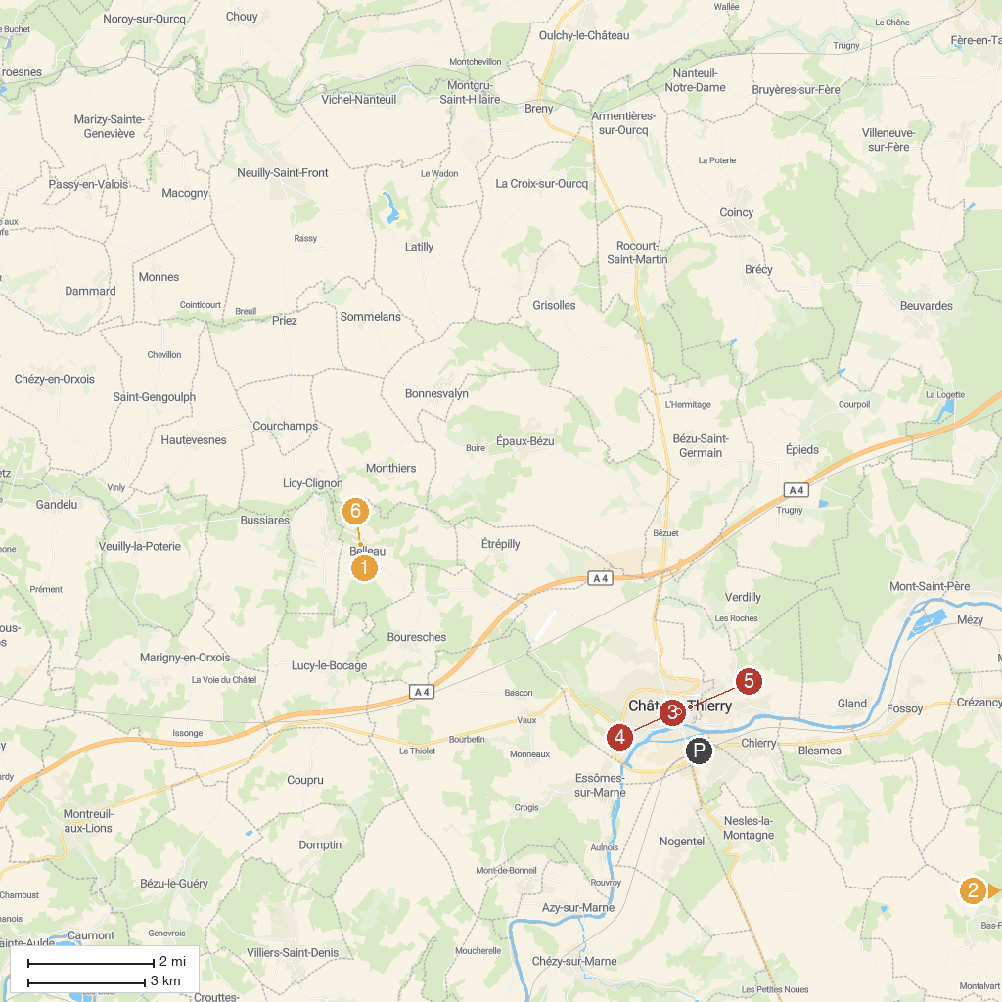
MAP KEY
1. Aisne-Marne American Cemetery | 4. Chateau-Thierry Stephen castle
2. Château des Princes de Condé | 5. Porte Saint-Pierre
3. Jean de La Fontaine Museum | 6. Musée de la Mémoire de Belleau 1914-1918
P. Cruise port / terminal
Map © MapTiler © OpenStreetMap contributors · cruiseports.org

