Chau Doc, An Giang, Vietnam
Where the Hau River meets the Cambodian border, Chau Doc is a mosaic of Cham fishing villages, Buddhist pagodas, and steaming bowls of bún cá — a gateway to authentic Mekong Delta life.
⚓ River anchorage / tender · 🕒 Typical call: 6–8 hrs · 💵 Vietnamese Dong (VND) · 🗣️ Vietnamese (Cham, Khmer spoken locally)
✍️ MY DAY IN PORT (FILL IN)
Ship / Date
In port | arrive ______ · all aboard ______
Booked excursion
Notes / meeting point
GETTING ASHORE
- Docking: Vessels anchor in the Hau River and tender ashore to a pier near the town waterfront
- Walk to center: Tender drops passengers at the riverside — market and main streets are steps away
- Best For: River culture, floating villages, pilgrimage temples, Cambodian border atmosphere
- Don't Miss: Sam Mountain temples and the panoramic sunrise view over rice fields toward Cambodia
GETTING AROUND
- 🚕 Taxi: 15,000–30,000 VND — The most common and affordable way to get around Chau Doc. Drivers wait near the pier; negotiate the fare before you rid
- 📱 Rideshare: ✅ Grab
TOP THINGS TO DO
- Cham Floating Village Boat Tour — Board a local boat and cross the Hau River to the Cham villages of Chau Giang and Chau Phong.
- Sam Mountain Temples & Summit Hike — Nui Sam (Sam Mountain) rises 284 m from the flat delta plain 6 km from town — the highest peak in the Mekong Delta.
- Trà Sư Cajuput Forest — A flooded melaleuca forest 25 km from Chau Doc, best visited by rowboat through mirror-still waterways shaded by white-barked…
- Chau Doc Central Market — The riverside wet market is a sensory dive into Mekong Delta produce — towers of fresh herbs, live fish, mắm (fermented fish…
- Speedboat to Phnom Penh (Full Day / Overnight) — For ships with a generous port call or overnight stay, Chau Doc is the classic overland-river gateway to Cambodia.
BEST WALKS
- Riverside Stroll & Market Loop: 1.5 km · 30–45 min · Easy — From the waterfront tender drop at 30 Tháng 4 Park, walk south along the Hau River embankment past…
WEATHER · DAYLIGHT · MONEY
Month | High °F | Low °F | Rainy days
May | 92 | 79 | 15
Jul | 93 | 80 | 18
Sep | 88 | 77 | 24
Daylight: May 5:37AM–6:14PM · Jul 5:44AM–6:26PM · Sep 5:49AM–6:00PM
cruiseports.org/chau-doc · Confirm terminal & all-aboard time with your ship

Chau Doc, An Giang, Vietnam — Port Map
Red = walkable sights · Amber = excursions farther out · P = cruise terminal
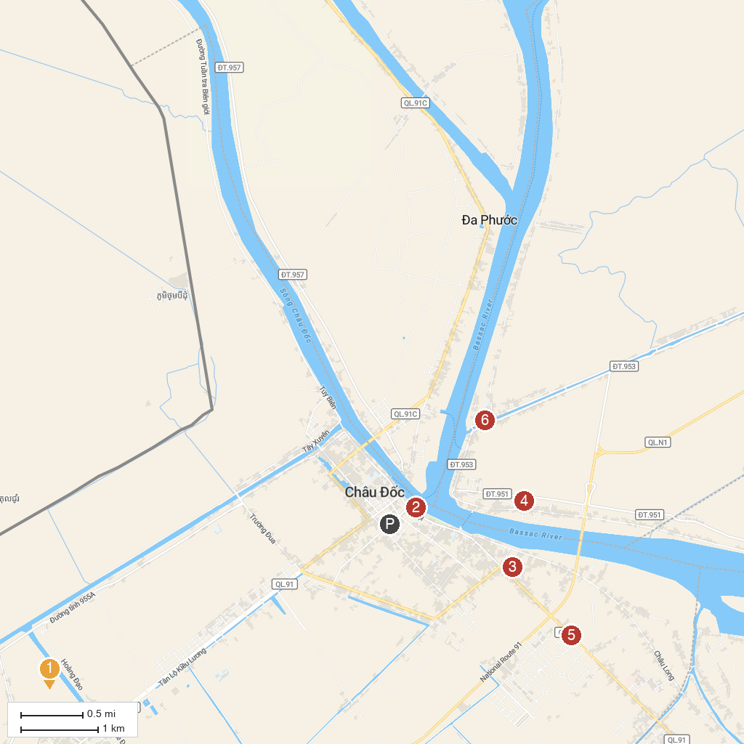
MAP KEY
1. Thoai Ngoc Hau Mausoleum | 4. Jamuil Azhar Mosque
2. Cá Basa Statue | 5. Cổng chào Thành phố Châu Đốc
3. Chau Long Market | 6. Masjid Nia'mah
P. Cruise port / terminal
Map © MapTiler © OpenStreetMap contributors · cruiseports.org

