Chennai, Tamil Nadu, India
The gateway to South India's cultural heartland — Chennai blends colonial-era forts, towering temple gopurams, and a 13-km beach boardwalk into a single action-packed shore day. Day-trippers who push 60 km south find one of the subcontinent's finest UNESCO coastlines at Mahabalipuram.
⚓ Docked — Ambedkar Dock terminal · 🕒 Typical call: 8-10 hrs · 💵 Indian Rupee (INR) · 🗣️ Tamil & English · 🌡️ Best Oct–Mar
✍️ MY DAY IN PORT (FILL IN)
Ship / Date
In port | arrive ______ · all aboard ______
Booked excursion
Notes / meeting point
GETTING ASHORE
- Docking: Ambedkar Dock, Royapuram — fully docked, no tender
- Walk to centre: ~4 km by taxi/Ola to central Chennai (10–15 min)
- Best For: Temple culture, UNESCO ruins, colonial history, beach walks
- Don't Miss: Mahabalipuram Shore Temple & Five Rathas (60 km south)
GETTING AROUND
- 🚕 Taxi: ₹200–350 (~$2–4 USD) — Metered taxis from the port use a base fare of ₹130 plus ₹25/km. The city center (George Town) is roughly 4 km away. Pre
- 📱 Rideshare: ✅ Uber, Ola
- 🚌 Hop-on hop-off: ✅
TOP THINGS TO DO
- Mahabalipuram UNESCO Shore Temples — A must-do if your call is long enough.
- Fort St. George & City Heritage — India's first English fort (1644) is just 3 km from the port.
- Kapaleeshwarar Temple, Mylapore — One of Chennai's most celebrated Dravidian temples, dedicated to Lord Shiva.
- Marina Beach Stroll — At 13 km, Marina Beach is the world's second-longest urban beach.
- DakshinaChitra Heritage Museum — A living museum 25 km south of Chennai showcasing traditional South Indian homes, crafts, and performing arts from Tamil Nadu…
BEST WALKS
- Royapuram Waterfront to Fort St. George: 3 km · Easy · 45–60 min — From the port gate, head south along the waterfront past the Kasimedu Fishing Harbour — arrive…
- Mylapore Temple Neighbourhood Walk: 2 km loop · Easy · 1-1.5 hrs — Start at Kapaleeshwarar Temple, circle through the tank courtyard, then weave through Mylapore's…
WEATHER · DAYLIGHT · MONEY
Month | High °F | Low °F | Rainy days
May | 95 | 82 | 4
Jul | 93 | 80 | 16
Sep | 90 | 79 | 20
Daylight: May 5:43AM–6:27PM · Jul 5:50AM–6:39PM · Sep 5:58AM–6:09PM
cruiseports.org/chennai · Confirm terminal & all-aboard time with your ship

Chennai, Tamil Nadu, India — Port Map
Red = walkable sights · Amber = excursions farther out · P = cruise terminal
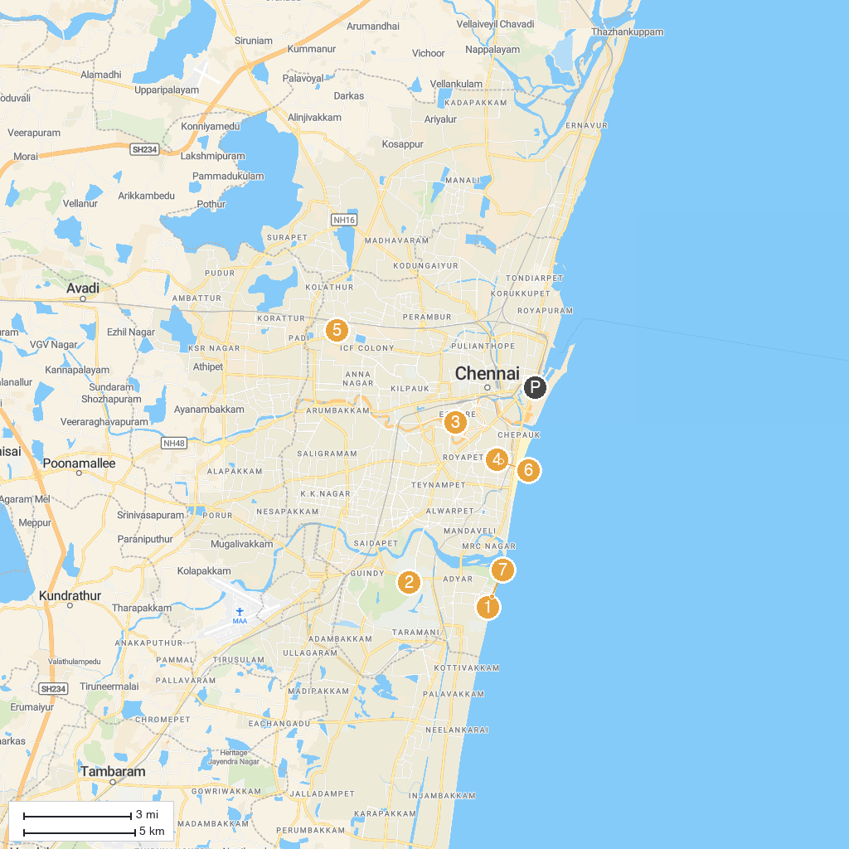
MAP KEY
1. Sri Utthara Guruvayoorappan Temple | 5. Arulmigu sri Ellamman Kovil
2. Annai Velankanni Shrine Basilica | 6. Arulmigu Sowmya Damodara Perumal Koil
3. Guindy National Park | 7. Arulmigu Thelliyasinga Perumal Temple
4. Government Museum Chennai | 8. Karl Schmidt Memorial
P. Cruise port / terminal
Map © MapTiler © OpenStreetMap contributors · cruiseports.org

