Chilean Fjords, Patagonia, Chile
A thousand-kilometre labyrinth of glacial channels, towering granite walls, and ice-blue waterways stretching from Chilean Lake District to the Strait of Magellan. Most of the time you're simply sailing — and the sailing is the destination.
⚓ Scenic sailing / tender at Puerto Edén · 🕒 Typically 1-2 days transit · 💵 Chilean Peso (CLP) · 🗣️ Spanish · 🌡️ Best: Sep–Apr (Austral summer)
✍️ MY DAY IN PORT (FILL IN)
Ship / Date
In port | arrive ______ · all aboard ______
Booked excursion
Notes / meeting point
GETTING ASHORE
- Docking: No fixed pier — scenic cruising passage; tender stop at Puerto Edén (remote village) on some itineraries
- Coverage: ~1,000 km of fjords from Puerto Montt south to the Strait of Magellan
- Best For: Glaciers, Patagonian wildlife, remote wilderness scenery
- Don't Miss: Amalia Glacier, Pía Glacier, Andean condors soaring the channel walls
GETTING AROUND
- 🚕 Taxi: $6–10 USD city rides — Punta Arenas cruise terminal is near the city center — often walkable. Taxis are available dockside for city transfers a
TOP THINGS TO DO
- Glacier Zodiac Excursion — Approach tidewater glaciers — Amalia (Skua), Pía, or Garibaldi — by inflatable Zodiac, close enough to hear the ice creak and…
- Magellanic Penguin & Seabird Watching — Magellanic penguins nest on rocky islets throughout the channels.
- White Narrows & English Narrows Navigation — The Angostura Inglesa (English Narrows) is a famous ship-width passage where the channel squeezes to a few hundred metres.
- Puerto Edén Village Visit — A tender stop at Puerto Edén, home to one of the last communities of the Kawésqar indigenous people.
- Torres del Paine Day Tour (from Puerto Natales) — If your itinerary calls at Puerto Natales, this is your gateway to Torres del Paine National Park — the granite towers, turquoise…
BEST WALKS
- Puerto Edén Village Walk: 0.5 km · Easy · 30 min — From the dock, follow the main boardwalk through the village past the school, the small Kawésqar…
WEATHER · DAYLIGHT · MONEY
Month | High °F | Low °F | Rainy days
May | 44 | 37 | 12
Jul | 39 | 32 | 13
Sep | 45 | 36 | 11
Daylight: May 9:22AM–6:25PM · Jul 9:45AM–6:22PM · Sep 8:01AM–7:45PM
cruiseports.org/chilean-fjords · Confirm terminal & all-aboard time with your ship

Chilean Fjords, Patagonia, Chile — Port Map
Red = walkable sights · Amber = excursions farther out · P = cruise terminal
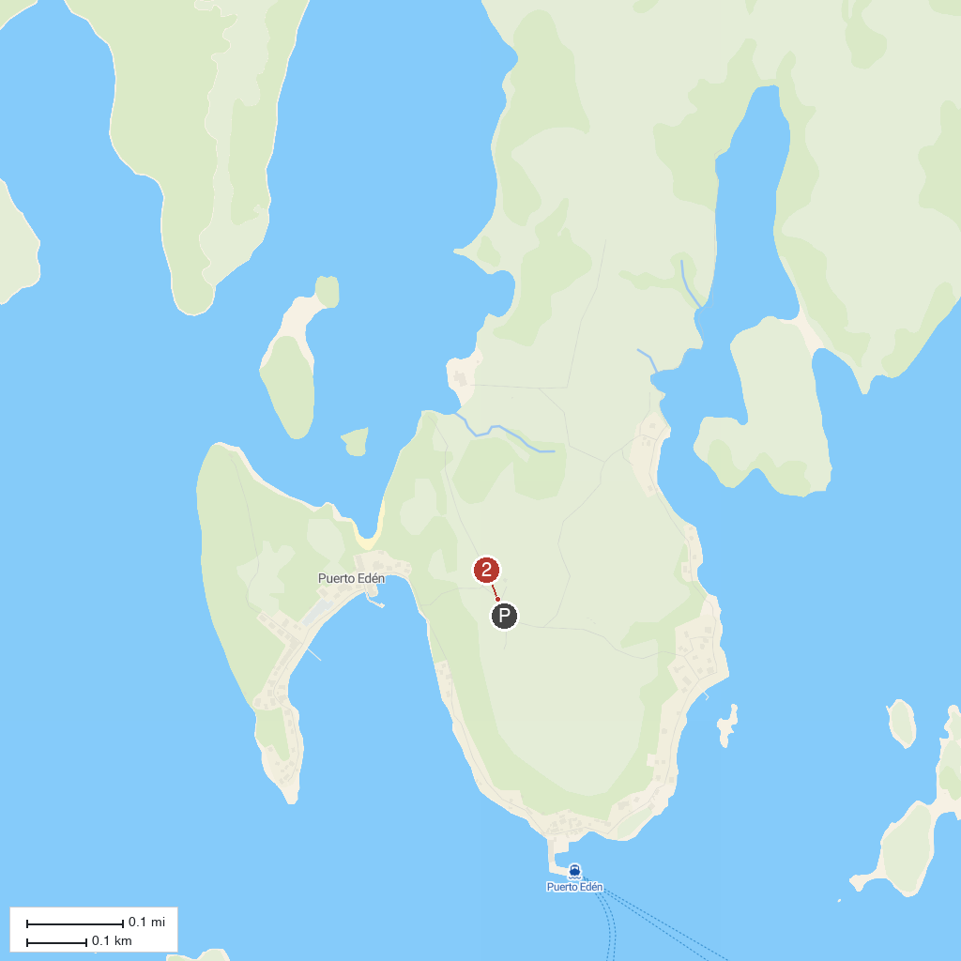
MAP KEY
1. Pasarelas de Puerto Eden | 3. Parque Nacional Bernardo O'Higgins
2. Comunidad Kaweskar
P. Cruise port / terminal
Map © MapTiler © OpenStreetMap contributors · cruiseports.org

