Chiloé Island, Los Lagos, Chile
Chiloé is a world apart — a misty island of rainbow palafito stilt houses, hand-built wooden churches recognized by UNESCO, and a seafood culture rooted in centuries of Chilote tradition. Ships anchor offshore and tender into Castro's downtown waterfront, putting you within walking distance of the island's best.
⚓ Tender port · 🕒 Typical call: 8–10 hrs · 💵 Chilean Peso (CLP) · 🗣️ Spanish
✍️ MY DAY IN PORT (FILL IN)
Ship / Date
In port | arrive ______ · all aboard ______
Booked excursion
Notes / meeting point
GETTING ASHORE
- Docking: Tender — ships anchor offshore; small boats land at Castro's downtown pier
- Walk to center: Immediate — tender dock is steps from Plaza de Armas
- Best For: UNESCO architecture, palafito stilt houses, Chilote food & handicrafts
- Don't Miss: Iglesia San Francisco de Castro and the Gamboa palafito waterfront
GETTING AROUND
- 🚕 Taxi: $3–8 USD (short rides) — Local taxis are readily available near the tender pier. Fares are reasonable; longer island excursions (30–40 km) run $3
- 📱 Rideshare: ✅ Uber
TOP THINGS TO DO
- Palafitos & Iglesia San Francisco — Walk the Gamboa and Pedro Montt waterfront to photograph the iconic colorful stilt houses, then climb to Plaza de Armas and the…
- UNESCO Wooden Churches Circuit — Chiloé has 16 UNESCO World Heritage wooden churches across the archipelago.
- Puñihuil Penguin Colony — The islets of Puñihuil are the only place on Earth where Humboldt and Magellanic penguins nest together.
- Chiloé National Park — On the island's wild Pacific coast, this park protects ancient evergreen Valdivian rainforest, peat bogs, and coastal dunes.
- Castro Food & Market Tour — Taste Chilote specialties — curanto, milcao, chupe de jaiba, seafood empanadas — at the Mercado Municipal and waterfront…
BEST WALKS
- Waterfront Palafitos to Plaza de Armas: 1.5 km · 30–45 min · Easy (some uphill) — Start at the tender pier at the Feria Artesanal, walk south along Ernesto Riquelme street to view…
- Pedro Montt Palafito Strip: 1 km · 20 min · Easy — Head north from the tender dock along Avenida Pedro Montt for a longer stretch of palafitos with…
- Waterfront to Palafitos: ~2 km · 1 hr · easy — From the tender dock, walk north along the Costanera waterfront past the Feria Artesanal to the…
WEATHER · DAYLIGHT · MONEY
Month | High °F | Low °F | Rainy days
May | 68 | 52 | 10
Jul | 66 | 48 | 5
Sep | 73 | 54 | 10
Daylight: May 6:49AM–5:43PM · Jul 7:04AM–5:48PM · Sep 6:17AM–6:13PM
cruiseports.org/chiloe-island-chile · Confirm terminal & all-aboard time with your ship

Chiloé Island, Los Lagos, Chile — Port Map
Red = walkable sights · Amber = excursions farther out · P = cruise terminal
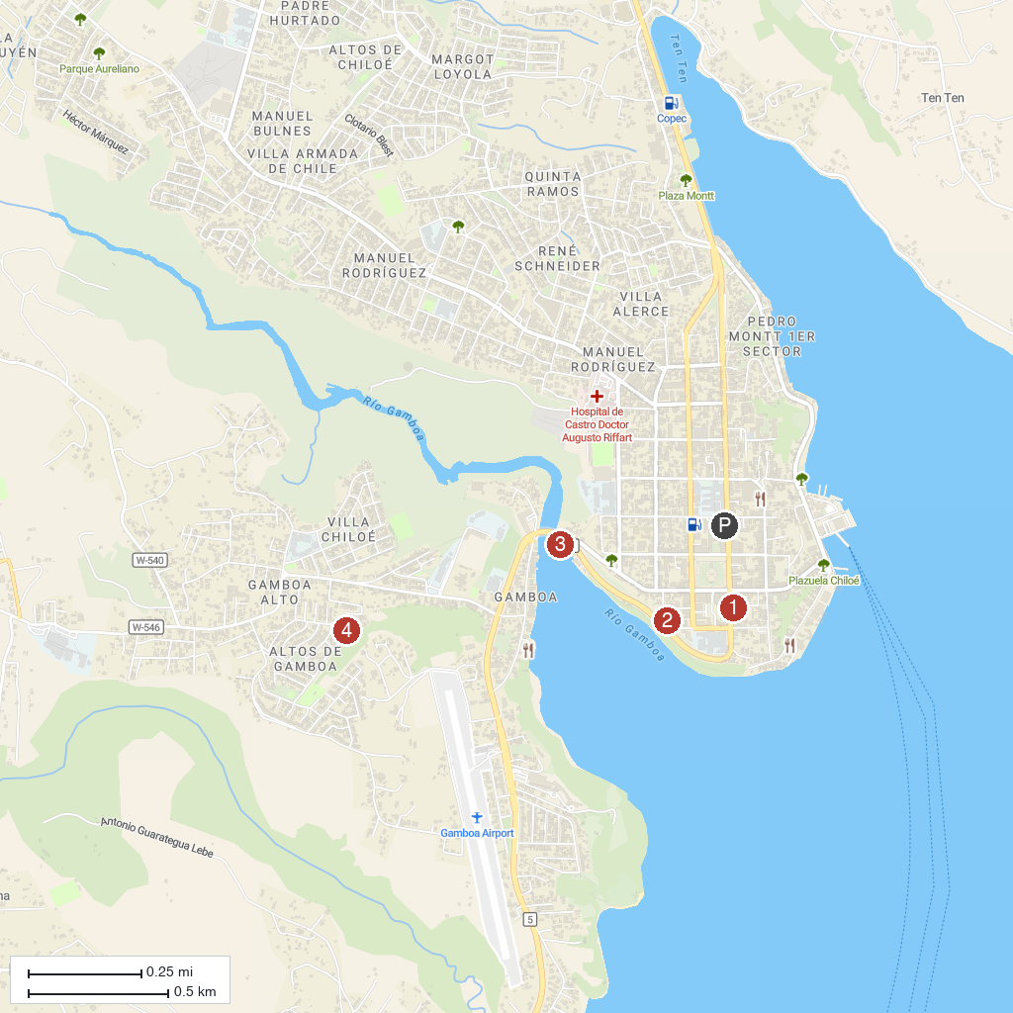
MAP KEY
1. Municipal Museum Castro | 4. Mirador Gamboa
2. Feria Artesanal de Dalcahue | 5. Cabañas el Isleño Castro Chiloe.
3. Mirador Chacabuco
P. Cruise port / terminal
Map © MapTiler © OpenStreetMap contributors · cruiseports.org

