Chongqing, Chongqing Municipality, China
Where the Yangtze and Jialing Rivers meet, China's mountain megacity stacks neighborhoods on cliff faces, threads monorail trains through skyscrapers, and fuels it all with the nation's most famous spicy hotpot.
⚓ Docked (river pier) · 🕒 Typical call: embark/debark port · 💵 Chinese Yuan (CNY) · 🗣️ Mandarin Chinese · 🌶️ Hotpot capital of China
✍️ MY DAY IN PORT (FILL IN)
Ship / Date
In port | arrive ______ · all aboard ______
Booked excursion
Notes / meeting point
GETTING ASHORE
- Docking: Chaotianmen Dock, Piers 1–17; specific pier confirmed 1–2 days before sailing
- Walk to center: Chaotianmen Square is immediately adjacent; Jiefangbei CBD ~1.5 km
- Best For: Yangtze River cruise embark/debark, urban exploration, food lovers
- Don't Miss: Hongya Cave at night, Ciqikou Ancient Town, a Chongqing hotpot dinner
GETTING AROUND
- 🚕 Taxi: CNY 10–20 (~$1.50–3) — Metered yellow taxis are plentiful near Chaotianmen Port. Jiefangbei CBD is ~4 km (CNY 10–15); Hongya Cave ~4.5 km (CNY
- 📱 Rideshare: ✅ DiDi
- 🚌 Hop-on hop-off: ✅
TOP THINGS TO DO
- Ciqikou Ancient Town — A well-preserved Ming and Qing dynasty trading port neighborhood, with narrow flagstone lanes, traditional teahouses, Baolun…
- Hongya Cave (Hongyadong) at Night — An 11-story stilted building complex built into a cliff above the Jialing River, blazing with neon at night in a scene that…
- Three Gorges Museum — Chongqing's premier museum covers the science, history, and folk culture of the Three Gorges region, with exhibits on ancient Ba…
- Chongqing Hotpot Experience — Chongqing invented the nine-palace-grid hotpot and remains its spiritual home.
- Yangtze River Ropeway — The last surviving cross-river ropeway in Chongqing, once a daily commute for residents, now carries tourists 1,166 metres over…
BEST WALKS
- Chaotianmen to Jiefangbei CBD Riverside Walk: 2.5 km · 40 min · Easy — From the dock at Chaotianmen Square, follow the riverfront promenade southwest along the Yangtze…
- Ciqikou Ancient Town Loop: 2 km · 1.5 hrs · Easy — Explore the flagstone lanes of Ciqikou, visit Baolun Temple, browse handicraft stalls, and settle…
WEATHER · DAYLIGHT · MONEY
Month | High °F | Low °F | Rainy days
May | 78 | 65 | 17
Jul | 90 | 76 | 14
Sep | 82 | 70 | 16
Daylight: May 6:01AM–7:39PM · Jul 6:04AM–7:55PM · Sep 6:38AM–6:58PM
cruiseports.org/chongqing · Confirm terminal & all-aboard time with your ship

Chongqing, Chongqing Municipality, China — Port Map
Red = walkable sights · Amber = excursions farther out · P = cruise terminal
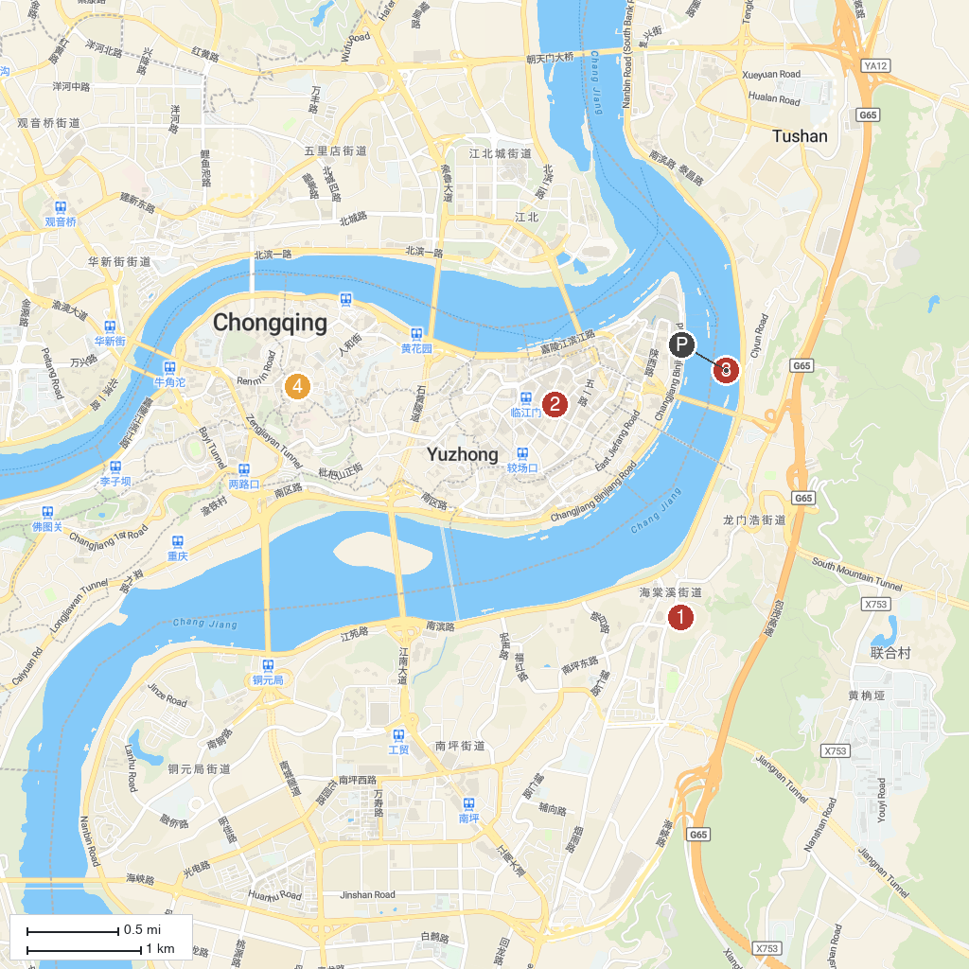
MAP KEY
1. Nanbin Road Scenic Area | 3. Chaotianmen Dock
2. CiCi·PARK | 4. Three Gorges Museum
P. Cruise port / terminal
Map © MapTiler © OpenStreetMap contributors · cruiseports.org

