Civitavecchia, Lazio, Italy
Rome's cruise gateway puts you 80 km from the Colosseum — a regional train from the port has you inside the Forum in under 90 minutes. Stay local and Civitavecchia rewards too: a Bramante-designed fortress, Etruscan ruins, and the best seafood lunches you'll find at a cruise port.
⚓ Docked (cruise terminal) · 🕒 Typical call: 8–12 hrs · 💶 Currency: Euro (€) · 🗣️ Language: Italian · 🚆 Train to Rome: ~45–80 min
✍️ MY DAY IN PORT (FILL IN)
Ship / Date
In port | arrive ______ · all aboard ______
Booked excursion
Notes / meeting point
GETTING ASHORE
- Docking: Fully docked at Stazione Marittima; ships use Amerigo Vespucci Terminal (Pier 12bis), Bramante Terminal (Pier 12), or Piers 10–13 & 25
- Walk to center: Free port shuttle to Largo della Pace, then 5–10 min walk to Forte Michelangelo and city center
- Best For: Rome (Colosseum, Vatican, Ostia Antica), Terme Taurine ruins, Santa Marinella beach, authentic Lazio seafood
- Don't Miss: Book Colosseum and Vatican timed-entry tickets weeks before you sail — they sell out
GETTING AROUND
- 🚕 Taxi: €125–€180 — Licensed taxis are available at the port gate. Confirm the fixed fare before departing; avoid unmarked vehicles that may
- 📱 Rideshare: ✅ Uber
- 🚌 Hop-on hop-off: ✅ Hop-on hop-off
TOP THINGS TO DO
- Rome Highlights: Colosseum, Roman Forum & Palatine Hill — The non-negotiable headline.
- Vatican Museums, Sistine Chapel & St. Peter's Basilica — The world's largest art museum ends at Michelangelo's Sistine Chapel ceiling and deposits you in St.
- Ostia Antica — Rome's Ancient Port City — Far less crowded than Pompeii and arguably better preserved, Ostia Antica is Rome's ancient harbour town: intact apartment…
- Santa Marinella Beach Day — One train stop south of Civitavecchia (5–10 min, ~€2), Santa Marinella is a proper Italian beach resort.
- Terme Taurine & Etruscan Necropolis (Tarquinia) — Within 15 km of the port lie two underrated gems: the Terme Taurine Roman bath ruins (~5 km; taxi), and Tarquinia's painted…
BEST WALKS
- Civitavecchia Waterfront & Forte Michelangelo: 1.5 km · 20–25 min · Flat — From Largo della Pace, walk north past the harbour wall to Forte Michelangelo — the 16th-century…
- Rome: Colosseum to Circus Maximus Loop: 2.5 km · 1.5 hrs walking (+ monument time) · Some slopes — Exit Colosseo Metro, walk to the Colosseum, then follow Via Sacra through the Roman Forum, up to…
- Rome: Vatican to Castel Sant'Angelo: 1.2 km · 20 min · Flat — Exit Vatican Museums into St.
WEATHER · DAYLIGHT · MONEY
Month | High °F | Low °F | Rainy days
May | 71 | 58 | 9
Jul | 85 | 71 | 3
Sep | 78 | 66 | 8
Daylight: May 5:52AM–8:26PM · Jul 5:50AM–8:46PM · Sep 6:53AM–7:22PM
ESSENTIAL TRAVEL QUALIFICATIONS
Largo della Pace–station approximately 1.5 km / 20 minutes on foot; allow more with luggage or mobility needs. Confirm assigned berth and permitted exit route.
cruiseports.org/civitavecchia-rome · Confirm terminal & all-aboard time with your ship

Civitavecchia, Lazio, Italy — Port Map
Red = walkable sights · Amber = excursions farther out · P = cruise terminal
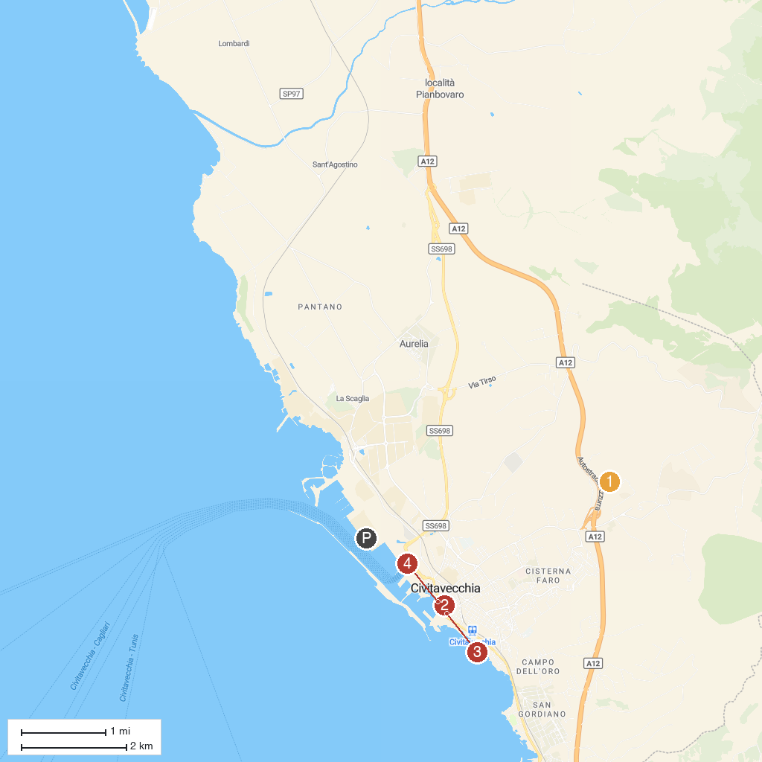
MAP KEY
1. Museo Civico di Tolfa | 4. Museo Archeologico Nazionale di Civitavecchia
2. Aquafelix | 5. Fontana del Vanvitelli
3. Cattedrale di S. Francesco d’Assisi
P. Cruise port / terminal
Map © MapTiler © OpenStreetMap contributors · cruiseports.org

