Clayton, New York, USA
Gateway to the Thousand Islands, Clayton sits right on the St. Lawrence River where more than 1,800 islands dot the water between the US and Canada — Boldt Castle is just a boat ride away.
⚓ Docked (Thousand Islands Regional Dock) · 🕒 Typical call: 7-9 hrs · 💵 USD · 🗣️ English · 🏝️ Island hopping
✍️ MY DAY IN PORT (FILL IN)
Ship / Date
In port | arrive ______ · all aboard ______
Booked excursion
Notes / meeting point
GETTING ASHORE
- Docking: Thousand Islands Regional Dock, downtown Riverside Drive — steps to shops and restaurants
- Walk to center: Immediate — dock is at Frink Park in the heart of downtown Clayton
- Best For: Boldt Castle boat tours, antique boats, Riverwalk strolls, local cheese & fudge
- Don't Miss: Antique Boat Museum and a narrated island cruise past Heart Island
GETTING AROUND
- 🚕 Taxi: Varies (hourly rates) — 1000 Island Taxi (315-418-0618) serves Clayton and the surrounding region. Best for reaching destinations outside the vi
- 📱 Rideshare: ✅ Uber
TOP THINGS TO DO
- Boldt Castle Island Tour — Board a narrated boat to Heart Island and tour Boldt Castle, the unfinished million-dollar estate built by Waldorf Astoria owner…
- Rock Island Lighthouse — A glass-bottom boat tour with Clayton Island Tours takes you to this 1847 lighthouse on American soil.
- Antique Boat Museum — The largest freshwater recreational boat collection in North America, housed right on the Clayton waterfront.
- Two Nation Island Cruise — Narrated cruise through both US and Canadian waters of the Thousand Islands — no passport stop required.
- Clayton Local Food & Drink Loop — Sample the region on foot: River Rat Cheese for local curds, Lil' River Fudge Company for handmade sweets, and Coyote Moon…
BEST WALKS
- Clayton Riverwalk: 1.5 km · Flat · 20-30 min — Follow the paved Riverwalk along the St.
- Downtown Clayton Historic Stroll: 1 km loop · Flat · 30 min — Walk Riverside Drive and Merrick Street through the small Victorian-era downtown.
WEATHER · DAYLIGHT · MONEY
Month | High °F | Low °F | Rainy days
May | 66 | 46 | 12
Jul | 79 | 62 | 10
Sep | 70 | 53 | 11
Daylight: May 5:44AM–7:32PM · Jul 5:47AM–7:48PM · Sep 6:26AM–6:47PM
cruiseports.org/clayton-ny · Confirm terminal & all-aboard time with your ship

Clayton, New York, USA — Port Map
Red = walkable sights · Amber = excursions farther out · P = cruise terminal
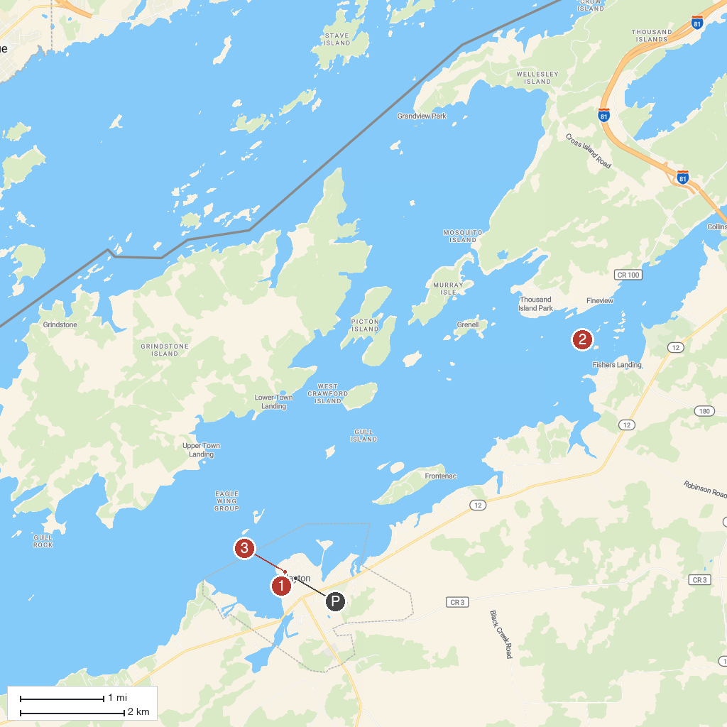
MAP KEY
1. Antique Boat Museum | 3. Rock Island Lighthouse
2. Boldt Castle | 4. Thousand Islands Museum
P. Cruise port / terminal
Map © MapTiler © OpenStreetMap contributors · cruiseports.org

