Kochi, Kerala, India
A layered port city where colonial spice-trade history meets Kerala's backwater canals — the Chinese fishing nets at dusk alone are worth the visit.
⚓ Docked (Willingdon Island) · 🕒 Typical call: 8-10 hrs · 💵 Indian Rupee (INR) · 🗣️ Malayalam / English widely spoken · 🌡️ Best Oct–Mar
✍️ MY DAY IN PORT (FILL IN)
Ship / Date
In port | arrive ______ · all aboard ______
Booked excursion
Notes / meeting point
GETTING ASHORE
- Docking: Sagarika or Samudrika terminal, Willingdon Island — ~10 km from Fort Kochi
- Walk to center: Not walkable; taxi, tuk-tuk or ferry to Fort Kochi required
- Best For: History, culture, backwaters, spice markets, Kathakali dance
- Don't Miss: Chinese Fishing Nets at sunset and Paradesi Synagogue in Jew Town
GETTING AROUND
- 🚕 Taxi: ₹300–500 — Prepaid taxis queue outside the terminal. Metered rate is ₹70 base + ₹30/km (2025 tariff). Fort Kochi runs ₹300–400; Ern
- 📱 Rideshare: ✅ Uber, Ola
TOP THINGS TO DO
- Fort Kochi Heritage Walk — Explore the colonial grid of Fort Kochi on foot: the Chinese Fishing Nets on the waterfront, St.
- Mattancherry Palace & Paradesi Synagogue — The Mattancherry Palace (Dutch Palace) was built by the Portuguese in 1555 and features stunning Kerala murals depicting the…
- Kerala Backwaters Houseboat Cruise — A 2–3 hour motorized houseboat cruise through Kochi's network of canals and lagoons reveals rice paddy fields, coconut groves…
- Kathakali & Kalaripayattu Show — Several performance venues in Fort Kochi offer early-evening Kathakali (classical Kerala dance-drama with elaborate costume and…
- Spice Market & Kerala Food Tour — Kochi was the epicenter of the global spice trade.
BEST WALKS
- Fort Kochi Waterfront & Heritage Loop: 2.5 km | 1-1.5 hrs | Easy — Start at Fort Kochi Jetty (Customs Jetty) and walk north along the waterfront to the Chinese…
- Mattancherry Spice & Synagogue Stroll: 1.5 km | 45 min | Easy — From the Mattancherry Boat Jetty (short ferry from Fort Kochi Jetty or tuk-tuk), walk through the…
WEATHER · DAYLIGHT · MONEY
Month | High °F | Low °F | Rainy days
May | 90 | 77 | 10
Jul | 84 | 74 | 24
Sep | 85 | 75 | 15
Daylight: May 6:04AM–6:38PM · Jul 6:11AM–6:50PM · Sep 6:15AM–6:25PM
Representative sunrise/sunset — 2025, 15th of each month; local civil time including DST (Asia/Kolkata). Source: Astral; not a forecast or climate average.
cruiseports.org/cochin · Confirm terminal & all-aboard time with your ship

Kochi, Kerala, India — Port Map
Red = walkable sights · Amber = excursions farther out · P = cruise terminal
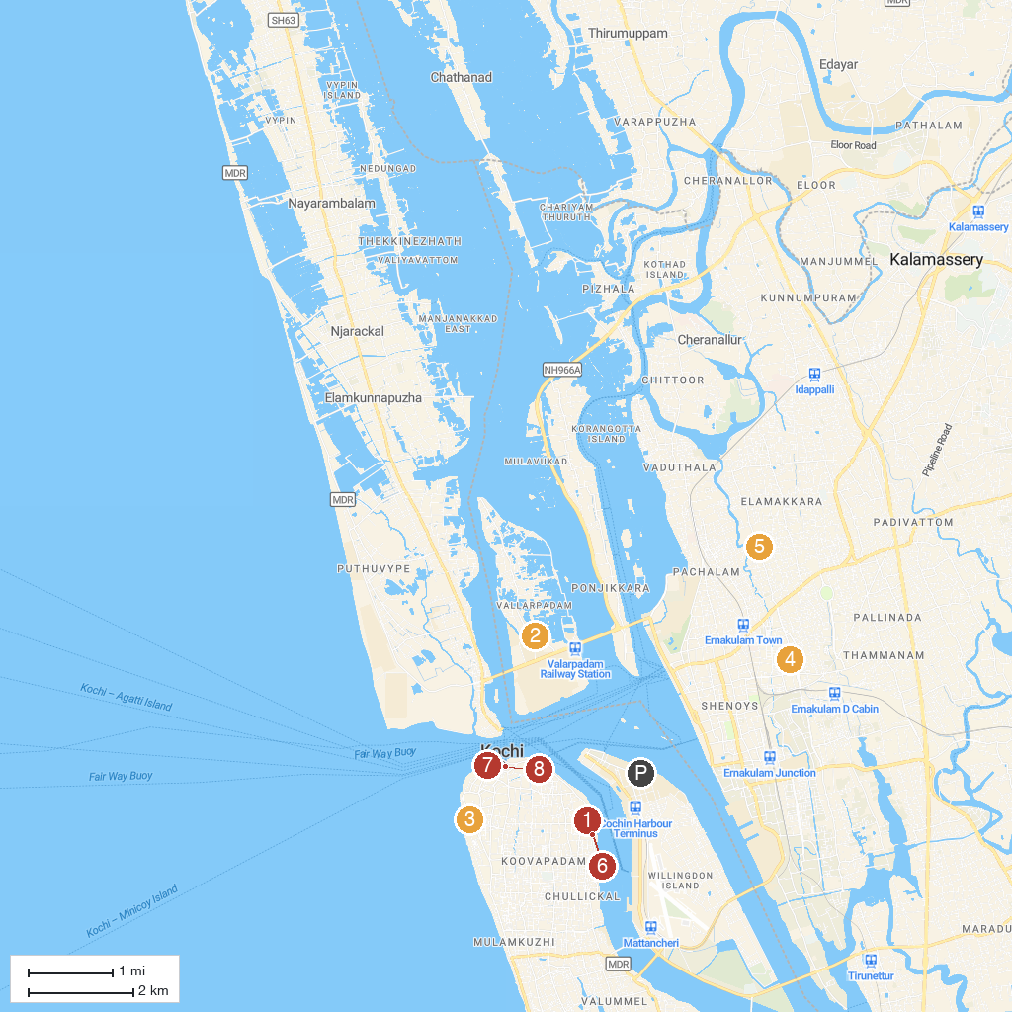
MAP KEY
1. Mattancherry Palace | 5. Little Flower Roman Catholic Church
2. National Shrine Basilica of Our Lady of Ransom - Vallarpadam | 6. International Tourism Police Station And Police Museum
3. Indian Naval Maritime Museum | 7. Vasco Da Gama Square
4. St. Francis Xavier's Roman Catholic Church | 8. Cochin Cultural Centre (Kathakali, Kalaripayattu, Mohiniyattam, Bharatanatyam)
P. Cruise port / terminal
Map © MapTiler © OpenStreetMap contributors · cruiseports.org

