CocoCay, Berry Islands, Bahamas
Royal Caribbean's showpiece private island transforms a sun-drenched Berry Islands cay into a fully-loaded beach resort — all in a single shore day. From the tallest waterslide in the Caribbean to a lively adults-only escape and free white-sand beaches, there's more here than most full-day resorts can offer.
⚓ Docked (dedicated pier, two berths) · 🕒 Typical call: 7-10 hrs · 💵 SeaPass card only — no cash needed · 🗣️ English · 🏝️ Royal Caribbean & Celebrity Cruises only
✍️ MY DAY IN PORT (FILL IN)
Ship / Date
In port | arrive ______ · all aboard ______
Booked excursion
Notes / meeting point
GETTING ASHORE
- Docking: Pier — walk directly off the ship, ~6-min walk to Arrivals Plaza
- Walk to center: 6 min pier to Arrivals Plaza; 15 min to Chill Island; tram for mobility needs
- Best For: Families, thrill-seekers, beach lovers, and adults-only escapes at Hideaway Beach
- Don't Miss: Thrill Waterpark's Daredevil's Peak (135 ft) or the Up, Up & Away helium balloon at 450 ft
GETTING AROUND
- 📱 Rideshare: ❌ not available
TOP THINGS TO DO
- Thrill Waterpark — Fourteen waterslides crowned by Daredevil's Peak — at 135 feet, the tallest waterslide in the Caribbean.
- Oasis Lagoon & Free Beaches — Oasis Lagoon is the Caribbean's largest freshwater pool — a swim-up bar, live DJ, and zero entry fee.
- Hideaway Beach (Adults-Only) — Opened January 2024, this gated 18+ zone holds a maximum of ~1,800 guests, keeping it genuinely uncrowded.
- Coco Beach Club — A premium beach club offering infinity pool access, elevated dining, and exclusive loungers on a quiet stretch of beach.
- Up, Up & Away Helium Balloon — Ascend 450 feet above CocoCay in a tethered helium balloon for 360-degree panoramas of the Berry Islands.
BEST WALKS
- Arrivals Plaza to Chill Island Beach: ~15 min · Flat · Free — The main island promenade from the Arrivals Plaza winds past Oasis Lagoon to Chill Island, the most…
- Chill Island to South Beach: ~25 min one-way · Easy · Free — Continue from Chill Island through Breezy Bay to quieter South Beach — noticeably less crowded even…
WEATHER · DAYLIGHT · MONEY
Month | High °F | Low °F | Rainy days
May | 79 | 76 | 13
Jul | 84 | 81 | 15
Sep | 84 | 81 | 16
Daylight: May 6:25AM–7:49PM · Jul 6:29AM–8:04PM · Sep 6:57AM–7:14PM
ESSENTIAL TRAVEL QUALIFICATIONS
Paid-upgrade prices unknown; check your sailing in Cruise Planner. Free beach access does not include every upgrade.
cruiseports.org/coco-cay · Confirm terminal & all-aboard time with your ship

CocoCay, Berry Islands, Bahamas — Port Map
Red = walkable sights · Amber = excursions farther out · P = cruise terminal
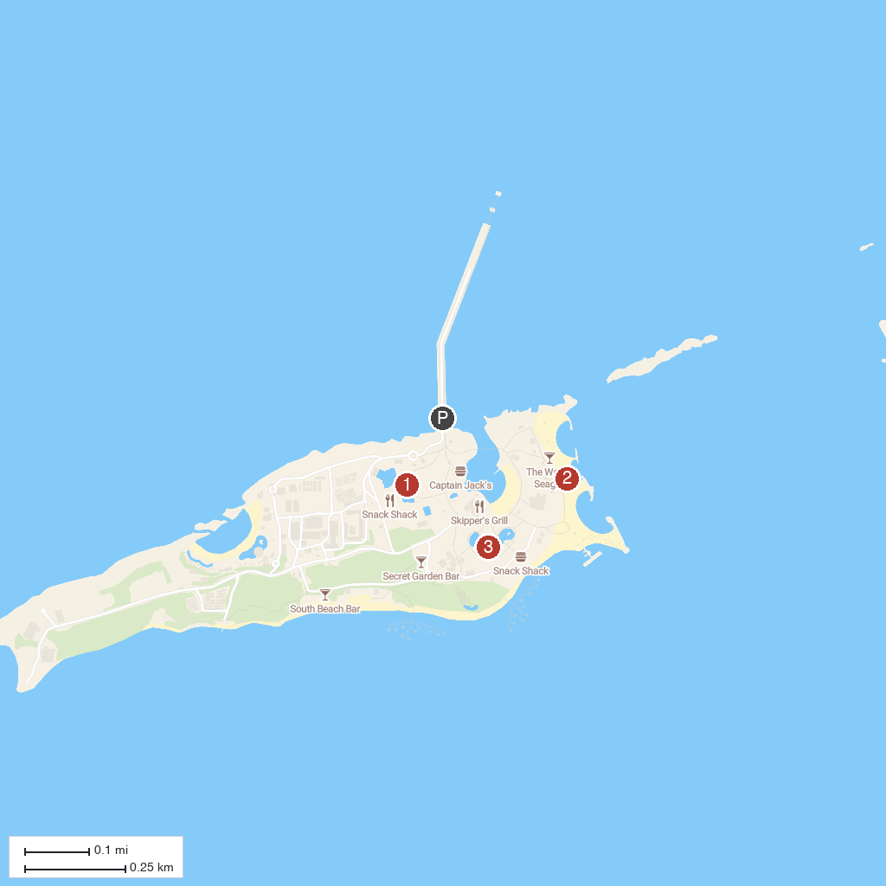
MAP KEY
1. Thrill Waterpark | 3. Oasis Lagoon
2. Chill Island
P. Cruise port / terminal
Map © MapTiler © OpenStreetMap contributors · cruiseports.org

