Cognac, Charente, France
The town that gave the world's finest brandy its name. Amber cellars, medieval streets, and the gentle Charente await — best explored on foot or by gabare.
⚓ River port — quay docking · 🕒 Typical call: 6–8 hrs · 💶 Currency: Euro (€) · 🗣️ Language: French
✍️ MY DAY IN PORT (FILL IN)
Ship / Date
In port | arrive ______ · all aboard ______
Booked excursion
Notes / meeting point
GETTING ASHORE
- Docking: River cruise ships tie up at the Charente quays, steps from the old town. Larger ocean-ship passengers arrive by coach from La Rochelle or Bordeaux.
- Walk to Centre: The quays are the centre — Vieux Cognac and the distilleries are within 5–10 minutes on foot.
- Best For: Cognac house tours and tastings, medieval architecture, slow river life.
- Don't Miss: A cellar tour at Hennessy or Martell, and a stroll through the cobblestones of Vieux Cognac.
GETTING AROUND
- 🚕 Taxi: €8–€15 — Regulated taxis available with a €8 base fare plus €2.24/km during the day. Rides from the quay to any city attraction a
- 📱 Rideshare: ✅ Uber
TOP THINGS TO DO
- Hennessy Cellar Tour & Tasting — Founded in 1765, Hennessy is the world's largest cognac producer.
- Château de Cognac & Baron Otard — The birthplace of Renaissance King François I (1494) now houses Baron Otard cognac.
- Martell Estate Tour — Martell, founded in 1715 and the oldest of the Grande Marques, offers guided tours of its historic estate, aging warehouses, and…
- Gabare River Cruise on the Charente — Board a traditional flat-bottomed gabare — a replica of the historical cargo boats that once shipped cognac barrels to the coast…
- Rémy Martin Production Estate at Merpins — A short drive from town, Rémy Martin's Merpins estate offers tours by electric train through the cognac-making process, from…
BEST WALKS
- Vieux Cognac & the Grande Maisons: 2–3 km · 45–60 min · Easy — From the quay, cross into the old town to the Château de Cognac, then wind through medieval lanes…
- Charente Quay Stroll to Martell: 1.5 km · 20 min · Easy — Follow the riverside path west along the Charente from the town centre to the Martell estate on…
WEATHER · DAYLIGHT · MONEY
Month | High °F | Low °F | Rainy days
May | 69 | 52 | 12
Jul | 80 | 62 | 7
Sep | 75 | 57 | 9
Daylight: May 6:30AM–9:25PM · Jul 6:26AM–9:47PM · Sep 7:40AM–8:12PM
cruiseports.org/cognac · Confirm terminal & all-aboard time with your ship

Cognac, Charente, France — Port Map
Red = walkable sights · Amber = excursions farther out · P = cruise terminal
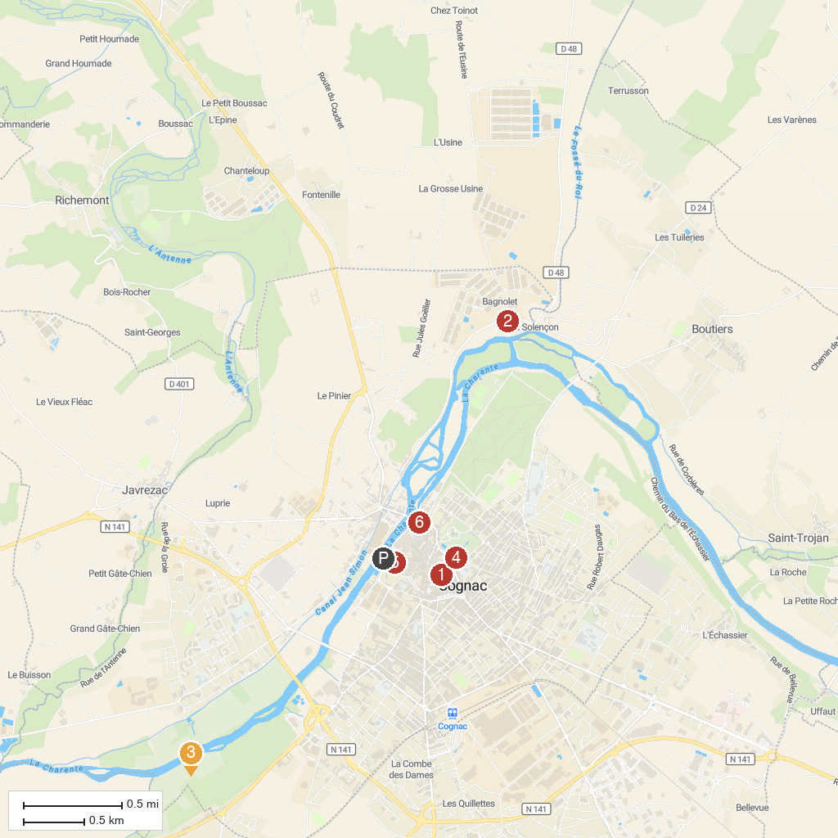
MAP KEY
1. Couvent des Récollets de Cognac | 5. Ecomusée du Cognac
2. Adventure Park Valley Fontdouce | 6. Maison du négociant - Musée d'Art et d'Histoire
3. Château de Bagnolet | 7. Musée des savoir-faire du cognac
4. Rémy Martin Estate | 8. Royal Castle of Cognac
P. Cruise port / terminal
Map © MapTiler © OpenStreetMap contributors · cruiseports.org

