Coimbra, Centro, Portugal
Portugal's most scholarly city perches on a hilltop above the Mondego River, its Baroque library and Romanesque cathedral drawing cruise visitors who arrive overland by coach from Porto-Leixões or the nearby coast.
🚌 Inland city — visited as a coach excursion · ⚓ Nearest ports: Porto-Leixões or Figueira da Foz · 🕒 Typical call: full-day excursion · 💶 Euro (€) · 🗣️ Portuguese
✍️ MY DAY IN PORT (FILL IN)
Ship / Date
In port | arrive ______ · all aboard ______
Booked excursion
Notes / meeting point
GETTING ASHORE
- Docking: Coimbra is inland and not a cruise berth. River-cruise itineraries visit it as a coach excursion from Porto-Leixões; the occasional small ocean ship docks at Figueira da Foz and transfers ~44 km by bus.
- Walk to centre: Coaches drop near Largo da Portagem in the lower town (Baixa). Hilly — the upper town (Alta) requires a stiff climb or the market elevator.
- Best For: History lovers, UNESCO fans, architecture, Fado music, and Portuguese academic culture.
- Don't Miss: The Joanina Library — one of the world's most beautiful Baroque libraries; book timed tickets in advance.
GETTING AROUND
- 🚕 Taxi: €6–€10 — Metered taxis available from the river dock or train station area to the city center. Base fare ~€3.25 (day) with €0.47/
- 📱 Rideshare: ✅ Uber, Bolt
- 🚌 Hop-on hop-off: ✅ Yellow Bus Tours (Funtastic Coimbra)
TOP THINGS TO DO
- University of Coimbra & Joanina Library — Explore the UNESCO-listed university complex founded in 1290.
- Coimbra Fado Experience — Coimbra's Fado is distinct from Lisbon's — performed by black-caped male students, it carries a poetic, academic melancholy.
- Sé Velha (Old Cathedral) & Arco de Almedina — Coimbra's 12th-century Romanesque cathedral is one of Portugal's best-preserved medieval churches.
- Santa Cruz Monastery — Coimbra's oldest monastery (1131) is the burial site of Portugal's first two kings, Afonso Henriques and Sancho I.
- Machado de Castro National Museum — Built above a Roman cryptoporticus (underground gallery), this museum holds a superb collection of medieval sculpture and…
BEST WALKS
- Baixa to Alta — The Classic Climb: 2.5–3 km | 2–3 hrs | Moderate (steep ascent) — Start at the riverfront Largo da Portagem, walk up Rua Ferreira Borges to Praça 8 de Maio and Santa…
- Santa Clara & the Other Bank: 2 km | 1–1.5 hrs | Easy — Cross the Ponte de Santa Clara from Largo da Portagem to explore the quieter left bank.
WEATHER · DAYLIGHT · MONEY
Month | High °F | Low °F | Rainy days
May | 73 | 54 | 9
Jul | 83 | 61 | 2
Sep | 80 | 59 | 7
Daylight: May 6:18AM–8:42PM · Jul 6:17AM–9:01PM · Sep 7:14AM–7:42PM
cruiseports.org/coimbra · Confirm terminal & all-aboard time with your ship

Coimbra, Centro, Portugal — Port Map
Red = walkable sights · Amber = excursions farther out · P = cruise terminal
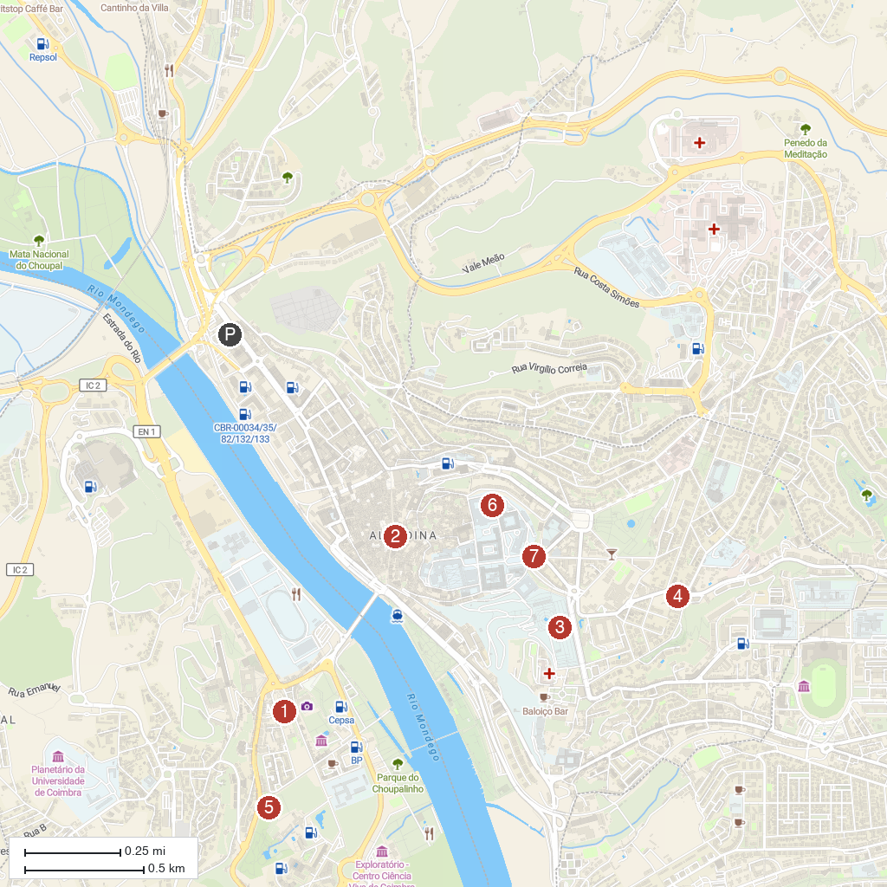
MAP KEY
1. Portugal dos Pequenitos | 5. Jardins da Quinta das Lágrimas
2. Barbican Gate | 6. Academic Museum of the University of Coimbra
3. Jardim Botânico da Universidade de Coimbra | 7. Escadas Monumentais
4. Carmel of Saint Teresa / Discalced Carmelite nuns
P. Cruise port / terminal
Map © MapTiler © OpenStreetMap contributors · cruiseports.org

