Collioure, Occitanie, France
Perched on the Côte Vermeille where the Pyrenees tumble into the Mediterranean, Collioure seduced Matisse, Derain, and a generation of Fauvist painters — its candy-colored harbor, medieval castle, and salted anchovy tradition are just as beguiling today.
⚓ Tender port · 🕒 Typical call: 6–8 hrs · 💶 Currency: Euro (€) · 🗣️ French (Catalan culture)
✍️ MY DAY IN PORT (FILL IN)
Ship / Date
In port | arrive ______ · all aboard ______
Booked excursion
Notes / meeting point
GETTING ASHORE
- Docking: Tender — anchored in the bay, tender lands in the harbor center
- Walk to center: 2–3 min from tender quay to Château Royal
- Best For: Art lovers, foodies, history, relaxed Mediterranean wandering
- Don't Miss: Château Royal, Church of Notre-Dame-des-Anges, anchovy tasting
GETTING AROUND
- 🚕 Taxi: €5 base + ~€1.80/km — Local taxis available; a short ride within town runs roughly €10–14. Useful for reaching Fort Saint-Elme or heading to n
- 📱 Rideshare: ✅ Uber
TOP THINGS TO DO
- Château Royal de Collioure — The castle's walls plunge straight into the sea.
- Fauvism Art Trail — Matisse and Derain spent the summer of 1905 here inventing Fauvism.
- Anchovy & Local Wine Tasting — Collioure anchovies (salted, not canned in oil) carry a PGI (Protected Geographical Indication) — the only fish in France to do…
- Plage Saint-Vincent & Plage Boramar — Two small pebble beaches flank the church in the harbor — sheltered, clear water, easy to reach from the tender quay.
- Hike to Fort Saint-Elme — A steep 1-hour climb above the vineyards rewards with sweeping views of Collioure, the Côte Vermeille, and on clear days, the…
BEST WALKS
- Old Town & Harbor Loop: 1.5 km · 30–45 min · Easy — From the tender quay, stroll past Plage Boramar to the Château Royal entrance, then thread through…
- Vineyard & Coastal Path to Port-Vendres: 4 km one-way · 1.5–2 hrs · Moderate — Head south from the harbor along the Sentier du Littoral (coastal path, yellow blazes) through…
WEATHER · DAYLIGHT · MONEY
Month | High °F | Low °F | Rainy days
May | 71 | 58 | 8
Jul | 85 | 71 | 3
Sep | 78 | 65 | 6
Daylight: May 6:25AM–9:02PM · Jul 6:24AM–9:22PM · Sep 7:27AM–7:57PM
cruiseports.org/collioure · Confirm terminal & all-aboard time with your ship

Collioure, Occitanie, France — Port Map
Red = walkable sights · Amber = excursions farther out · P = cruise terminal
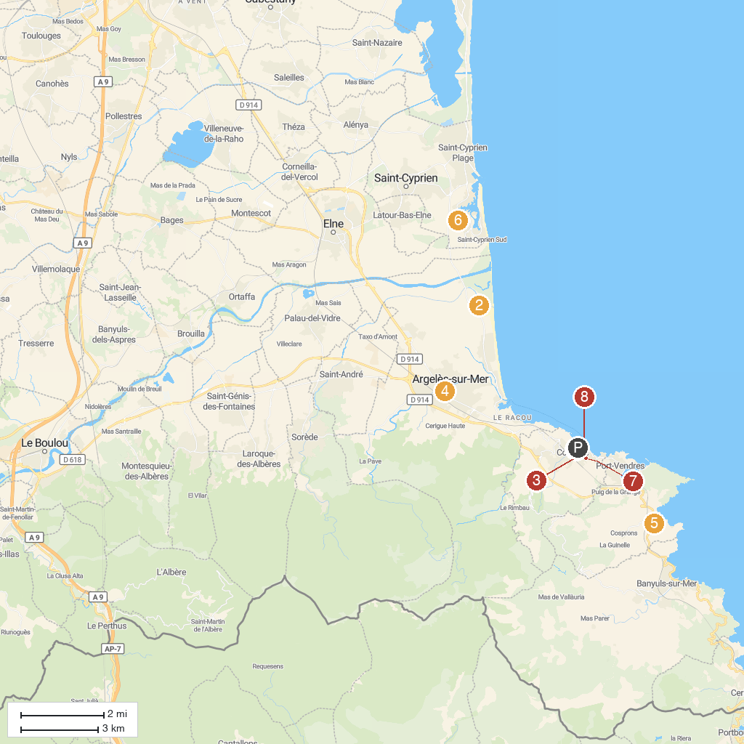
MAP KEY
1. Royal Castle of Collioure | 5. Site House, Museum Of Catalan boats
2. Canyoning Park | 6. Botanical Garden of the Capellans
3. Musée d'art moderne | 7. Moulin de Collioure
4. Église Notre-Dame del Prat d'Argelès-sur-Mer | 8. Collioure Lighthouse
P. Cruise port / terminal
Map © MapTiler © OpenStreetMap contributors · cruiseports.org

