Collonges-la-Rouge, Corrèze, France
Built entirely from glowing red iron-rich sandstone, Collonges-la-Rouge looks like a fairy-tale village carved in rust and slate. It founded the famous Les Plus Beaux Villages de France association and remains one of the most visited sites in the Nouvelle-Aquitaine region.
⚓ Coach transfer (no pier) · 🕒 Typical call: 3-5 hrs · 💶 Euro (€) · 🗣️ French
✍️ MY DAY IN PORT (FILL IN)
Ship / Date
In port | arrive ______ · all aboard ______
Booked excursion
Notes / meeting point
GETTING ASHORE
- Docking: No cruise pier — Collonges-la-Rouge is an inland village reached by coach excursion from an ocean cruise port (most often Bordeaux).
- Walk to center: The historic village is compact and entirely pedestrian — all sights within a 10-min walk of the main street.
- Best For: Medieval architecture, photography, easy walking, and authentic French village atmosphere.
- Don't Miss: Saint-Pierre Church (11th–15th c.) and Maison de la Sirène with its carved vaulted porch.
GETTING AROUND
- 🚕 Taxi: ~€50–60 one way — Brive-la-Gaillarde (~20 km away) is the nearest hub with reliable taxi services. Pre-booking is recommended as cabs are
TOP THINGS TO DO
- Village Walking Tour — Stroll the cobbled lanes past 15th- and 16th-century mansions, fortified towers, and the famous Maison de la Sirène with its…
- Saint-Pierre Church — Dating from the 11th, 12th, and 15th centuries, this Romanesque church was fortified during the French Wars of Religion and…
- Sentier des Sources Hike — A marked countryside trail looping through meadows, walnut groves, and farmland with views back to the red rooftops of the village.
- Nearby Village Combo: Turenne — About 10 km away, Turenne is another Les Plus Beaux Villages de France member, dominated by the ruins of a medieval château with…
BEST WALKS
- Red Village Loop: 1.5 km · Easy · ~1.5 hrs — Start at the Covered Market (Halle) in the centre of the village, walk past Maison de la Sirène and…
WEATHER · DAYLIGHT · MONEY
Month | High °F | Low °F | Rainy days
May | 67 | 50 | 12
Jul | 79 | 61 | 8
Sep | 73 | 55 | 10
Daylight: May 6:24AM–9:15PM · Jul 6:21AM–9:37PM · Sep 7:32AM–8:03PM
cruiseports.org/collonges-la-rouge · Confirm terminal & all-aboard time with your ship

Collonges-la-Rouge, Corrèze, France — Port Map
Red = walkable sights · Amber = excursions farther out · P = cruise terminal
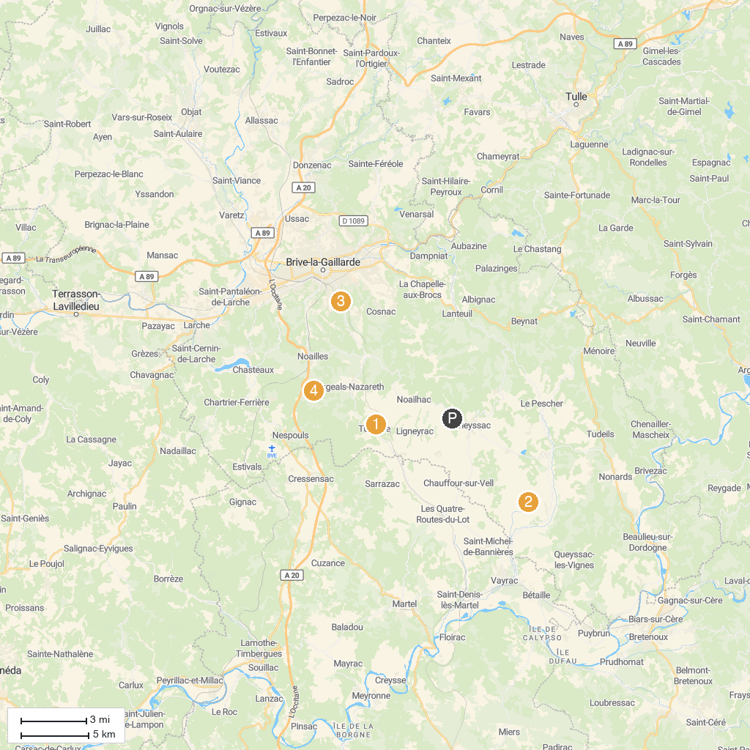
MAP KEY
1. Chateau de Turenne | 4. Uxellodunum
2. Eglise de la Combe | 5. Abyss of Fage
3. Ti Goui Goui | 6. Gaillard Académie
P. Cruise port / terminal
Map © MapTiler © OpenStreetMap contributors · cruiseports.org

