Colmar, Alsace, France
A fairy-tale Alsatian town of cobblestone lanes, flower-draped canal houses, and Riesling-soaked wine villages — most cruise passengers arrive by coach from nearby Breisach or Strasbourg, stepping into one of France's most photogenic historic centres.
⚓ Shore excursion (coach from Breisach or Strasbourg) · 🕒 Typical call: 5-7 hrs in Colmar · 💶 Currency: Euro (€) · 🗣️ Language: French (Alsatian dialect common)
✍️ MY DAY IN PORT (FILL IN)
Ship / Date
In port | arrive ______ · all aboard ______
Booked excursion
Notes / meeting point
GETTING ASHORE
- Docking: Rhine cruise ships dock at Breisach, Germany (~45 min by coach) or Strasbourg (~1 hr). CroisiEurope canal barges dock on the Colmar Canal.
- Walk to Centre: Old Town is compact and fully pedestrianised — ~15-20 min walk (about 1 km) from the Port de Colmar barge marina; ~5 min from coach drop-off near Place Rapp.
- Best For: Medieval architecture, Alsatian wine tastings, canal boat rides, and the Isenheim Altarpiece at Unterlinden Museum.
- Don't Miss: A flat-bottomed boat tour through Petite Venise and the Quai de la Poissonnerie — unique canal-level views of the half-timbered houses.
GETTING AROUND
- 🚕 Taxi: €4–6 (station to center) — Metered taxis available at Colmar train station. Short rides within the city are inexpensive; rates are ~€1.60/km.
- 📱 Rideshare: ✅ Uber, Bolt
- 🚌 Hop-on hop-off: ✅ Kut'zig
TOP THINGS TO DO
- Little Venice Canal Boat Ride — Board a traditional flat-bottomed punt for a 25-minute guided glide through the Petite Venise district — past the Quai de la…
- Unterlinden Museum & Isenheim Altarpiece — Housed in a 13th-century Dominican convent, the Unterlinden Museum contains the stunning Isenheim Altarpiece by Matthias…
- Old Town Walking Tour — Follow Colmar's golden-triangle tourist trail through its perfectly preserved medieval centre: the Gothic St.
- Alsatian Wine Route Villages — Drive or coach through the vineyard-draped hills to fairy-tale villages Riquewihr and Ribeauvillé — walled medieval towns…
- Bartholdi Museum — A compact but fascinating museum in the birthplace of Frédéric Auguste Bartholdi, the sculptor who designed the Statue of Liberty.
BEST WALKS
- Old Town & Little Venice Loop: 2 km · 2 hrs · Easy · All pavement — Start at Place d'Unterlinden and the Unterlinden Museum, then head south through Rue des Marchands…
- Golden Triangle Tourist Trail: 1.5 km · 1.5 hrs · Easy · Self-guided — Follow the golden triangle markers embedded in the pavement — a self-guided circuit linking…
WEATHER · DAYLIGHT · MONEY
Month | High °F | Low °F | Rainy days
May | 66 | 49 | 14
Jul | 79 | 61 | 12
Sep | 71 | 54 | 8
Daylight: May 5:51AM–9:02PM · Jul 5:46AM–9:25PM · Sep 7:08AM–7:42PM
cruiseports.org/colmar · Confirm terminal & all-aboard time with your ship

Colmar, Alsace, France — Port Map
Red = walkable sights · Amber = excursions farther out · P = cruise terminal
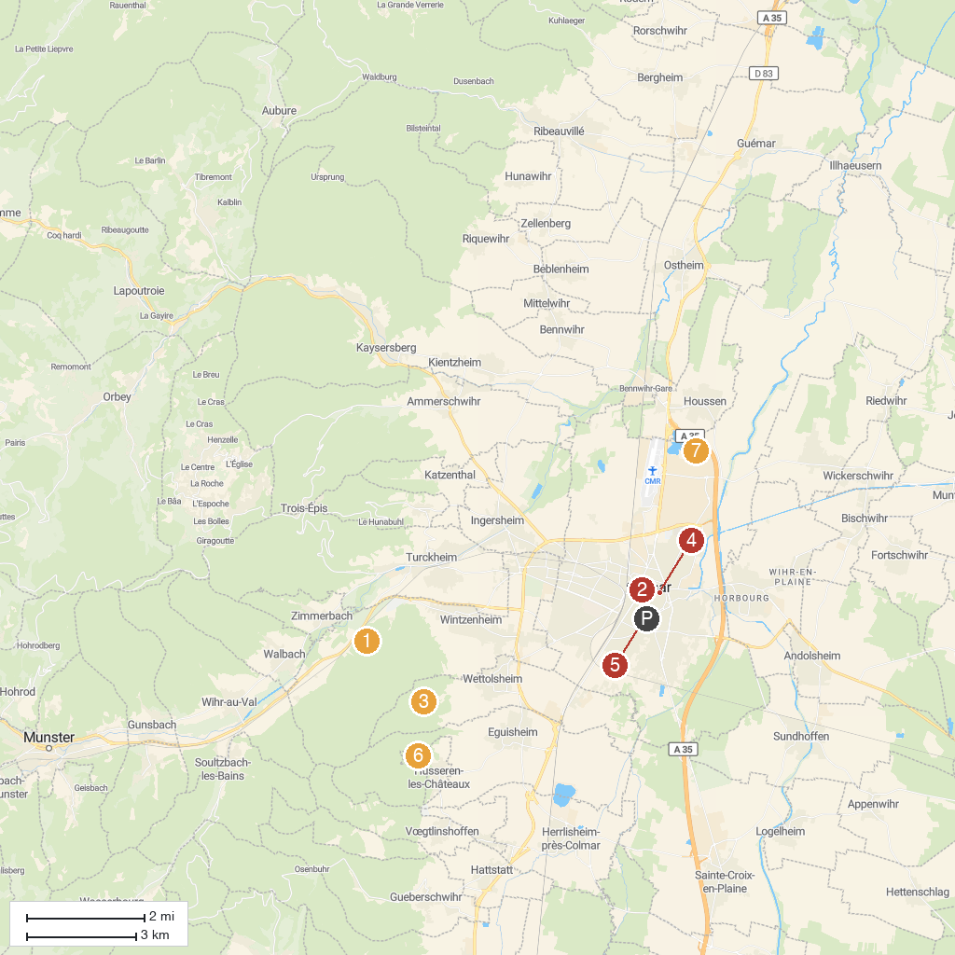
MAP KEY
1. Château de Pflixbourg | 5. Musée du Jouet
2. Maison Albert Schweitzer | 6. La Petite Venise
3. Musée Unterlinden | 7. Trois Châteaux d'Eguisheim
4. Château du Hagueneck | 8. Base Nautique Colmar Houssen
P. Cruise port / terminal
Map © MapTiler © OpenStreetMap contributors · cruiseports.org

