Cologne, North Rhine-Westphalia, Germany
Germany's iconic Rhine city greets ships just steps from a Gothic cathedral that took 600 years to finish. Pair world-class Roman history with a Kölsch at a centuries-old Brauhaus — all within easy walking distance of the dock.
⚓ Docked (Rhine riverside berths) · 🕒 Typical call: 8–10 hrs · 💶 Euro (€) · 🗣️ German
✍️ MY DAY IN PORT (FILL IN)
Ship / Date
In port | arrive ______ · all aboard ______
Booked excursion
Notes / meeting point
GETTING ASHORE
- Docking: Riverside berths on Konrad-Adenauer-Ufer; most ships dock ~500 m from the main train station and 15–20 min walk to the Cathedral
- Walk to center: Old Town and Cathedral are 15–20 min on foot from the main dock; Rheinauhafen berths are slightly further south
- Best For: Gothic architecture, Roman history, craft beer culture, world-class museums
- Don't Miss: Climbing the Cologne Cathedral's south tower (533 steps) for a panoramic Rhine view
GETTING AROUND
- 🚕 Taxi: €10–€15 — Metered taxis are plentiful near the port. Base fare €4.90 plus ~€2.20–€2.60/km; a ride to the city center is typically
- 📱 Rideshare: ✅ Uber, Bolt
- 🚌 Hop-on hop-off: ✅
TOP THINGS TO DO
- Cologne Cathedral (Kölner Dom) — A UNESCO World Heritage Site and Germany's most-visited landmark, the Dom's twin Gothic spires soar 157 m above the Rhine.
- Romano-Germanic Museum — This museum traces Cologne's 2,000-year history from its founding as Colonia Claudia Ara Agrippinensium in 50 AD.
- Kölsch Beer & Brauhaus Culture — Kölsch is Cologne's own protected-designation beer — light, crisp, served in slender 200 ml glasses called Stangen.
- Lindt Chocolate Museum — Trace 5,000 years of chocolate history at this Rheinauhafen landmark, with a 3-metre chocolate fountain and hands-on praline…
- Cologne Old Town (Altstadt) Guided Walk — Explore the Alter Markt, the Fischmarkt by the river, the medieval Great St.
BEST WALKS
- Cathedral to Old Town Circuit: 2.5 km · 45–60 min · flat — The classic Cologne walk: from the dock south along the Rhine embankment to the Cathedral square…
- South to Rheinauhafen & Chocolate Museum: 3 km · 50–70 min · flat — Head south from the Cathedral along the Rhine to the converted Rheinauhafen crane-house district, a…
WEATHER · DAYLIGHT · MONEY
Month | High °F | Low °F | Rainy days
May | 65 | 49 | 12
Jul | 76 | 59 | 13
Sep | 69 | 54 | 10
Daylight: May 5:42AM–9:15PM · Jul 5:35AM–9:39PM · Sep 7:07AM–7:45PM
cruiseports.org/cologne · Confirm terminal & all-aboard time with your ship

Cologne, North Rhine-Westphalia, Germany — Port Map
Red = walkable sights · Amber = excursions farther out · P = cruise terminal
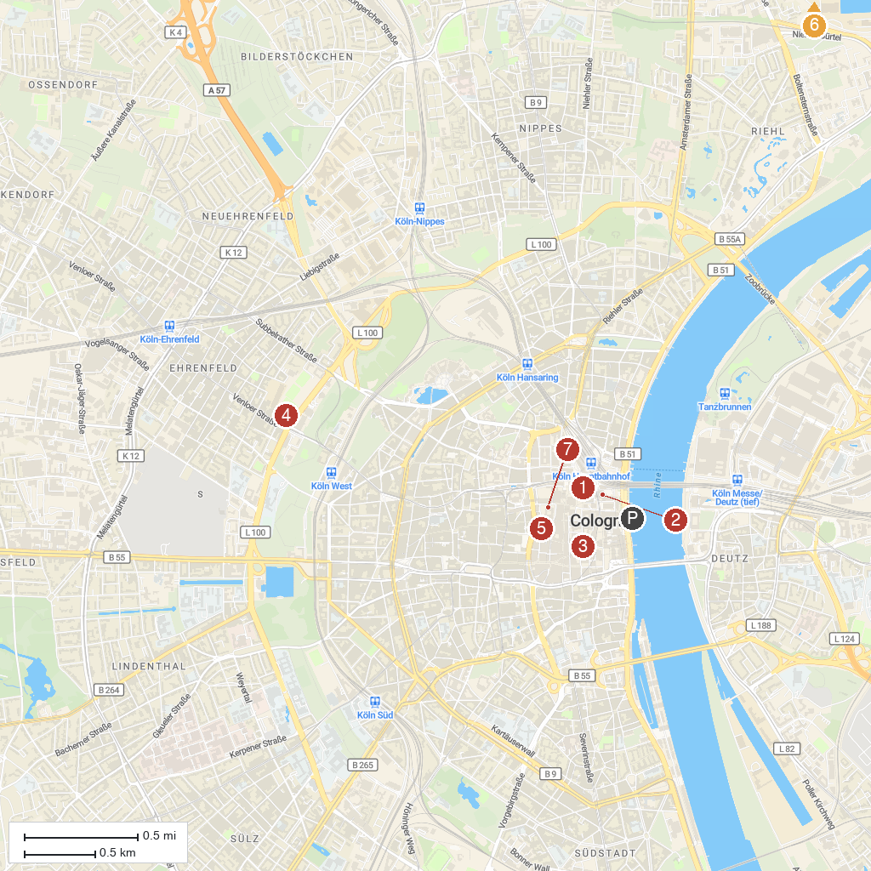
MAP KEY
1. Cologne Cathedral | 5. Kolumba
2. Museum Ludwig | 6. Japanese Garden Leverkusen
3. Wallraf-Richartz-Museum & Fondation Corboud | 7. Museum of Applied Arts Cologne
4. Cologne Central Mosque | 8. Brühl Castle
P. Cruise port / terminal
Map © MapTiler © OpenStreetMap contributors · cruiseports.org

