Colombo, Sri Lanka
Sri Lanka's bustling capital delivers spice-scented bazaars, gilded Buddhist temples, and a breezy seafront promenade — all within a tuk-tuk ride of the cruise terminal, with colonial Galle Fort and the sacred Temple of the Tooth a day-trip away.
⚓ Docked (Colombo Cruise Terminal) · 🕒 Typical call: 8–10 hrs · 💵 Sri Lankan Rupee (LKR) · 🗣️ Sinhala · Tamil · English
✍️ MY DAY IN PORT (FILL IN)
Ship / Date
In port | arrive ______ · all aboard ______
Booked excursion
Notes / meeting point
GETTING ASHORE
- Docking: Colombo Cruise Terminal (city port)
- Walk to center: Shuttle/transfer to gate, then ~10 min by tuk-tuk
- Best For: Temples · Markets · Colonial history
- Don't Miss: Gangaramaya Temple & Pettah Market
GETTING AROUND
- 🚕 Taxi: $5–$10 USD — Metered and negotiated taxis are available just outside the port gates. Always agree on a price before departure; most c
- 📱 Rideshare: ✅ Uber, PickMe
TOP THINGS TO DO
- Gangaramaya Temple & Seema Malaka — Colombo's most atmospheric temple complex — an eclectic mix of Sri Lankan, Thai, Indian, and Chinese architecture stuffed with…
- Pettah Bazaar & Red Mosque — Colombo's oldest market district is a sensory overload of spice stalls, fabric sellers, and street food.
- Galle Fort day trip — A UNESCO-listed Dutch colonial fort town on the southwest coast — cobblestone streets, whitewashed ramparts over the Indian…
- Kandy & Temple of the Tooth — Sri Lanka's cultural capital, set in the highland interior and home to the sacred Tooth Relic of the Buddha.
- Galle Face Green & Old Dutch Hospital — Stroll the long seafront esplanade of Galle Face Green for Indian Ocean breezes and street snacks (try isso wade — prawn fritters).
BEST WALKS
- Beira Lake & Galle Face seafront: ~3 km · 1.5 hrs · easy — From Gangaramaya Temple walk past Beira Lake to the Seema Malaka floating pavilion, then south…
- Pettah Market & Red Mosque: ~1.5 km · 1 hr · easy — Wander the lanes of Pettah — Sri Lanka's busiest bazaar — past spice sellers, gem shops, and the…
WEATHER · DAYLIGHT · MONEY
Month | High °F | Low °F | Rainy days
May | 85 | 78 | 30
Jul | 84 | 78 | 28
Sep | 83 | 76 | 28
Daylight: May 5:54AM–6:19PM · Jul 6:02AM–6:31PM · Sep 6:01AM–6:10PM
cruiseports.org/colombo · Confirm terminal & all-aboard time with your ship

Colombo, Sri Lanka — Port Map
Red = walkable sights · Amber = excursions farther out · P = cruise terminal
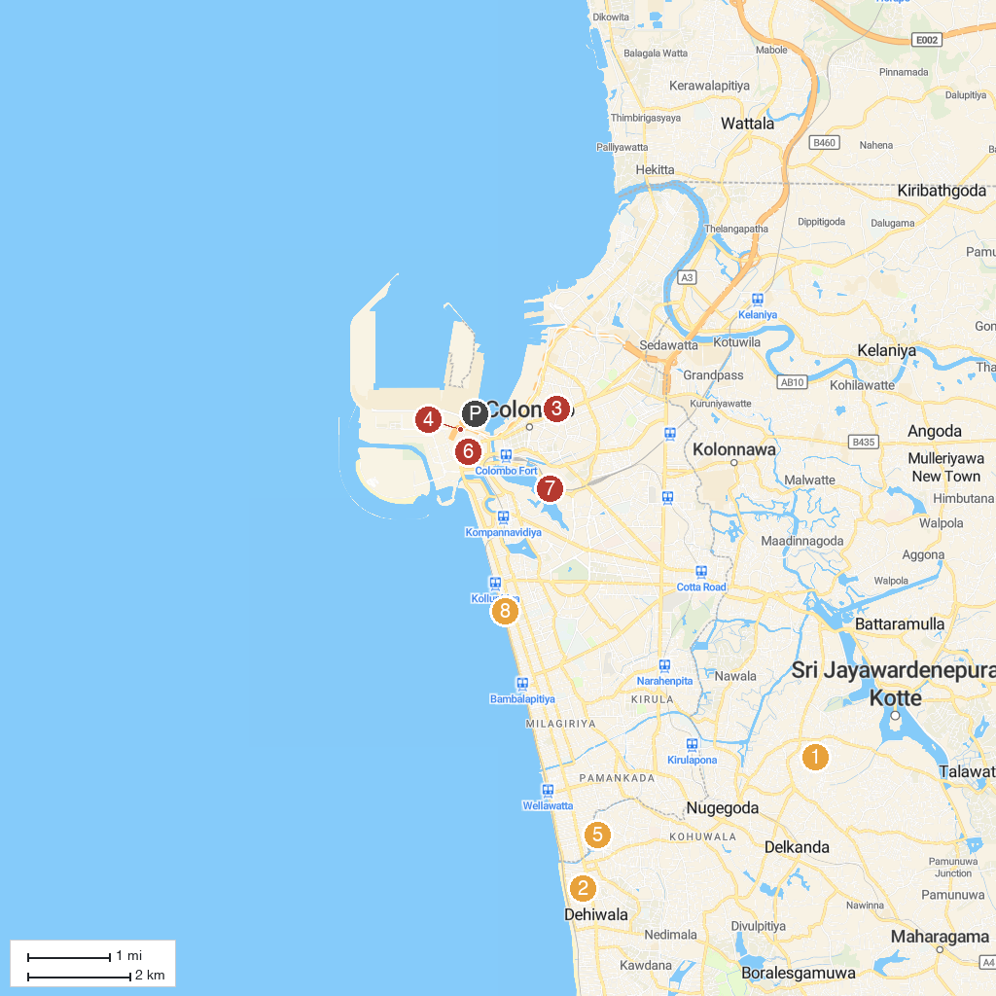
MAP KEY
1. Kotte Rajamaha Vihara | 5. Sri Aanjaneyar Temple
2. JourneyScapes Travel | 6. The Central Point - Economic History Museum
3. Christian Reformed Church of Sri Lanka | 7. Sri Lanka Philatelic Bureau
4. Sambodhi Pagoda Temple | 8. Casino Marina Colombo
P. Cruise port / terminal
Map © MapTiler © OpenStreetMap contributors · cruiseports.org

