Compiègne, Hauts-de-France, France
A town that shaped history twice over — where Napoleon held court and the Great War came to its close. Step ashore on the Oise River into a city that punches well above its size.
⚓ Docked — river berth (Port de Plaisance) · 🕒 Typical call: 8–10 hrs · 💶 Currency: Euro (€) · 🗣️ Language: French
✍️ MY DAY IN PORT (FILL IN)
Ship / Date
In port | arrive ______ · all aboard ______
Booked excursion
Notes / meeting point
GETTING ASHORE
- Docking: River barge/small ship docks at Port de Plaisance, central Compiègne
- Walk to centre: ~5 min to Hôtel de Ville; ~10 min to Château de Compiègne
- Best For: History buffs, palace fans, forest walks, day-trippers to Pierrefonds
- Don't Miss: Clairière de l'Armistice — the forest clearing where WWI ended
GETTING AROUND
- 🚕 Taxi: €5–€15 — Local taxis are readily available near the riverfront. The city center and Chateau de Compiegne are only a short ride fr
- 📱 Rideshare: ✅ Uber
TOP THINGS TO DO
- Château de Compiègne — One of France's three great royal palaces (with Versailles and Fontainebleau), Compiègne was the country retreat of Louis XV…
- Clairière de l'Armistice — Deep in the Compiègne Forest, this clearing is where Marshal Foch signed the armistice ending World War I on 11 November 1918…
- Château de Pierrefonds — A medieval fortress spectacularly restored by Viollet-le-Duc for Napoleon III, Pierrefonds looks lifted from a storybook.
- Historic Town Centre Walk — Compiègne's pedestrian core rewards wandering.
- Forêt de Compiègne — The 14,400-hectare royal hunting forest surrounds the town and offers well-marked trails for walking and cycling.
BEST WALKS
- Marina to Château de Compiègne: 1.2 km · ~15 min · Flat — A straight riverside and town-centre stroll from the Port de Plaisance to the grand palace forecourt.
- Historic Centre Loop: 2 km · ~30 min · Flat — From the Château, loop through the pedestrian streets past Église Saint-Jacques, along Rue…
WEATHER · DAYLIGHT · MONEY
Month | High °F | Low °F | Rainy days
May | 65 | 48 | 12
Jul | 76 | 59 | 8
Sep | 70 | 54 | 8
Daylight: May 6:05AM–9:25PM · Jul 5:59AM–9:49PM · Sep 7:25AM–8:01PM
cruiseports.org/compiegne · Confirm terminal & all-aboard time with your ship

Compiègne, Hauts-de-France, France — Port Map
Red = walkable sights · Amber = excursions farther out · P = cruise terminal
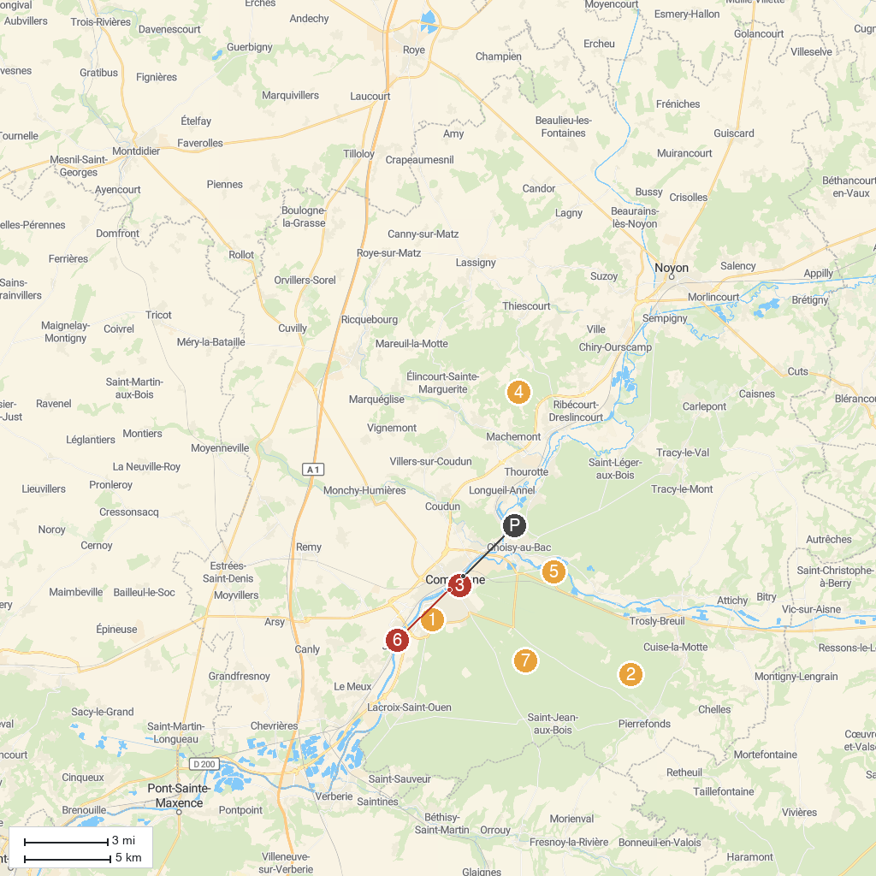
MAP KEY
1. Château de Pierrefonds | 5. CARRIERES DE MONTIGNY Machemont 60150
2. Mémorial de l'internement et de la déportation - Camp de Royallieu | 6. Glade of the Armistice
3. Grimp a l'Arb | 7. Musée Antoine Vivenel
4. Musée de la Figurine | 8. Forêt domaniale de Compiègne
P. Cruise port / terminal
Map © MapTiler © OpenStreetMap contributors · cruiseports.org

