Constanța, Romania
Romania's oldest continuously inhabited city greets ships with a dramatic clifftop casino, Roman-era mosaics, and the legend of Ovid's Black Sea exile — all within easy reach of a working seaport with a proper passenger terminal.
⚓ Pier (passenger terminal) · 🕒 Typical call: 8-10 hrs · 💵 Romanian Leu (RON) · 🗣️ Romanian (English widely spoken)
✍️ MY DAY IN PORT (FILL IN)
Ship / Date
In port | arrive ______ · all aboard ______
Booked excursion
Notes / meeting point
GETTING ASHORE
- Docking: Pier — Constanța Passenger Terminal, inside the commercial port
- Walk to center: ~1.5 km (20 min); steep staircase to Old Town or take ship shuttle
- Best For: History buffs, Art Nouveau fans, Black Sea beaches, Romanian cuisine
- Don't Miss: The Grand Mosque minaret view, Roman Mosaics complex, Casino cliffside
GETTING AROUND
- 🚕 Taxi: 20–40 RON (~€4–8) — Metered taxis queue at the port gate. Base fare is 4 RON plus ~3.45 RON/km. Ask the driver to use the meter; credit card
- 📱 Rideshare: ✅ Uber, Bolt
- 🚌 Hop-on hop-off: ✅
TOP THINGS TO DO
- Old Town & Roman Mosaics Walk — Ovidiu Square, the 4th-century Roman mosaic complex, and the History & Archaeology Museum — three millennia of Black Sea history…
- Grand Mosque Minaret Climb — Climb 140 steps inside the 1910 Carol I Mosque minaret for the best panoramic view of the port, city, and Black Sea — all for a…
- Mamaia Beach Resort — Romania's famous 'Ibiza of the East' — a 5-mile sandy strip with beach clubs, restaurants, and a telegondola cable car over the…
- Danube Delta Excursion — UNESCO biosphere reserve and Europe's best-preserved wetland — home to 300+ bird species.
- Constanța Casino & Faleza Promenade — The Art Nouveau Casino — a 1910 clifftop landmark by architect Daniel Renard, fully restored and reopened in May 2025 as a…
BEST WALKS
- Old Town Heritage Loop: 2.5 km · 1-1.5 hrs · Moderate (stairs at start) — From the port gate, climb the cliff staircase to Ovidiu Square, then circle past the Grand Mosque…
- Tomis Marina Seafood Lunch Walk: 1 km · 30 min · Easy (flat) — From Ovidiu Square, stroll down to Portul Tomis marina, lined with seafood restaurants and cafés…
WEATHER · DAYLIGHT · MONEY
Month | High °F | Low °F | Rainy days
May | 67 | 55 | 8
Jul | 80 | 68 | 6
Sep | 74 | 62 | 4
Daylight: May 5:39AM–8:25PM · Jul 5:36AM–8:46PM · Sep 6:44AM–7:15PM
cruiseports.org/constanta · Confirm terminal & all-aboard time with your ship

Constanța, Romania — Port Map
Red = walkable sights · Amber = excursions farther out · P = cruise terminal
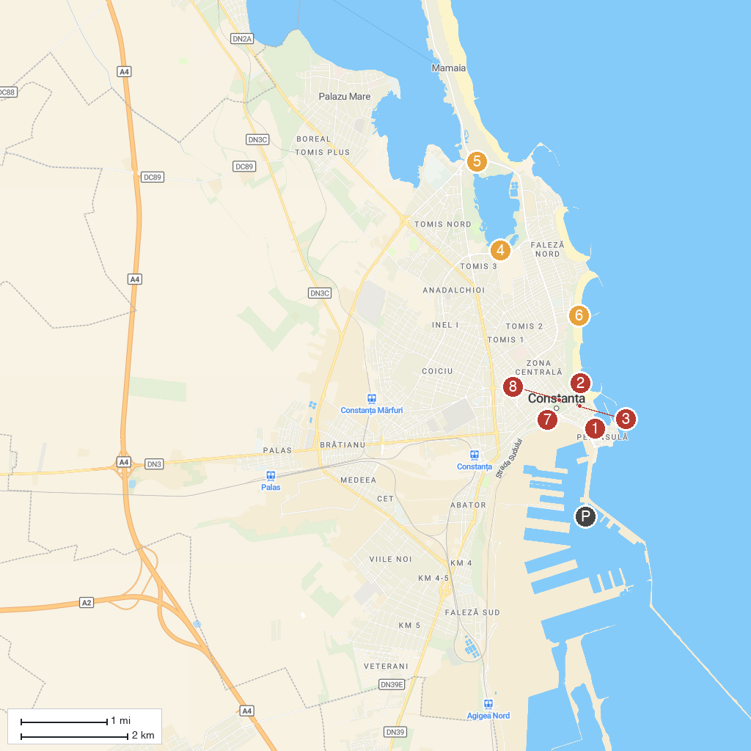
MAP KEY
1. The Great Mosque of Constanța | 5. Luna Park
2. "Modern" Beach | 6. ZooM Beach
3. The Greek Church of Metamorphosis in Constanța | 7. The Museum of Romanian Navy
4. Gravity Park | 8. Parcul Arheologic
P. Cruise port / terminal
Map © MapTiler © OpenStreetMap contributors · cruiseports.org

