Copenhagen, Denmark
Denmark's effortlessly cool capital — candy-colored Nyhavn quays, royal palaces, legendary New Nordic food, and bike-friendly streets all waiting just beyond the gangway.
⚓ Docked (Oceankaj, Langelinie or Nordre Toldbod) · 🕒 Typical call: 9–11 hrs · 💵 Danish Krone (DKK) · 🗣️ Danish · English universal
✍️ MY DAY IN PORT (FILL IN)
Ship / Date
In port | arrive ______ · all aboard ______
Booked excursion
Notes / meeting point
GETTING ASHORE
- Docking: Oceankaj (Nordhavn), Langelinie or Nordre Toldbod — confirm your assigned quay
- To center: Transfer depends on assigned quay; use the live journey planner
- Best For: Design · Royal history · Foodie scene
- Don't Miss: Nyhavn canal & Tivoli Gardens
GETTING AROUND
- 🚕 Taxi: DKK 135–520 (~$21–79 USD) — Fare depends on terminal. Langelinie (closest to city) ~DKK 135 daytime. Oceankaj (furthest) ~DKK 425 daytime, ~DKK 520
- 📱 Rideshare: ✅ Uber, Bolt
- 🚌 Hop-on hop-off: ✅ Stromma (City Sightseeing Copenhagen)
TOP THINGS TO DO
- Nyhavn & Royal Waterfront Walk — The candy-colored 17th-century harbor of Nyhavn, past Amalienborg Palace (watch the noon guard change), and on to the Little…
- Canal Boat Tour — See the city from its waterways — gliding past the Opera House, Christianshavn, the Black Diamond library, and the Little Mermaid…
- Tivoli Gardens — The historic pleasure garden that opened in 1843 and inspired Walt Disney — vintage rides, manicured gardens, live music, and…
- Kronborg or Frederiksborg Castle — Day trip to a Danish royal castle: Kronborg ('Hamlet's Castle') guards the Øresund strait as a UNESCO site, or visit…
- Freetown Christiania — A self-governing 'free town' carved from former military barracks in 1971 — car-free laneways, self-built homes, murals, organic…
BEST WALKS
- Little Mermaid to Nyhavn: ~3 km · 1.5 hrs · easy — From the Little Mermaid statue past the Gefion Fountain, Amalienborg Palace (noon guard change)…
- Strøget & the Old Center: ~2 km · 1.5 hrs · easy — Europe's longest pedestrian street, threading from Kongens Nytorv through the Latin Quarter past…
- Christianshavn & the Harbour Bus: ~2.5 km · 1.5 hrs · easy — Cross to canal-laced Christianshavn, with the twisted spiral spire of the Church of Our Saviour…
WEATHER · DAYLIGHT · MONEY
Month | High °F | Low °F | Rainy days
May | 59 | 47 | 10
Jul | 69 | 59 | 13
Sep | 64 | 55 | 12
Daylight: May 4:58AM–9:14PM · Jul 4:47AM–9:43PM · Sep 6:42AM–7:26PM
ESSENTIAL TRAVEL QUALIFICATIONS
Christiania is residential: ask before photographing people and follow current signs. Do not rely on old blanket Pusher Street photography-ban or camera-confiscation claims.
cruiseports.org/copenhagen · Confirm terminal & all-aboard time with your ship

Copenhagen, Denmark — Port Map
Red = walkable sights · Amber = excursions farther out · P = cruise terminal
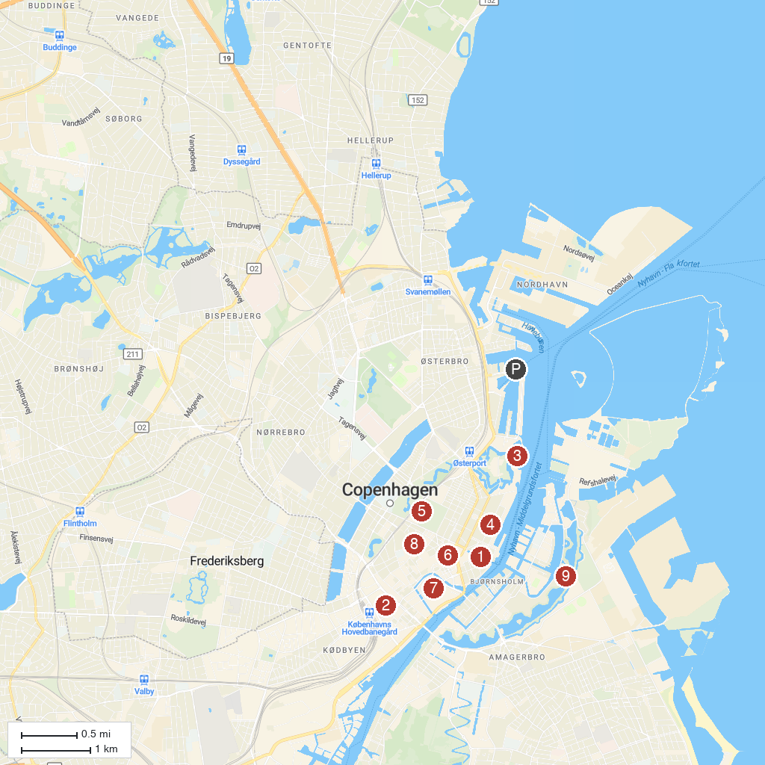
MAP KEY
1. Nyhavn | 6. Strøget (shopping)
2. Tivoli Gardens | 7. Christiansborg Palace
3. The Little Mermaid | 8. Round Tower
4. Amalienborg Palace | 9. Freetown Christiania
5. Rosenborg Castle
P. Cruise port / terminal
Map © MapTiler © OpenStreetMap contributors · cruiseports.org

