Coquimbo, Coquimbo Region, Chile
A gritty, salt-sprayed port with sea lions at the fish market, the tallest cross on the continent looming over the bay, and two cities' worth of beaches, seafood, and star-gazing valley just beyond the gates.
⚓ Pier (Terminal Puerto Coquimbo) · 🕒 Typical call: 8-10 hrs · 💵 Chilean Peso (CLP) · 🗣️ Spanish
✍️ MY DAY IN PORT (FILL IN)
Ship / Date
In port | arrive ______ · all aboard ______
Booked excursion
Notes / meeting point
GETTING ASHORE
- Docking: Pier — ships dock at Terminal Puerto Coquimbo; shuttle bus to exit gate
- Walk to center: 5 min from gate to Caleta fish market; La Serena 20 min by taxi
- Best For: Seafood, colonial history, Elqui Valley pisco tours, beaches
- Don't Miss: Caleta sea lions, Cruz del Tercer Milenio elevator views, pastel de jaiba crab casserole
GETTING AROUND
- 🚕 Taxi: ~2,000–5,000 CLP (~$2–5 USD) for short city rides — Taxis wait at the pier exit. Always agree on the fare before getting in — meters are not always used. Short hops within
- 📱 Rideshare: ✅ Uber, DiDi
TOP THINGS TO DO
- Elqui Valley Pisco Tour — Drive into the world's clearest-sky valley, visit a pisco distillery, and taste Chile's national spirit amid Andean scenery.
- Cruz del Tercer Milenio & Coquimbo City — Ride an elevator inside South America's tallest monument — the 93-metre concrete Cruz del Tercer Milenio — for panoramic views of…
- La Serena Colonial City Walk — Chile's second-oldest city is a 20-minute taxi ride away.
- Avenida del Mar Beach Walk — The sweeping coastal avenue connects Coquimbo to La Serena along miles of white sand.
- Caleta Fish Market & Seafood Lunch — Walk five minutes from the port gate to Coquimbo's waterfront Caleta — where pelicans and sea lions jostle below the docks and…
BEST WALKS
- Port Gate to Barrio Inglés Loop: ~1.5 km · 20 min · easy — Exit the terminal gate, swing through the Caleta fish market to spot the sea lions, then follow the…
- Mirador Cruz del Tercer Milenio: ~10 min by taxi · short walk at top · easy — Take a taxi up El Vigía hill to the giant cross.
WEATHER · DAYLIGHT · MONEY
Month | High °F | Low °F | Rainy days
May | 64 | 53 | 2
Jul | 60 | 48 | 2
Sep | 63 | 50 | 0
Daylight: May 7:23AM–5:59PM · Jul 7:39AM–6:03PM · Sep 7:43AM–7:37PM
cruiseports.org/coquimbo · Confirm terminal & all-aboard time with your ship

Coquimbo, Coquimbo Region, Chile — Port Map
Red = walkable sights · Amber = excursions farther out · P = cruise terminal
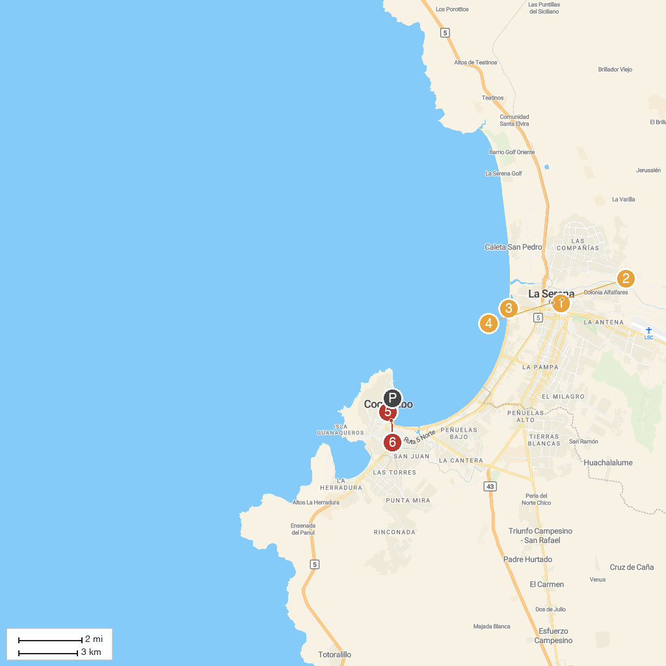
MAP KEY
1. Archaeological Museum of La Serena | 4. Catedral de La Serena
2. La Recova | 5. Iglesia de San Pedro
3. Faro Monumental de La Serena | 6. Bernardo O'Higgins Park
P. Cruise port / terminal
Map © MapTiler © OpenStreetMap contributors · cruiseports.org

