Cordova, Alaska, USA
Alaska the way it actually is — a working fishing port with no road to the outside world, world-class salmon, calving glaciers, and expedition ships instead of mega-liners.
⚓ Pier (small ships) / Tender (larger vessels) · 🕒 Typical call: 6–8 hrs · 💵 USD · 🗣️ English · 🐟 Copper River Salmon Country
✍️ MY DAY IN PORT (FILL IN)
Ship / Date
In port | arrive ______ · all aboard ______
Booked excursion
Notes / meeting point
GETTING ASHORE
- Docking: Small ships dock at City Dock; larger vessels anchor in Orca Inlet and tender ashore
- Walk to center: 10–15 min (0.5–0.7 mi) along the working harbor to First Street
- Best For: Authentic Alaska, glacier touring, Copper River salmon, wildlife, zero tourist crowds
- Don't Miss: Ilanka Cultural Center's killer whale skeleton and a Copper River salmon lunch
GETTING AROUND
- 🚕 Taxi: ~$5–$10 — Cordova Taxi (907-424-5151) serves the port area. Short ride to downtown given the ~1-mile distance.
- 📱 Rideshare: ❌ not available
TOP THINGS TO DO
- Sheridan Glacier Kayaking & Hiking — A van ride (~18 miles) delivers you to Sheridan Glacier Recreation Area, where you can kayak among icebergs on the glacial lake…
- Jet Boat to Childs Glacier & Million Dollar Bridge — The Copper River Highway washes out at Mile 36, so the only way to reach the thunderously calving Childs Glacier and the 1910…
- Ilanka Cultural Center & Cordova Museum — The Native Village of Eyak's cultural center houses one of only a handful of fully reassembled killer whale skeletons in the…
- Sea Otter & Shorebird Watching — Cordova claims the title of sea otter capital of the world — look into the harbor as soon as you step ashore.
- Flightseeing the Copper River Delta — The Copper River Delta is the largest contiguous wetland on North America's Pacific coast.
BEST WALKS
- Harbor to Downtown First Street: 0.6 mi · 15 min · Easy · Flat — Walk from the City Dock along the harbor past fishing vessels, net lofts, and the small-boat basin…
- Eyak Lake Loop: 1.5 mi · 30 min · Easy · Paved path — Head up Railroad Avenue from downtown to reach the serene shores of Lake Eyak, flanked by steep…
WEATHER · DAYLIGHT · MONEY
Month | High °F | Low °F | Rainy days
May | 50 | 40 | 17
Jul | 61 | 53 | 13
Sep | 54 | 46 | 19
Daylight: May 5:00AM–10:20PM · Jul 4:43AM–10:53PM · Sep 7:12AM–8:02PM
Representative sunrise/sunset — 2025, 15th of each month; local civil time including DST (America/Anchorage). Source: Astral; not a forecast or climate average.
cruiseports.org/cordova-ak · Confirm terminal & all-aboard time with your ship

Cordova, Alaska, USA — Port Map
Red = walkable sights · Amber = excursions farther out · P = cruise terminal
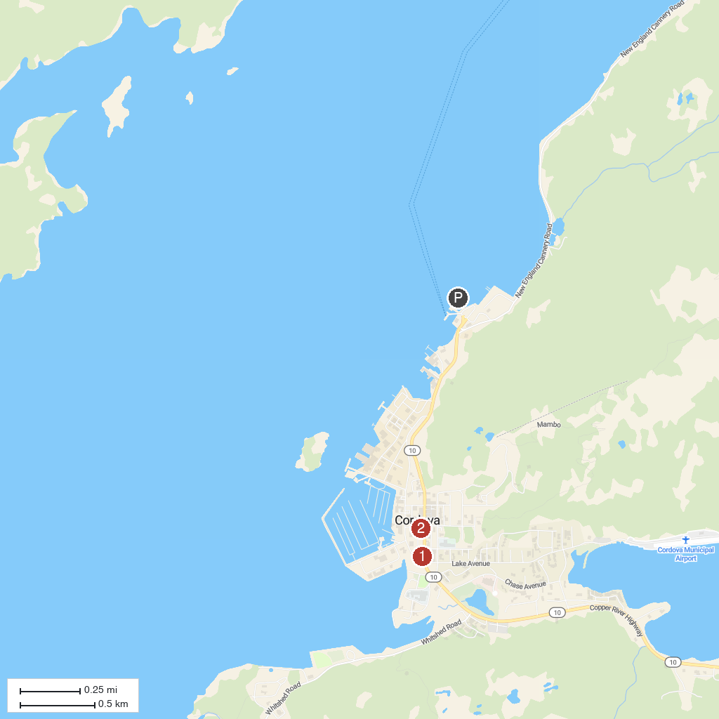
MAP KEY
1. Ilanka Cultural Center | 3. Alaganik Slough Trail
2. Cordova Historical Museum | 4. Sheridan Glacier
P. Cruise port / terminal
Map © MapTiler © OpenStreetMap contributors · cruiseports.org

