Corinto, Chinandega, Nicaragua
Nicaragua's working Pacific gateway drops you at the edge of a country that rewards the curious — volcanic landscapes, award-winning rum, and one of Central America's finest colonial cities are all within an hour.
⚓ Pier (deep-water dock) · 🕒 Typical call: 7-9 hrs · 💵 USD widely accepted · 🗣️ Spanish
✍️ MY DAY IN PORT (FILL IN)
Ship / Date
In port | arrive ______ · all aboard ______
Booked excursion
Notes / meeting point
GETTING ASHORE
- Docking: Pier — ships dock at Puerto de Corinto's commercial quay; no tendering
- Walk to center: 10-15 min on foot to Corinto's central park; bicitaxis available
- Best For: Volcano boarding, colonial city sightseeing, rum distillery tours
- Don't Miss: Flor de Caña Distillery in Chichigalpa or the Cathedral rooftop in León
GETTING AROUND
- 🚕 Taxi: ~$80 USD/day — Independent taxis wait at the port exit and offer private full-day tours (roughly 6 hours). Negotiate the price before d
TOP THINGS TO DO
- León Colonial City & Cathedral Rooftop — Central America's largest cathedral (UNESCO World Heritage Site) dominates León's skyline.
- Volcano Boarding on Cerro Negro — Strap onto a wooden sled and hurtle down the black gravel slopes of an active volcano — one of the world's few places you can do…
- Flor de Caña Rum Distillery — One of the world's most award-winning rums is made in nearby Chichigalpa.
- Hervideros de San Jacinto — A surreal field of boiling mud pots and steam vents connected to the Telica Volcano system.
- Costa Azul Beach & Seafood — A short bicitaxi ride from the port, this calm bay beach is lined with rustic open-air seafood shacks.
BEST WALKS
- Corinto Town Stroll: 1.5 km · 20-30 min · Easy — Walk from the port gate through the craft market welcome area, down to the Corinto Central Park…
WEATHER · DAYLIGHT · MONEY
Month | High °F | Low °F | Rainy days
May | 73 | 64 | 30
Jul | 74 | 63 | 28
Sep | 74 | 63 | 29
Daylight: May 5:53AM–6:09PM · Jul 6:02AM–6:19PM · Sep 5:56AM–6:03PM
cruiseports.org/corinto · Confirm terminal & all-aboard time with your ship

Corinto, Chinandega, Nicaragua — Port Map
Red = walkable sights · Amber = excursions farther out · P = cruise terminal
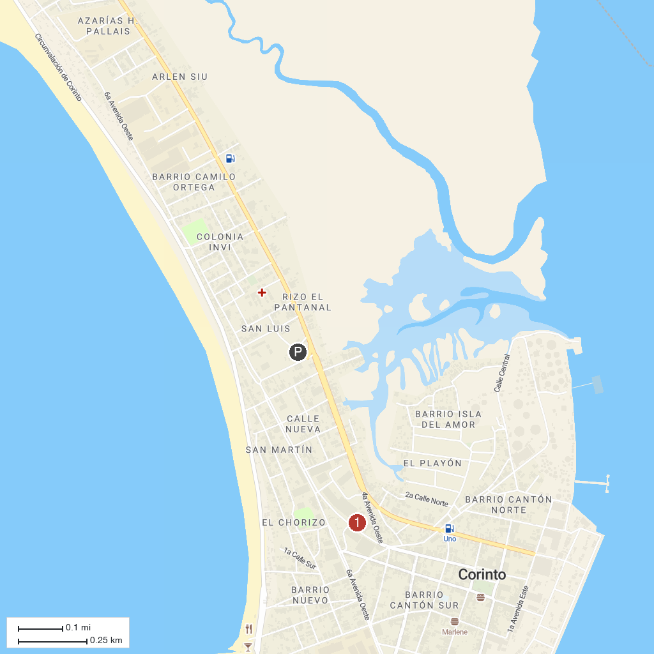
MAP KEY
1. León Cathedral (Basílica de la Asunción) | 3. Parroquia de Nuestra Señora de Santa Ana
2. Fortaleza El Castillo, Corinto
P. Cruise port / terminal
Map © MapTiler © OpenStreetMap contributors · cruiseports.org

