Corpach, Scottish Highlands, Scotland
Where the Caledonian Canal meets Loch Linnhe in the shadow of Ben Nevis. Corpach is a small Highland village with outsized scenery — and a photogenic shipwreck on the beach.
⚓ Small ships dock; larger ships tender · 🕒 Typical call: 6-8 hrs · 💷 British Pound Sterling (£) · 🗣️ English
✍️ MY DAY IN PORT (FILL IN)
Ship / Date
In port | arrive ______ · all aboard ______
Booked excursion
Notes / meeting point
GETTING ASHORE
- Docking: Small/expedition ships dock at Corpach Basin quay; larger cruise ships tender into the canal basin
- Walk to Fort William: 4 miles — take the train (~10 min) or bus from Corpach Station
- Best For: Scenery, canal engineering, whisky distillery, steam train excursions
- Don't Miss: The MV Dayspring shipwreck on Caol Beach with Ben Nevis behind it
GETTING AROUND
- 🚕 Taxi: £12–£15 — Local taxis (e.g. Lochaber Taxis) run from the cruise terminal to Fort William town centre in about 9 minutes. Pre-booki
TOP THINGS TO DO
- Jacobite Steam Train ("Harry Potter Train") — Board the famous steam train from Fort William to Mallaig, crossing the legendary Glenfinnan Viaduct over Loch Shiel.
- Glenfinnan Monument & Viaduct — 30 minutes by train or taxi from Corpach, the Glenfinnan Monument marks where Bonnie Prince Charlie raised his standard in 1745.
- Ben Nevis & Glen Nevis Walk — A 10-minute taxi from Corpach drops you at Glen Nevis, where walks range from an easy gorge path to the full summit of the UK's…
- Ben Nevis Distillery Tour & Tasting — One of Scotland's oldest licensed distilleries (est.
- Neptune's Staircase Canal Walk — A flat, scenic 30-minute walk along the Caledonian Canal towpath from Corpach brings you to Neptune's Staircase at Banavie — the…
BEST WALKS
- Corpach Shipwreck & Canal Sea Lock: 1.5 km · Easy · 20-30 min — Walk from the pier along the shoreline to the iconic MV Dayspring shipwreck on Caol Beach — best…
- Canal Towpath to Neptune's Staircase: 3.5 km one way · Easy, flat · 30-40 min — Follow the Caledonian Canal towpath north from Corpach through peaceful Highland scenery to…
WEATHER · DAYLIGHT · MONEY
Month | High °F | Low °F | Rainy days
May | 58 | 45 | 17
Jul | 64 | 53 | 20
Sep | 60 | 50 | 18
Daylight: May 5:03AM–9:32PM · Jul 4:50AM–10:01PM · Sep 6:52AM–7:37PM
cruiseports.org/corpach · Confirm terminal & all-aboard time with your ship

Corpach, Scottish Highlands, Scotland — Port Map
Red = walkable sights · Amber = excursions farther out · P = cruise terminal
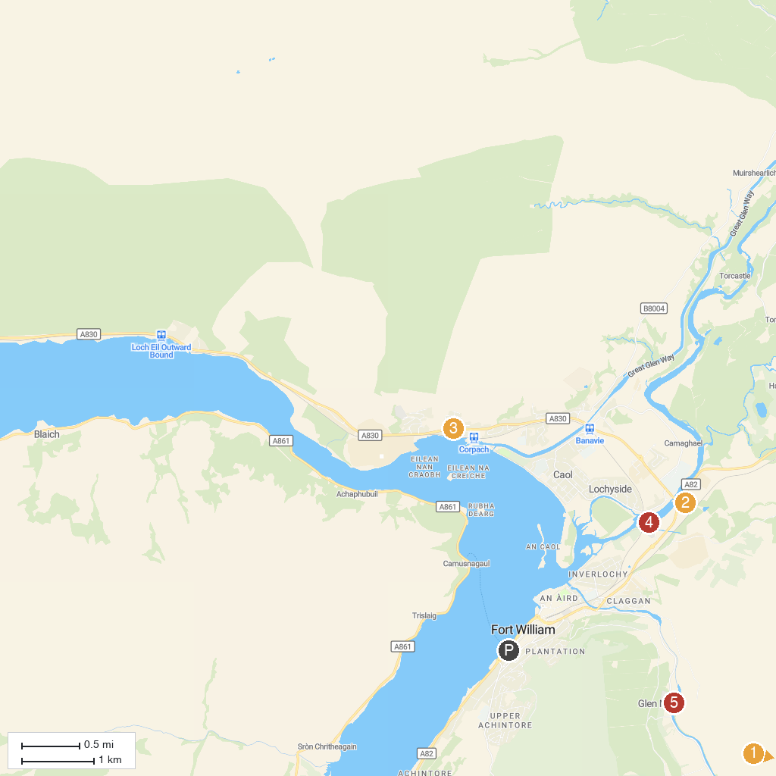
MAP KEY
1. Ben Nevis Weather Station | 5. Treasures of the Earth
2. Ben Nevis Distillery | 6. Old Inverlochy Castle
3. Commando Memorial | 7. Ben Nevis Visitor Centre
4. Clan Cameron Museum
P. Cruise port / terminal
Map © MapTiler © OpenStreetMap contributors · cruiseports.org

