Costa Maya (Mahahual), Quintana Roo, Mexico
Two worlds in one port day: a slick waterpark-and-beach-club complex right off the gangway, and a genuine Mexican fishing village 3 km up the malecón — plus the Yucatán's most accessible Mayan ruins just 45 minutes inland.
⚓ Docked (purpose-built pier) · 🕒 Typical call: 7-9 hrs · 💵 USD & Mexican Peso widely accepted · 🗣️ Spanish (English at pier & Mahahual) · 🏗️ Perfect Day Mexico: opening date unconfirmed
✍️ MY DAY IN PORT (FILL IN)
Ship / Date
In port | arrive ______ · all aboard ______
Booked excursion
Notes / meeting point
GETTING ASHORE
- Docking: Purpose-built pier; all ships dock (no tendering). Free tram runs the length of the long pier to the terminal complex. Capacity for up to 4 ships simultaneously.
- Walk to Center: ~45-min walk or taxi (current fare unverified) to Mahahual village (3 km). The pier complex itself has pools, restaurants, and beach clubs on-site.
- Best For: Chacchoben Mayan ruins, Bacalar 'Lake of Seven Colors', reef snorkeling, beach clubs, and the Lost Mayan Kingdom water park
- Don't Miss: Chacchoben ruins at sunrise, a boat tour on Bacalar Lagoon, fresh ceviche on the Mahahual malecón
GETTING AROUND
- 🚕 Taxi: Current fare unknown — confirm shared/private basis — Taxis wait at the cruise terminal exit for Mahahual town. Current fares are unverified: confirm the posted rate, currenc
TOP THINGS TO DO
- Chacchoben Mayan Ruins — The closest major Mayan archaeological site to the port, Chacchoben features well-preserved temple pyramids rising from dense…
- Bacalar — Lake of Seven Colors — About 75 minutes from the pier, Bacalar is one of Mexico's most extraordinary natural sites: a 42 km freshwater lagoon that…
- Snorkel the Mesoamerican Reef — The Mesoamerican Barrier Reef — second-largest in the world — runs right along the Costa Maya coastline.
- Chinchorro Atoll Dive & Snorkel — Banco Chinchorro, 30 km offshore, is the largest coral atoll in the Northern Hemisphere and a UNESCO Biosphere Reserve.
- Kohunlich & Dzibanche Mayan Sites — For those who want to go deeper into Mayan history, Kohunlich and nearby Dzibanche are larger, more remote sites about 2 hours…
BEST WALKS
- Pier to Mahahual Malecón: ~3 km one way · Easy (flat) · Taxi recommended midday · 45 min if walking — Take a taxi from the pier gate to Mahahual; current fare unknown—confirm total, currency and…
- Terminal Beach Club Loop: ~1 km · Easy · No taxi needed · 1-2 hrs — Stay inside the Puerto Costa Maya complex and explore on foot: the pool area, beach club strip…
WEATHER · DAYLIGHT · MONEY
Month | High °F | Low °F | Rainy days
May | 86 | 79 | 18
Jul | 87 | 80 | 19
Sep | 87 | 79 | 24
Daylight: May 6:16AM–7:17PM · Jul 6:22AM–7:30PM · Sep 6:38AM–6:52PM
ESSENTIAL TRAVEL QUALIFICATIONS
Perfect Day: original environmental procedure ended after withdrawal on 19 May 2026; beach-club application dismissed and pier modification not authorized (checked 3 October 2026). Revised approval/opening unconfirmed; not a claim of permanent cancellation. Taxi fare unknown: confirm total, currency and shared per-person versus private basis.
cruiseports.org/costa-maya · Confirm terminal & all-aboard time with your ship

Costa Maya (Mahahual), Quintana Roo, Mexico — Port Map
Red = walkable sights · Amber = excursions farther out · P = cruise terminal
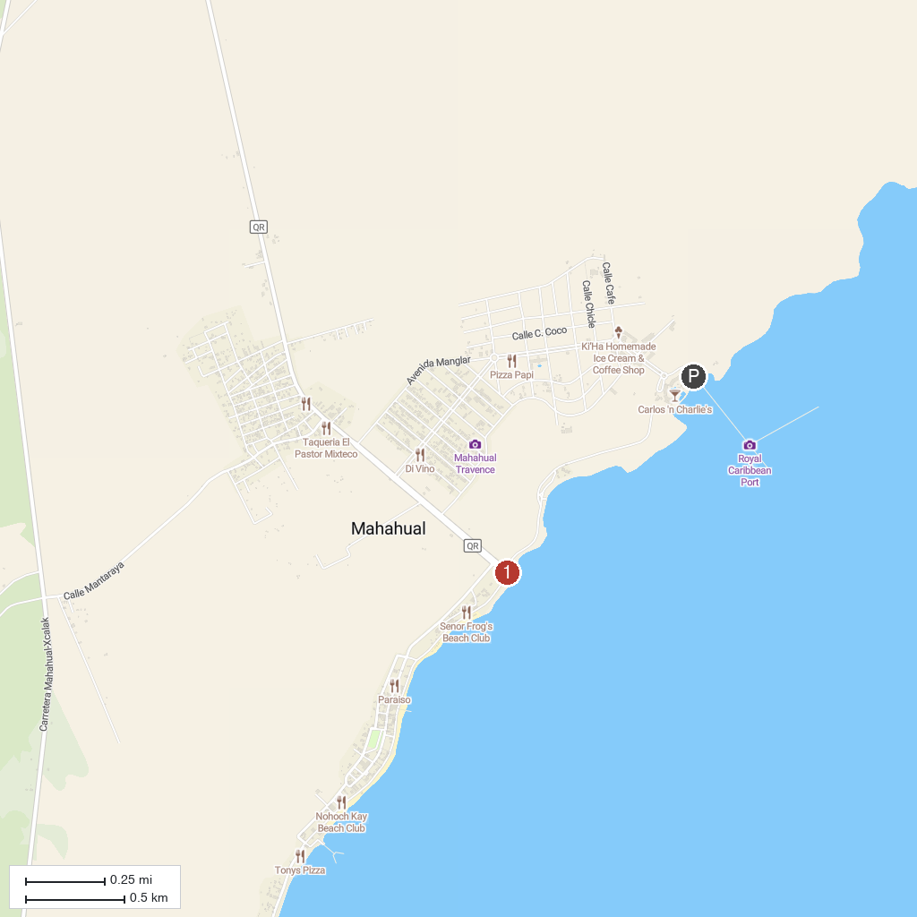
MAP KEY
1. Banco Chinchorro Biosphere Reserve | 2. Mahahual Malecón
P. Cruise port / terminal
Map © MapTiler © OpenStreetMap contributors · cruiseports.org

