Cozumel, Quintana Roo, Mexico
Made famous by Jacques Cousteau in the 1960s, Cozumel sits atop the Mesoamerican Barrier Reef — the world's second-largest — delivering world-class diving, Mayan pilgrimage sites, and easy beach days from three dedicated cruise piers.
⚓ Docked (3 cruise piers) · 🕒 Typical call: 8-10 hrs · 💵 USD & Mexican Peso · 🗣️ Spanish (English widely spoken) · 🤿 Top dive & snorkel destination
✍️ MY DAY IN PORT (FILL IN)
Ship / Date
In port | arrive ______ · all aboard ______
Booked excursion
Notes / meeting point
GETTING ASHORE
- Docking: Three dedicated cruise piers — all docked, no tendering required
- Walk to Center: Punta Langosta: steps from downtown. International Pier & Puerta Maya: ~$8-12 taxi ride; route and journey time depend on your assigned berth and destination
- Best For: Scuba diving, snorkeling, Mayan ruins, beach clubs, island loop by scooter or golf cart
- Don't Miss: El Cielo starfish lagoon, Palancar Reef dive, San Gervasio ruins, Punta Sur Eco Park
GETTING AROUND
- 🚕 Taxi: $5–$12 USD — Fixed-zone taxis are the most common transport. From Punta Langosta pier it is about $5 to downtown San Miguel; from Int
- 📱 Rideshare: ❌ not available
- 🚌 Hop-on hop-off: ✅ Hop-on hop-off
TOP THINGS TO DO
- El Cielo Snorkel — Starfish Lagoon — El Cielo ('heaven') is a shallow sandbar carpeted with hundreds of starfish in brilliant turquoise water.
- Palancar Reef Dive or Snorkel — Part of the Mesoamerican Barrier Reef — made world-famous by Jacques Cousteau in 1961.
- San Gervasio Mayan Ruins — Cozumel's own Mayan site was the island's most sacred — a pilgrimage center for Ix Chel, goddess of fertility and healing.
- Punta Sur Eco Park — The island's southern tip is a protected reserve with a working lighthouse, El Caracol Mayan storm-warning ruin, crocodile…
- All-Inclusive Beach Club Day — Mr.
BEST WALKS
- San Miguel Waterfront & Main Square: ~1.5 km · Easy · 30-45 min — From Punta Langosta pier, walk north along Avenida Rafael Melgar — the waterfront boulevard lined…
- South Pier to Town Walk (International or Puerta Maya): ~3-5 km · Moderate · 45-60 min — A long but pleasant walk north along the coastal road from either southern pier.
WEATHER · DAYLIGHT · MONEY
Month | High °F | Low °F | Rainy days
May | 85 | 78 | 15
Jul | 87 | 80 | 14
Sep | 86 | 79 | 21
Daylight: May 6:10AM–7:17PM · Jul 6:16AM–7:31PM · Sep 6:35AM–6:50PM
ESSENTIAL TRAVEL QUALIFICATIONS
Route and journey time depend on berth, permitted port exit and destination. Existing taxi estimates are not verified tariffs; confirm posted total before boarding.
cruiseports.org/cozumel · Confirm terminal & all-aboard time with your ship

Cozumel, Quintana Roo, Mexico — Port Map
Red = walkable sights · Amber = excursions farther out · P = cruise terminal
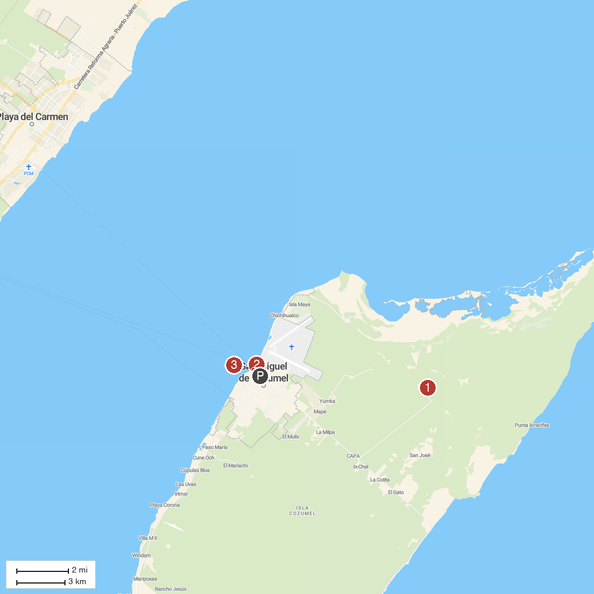
MAP KEY
1. San Gervasio Archaeological Site | 4. Museo de la Isla de Cozumel
2. Punta Sur Eco Beach Park | 5. Palancar Reef
3. El Cedral Maya Ruins | 6. Benito Juárez Park
P. Cruise port / terminal
Map © MapTiler © OpenStreetMap contributors · cruiseports.org

