Craobh Haven, Argyll, Scotland
Pronounced 'Krove Haven,' this purpose-built 1980s marina village is one of Scotland's most peaceful small-ship stops — surrounded by wildlife, ancient stones, and the world's third-largest whirlpool just offshore.
⚓ Tender (no cruise pier) · 🕒 Typical call: 5-7 hrs · 💷 Currency: GBP · 🗣️ Language: English · 🧳 Small-ship / expedition lines only
✍️ MY DAY IN PORT (FILL IN)
Ship / Date
In port | arrive ______ · all aboard ______
Booked excursion
Notes / meeting point
GETTING ASHORE
- Docking: Tender to marina pontoon — no pier for cruise ships
- Walk to village: 2 min from tender dock to pub/café
- Best For: Wildlife, coastal walks, ancient archaeology, boat excursions
- Don't Miss: Gulf of Corryvreckan whirlpool boat tour or Arduaine Garden
GETTING AROUND
- 🚕 Taxi: £35–60 — Pre-booked local taxis run to Lochgilphead (~18 miles, £35–50) or Oban (~22 miles, £45–60). There are no taxi ranks at t
TOP THINGS TO DO
- Gulf of Corryvreckan Whirlpool Boat Tour — The world's third-largest whirlpool, between Jura and Scarba, is best reached from Craobh Haven.
- Kilmartin Glen Archaeology — One of mainland Scotland's richest prehistoric landscapes, about 25 miles (40 min) south.
- Arduaine Garden (National Trust for Scotland) — A clifftop garden warmed by the Gulf Stream that shouldn't exist at this latitude — rhododendrons, Himalayan lilies, and even…
- Wildlife Spotting — Eagles, Seals & Otters — Walk the coastal path toward the Lunga Estate for harbour seals, otters, porpoises, and if you're lucky, White-tailed Sea Eagles…
- Sea Kayaking — Craignish Peninsula — Craobh Haven's marina has watersports facilities, and the sheltered waters of Loch Craignish are ideal for guided kayaking.
BEST WALKS
- Marina to Lunga Coastal Path: 2-3 miles round trip · Easy · 1-1.5 hrs — Follow the shoreline path north from the marina past the small shingle beach and along Loch Shuna…
- Village Viewpoint Walk: 0.5 miles · Easy-moderate · 20-30 min — A short uphill path from the marina leads to a viewpoint above the village with sweeping views over…
WEATHER · DAYLIGHT · MONEY
Month | High °F | Low °F | Rainy days
May | 55 | 46 | 17
Jul | 61 | 53 | 19
Sep | 59 | 51 | 18
Daylight: May 5:08AM–9:30PM · Jul 4:56AM–9:59PM · Sep 6:54AM–7:39PM
cruiseports.org/craobh-haven · Confirm terminal & all-aboard time with your ship

Craobh Haven, Argyll, Scotland — Port Map
Red = walkable sights · Amber = excursions farther out · P = cruise terminal
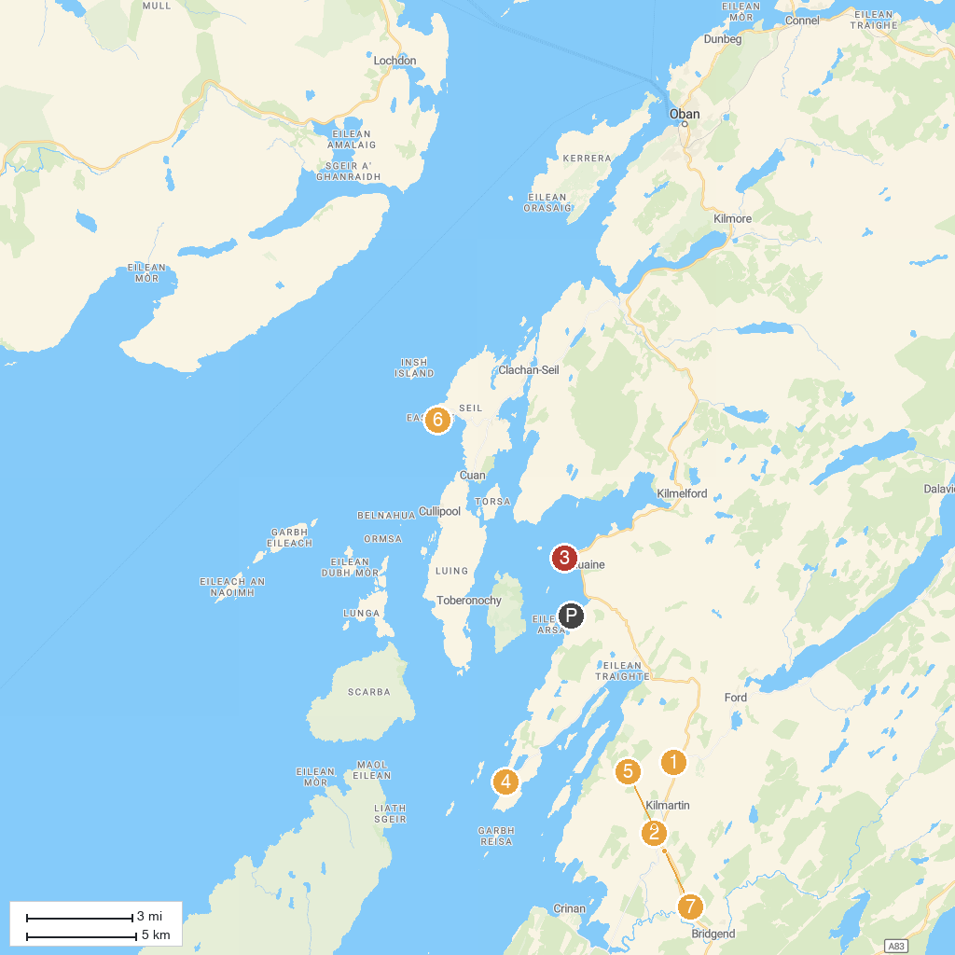
MAP KEY
1. Carnasserie Castle | 5. Nether Largie South Cairn
2. Nether Largie Standing Stones | 6. Easdale Island Folk Museum
3. Arduaine Garden | 7. Dunchraigaig Cairn
4. Craignish Point
P. Cruise port / terminal
Map © MapTiler © OpenStreetMap contributors · cruiseports.org

