Crișan, Danube Delta, Romania
A tiny fishing village on the Sulina Channel, Crișan is the beating heart of the UNESCO-listed Danube Delta — where pelicans outnumber cars and every canal hides a new world.
⚓ River pier (docked) · 🕒 Typical call: 6-8 hrs · 💵 Romanian Leu (RON) — no ATMs, bring cash · 🗣️ Romanian | some English at guesthouses · 🌿 UNESCO Biosphere Reserve
✍️ MY DAY IN PORT (FILL IN)
Ship / Date
In port | arrive ______ · all aboard ______
Booked excursion
Notes / meeting point
GETTING ASHORE
- Docking: River quay on the Sulina Channel — ships tie up directly at the village
- Walk to center: Steps — the quay IS the village center
- Best For: Wildlife & bird watching, boat excursions, authentic Delta cuisine
- Don't Miss: Early-morning pelican colony boat trip into the Delta canals
GETTING AROUND
- 🚕 Taxi: ~80 RON/person — Shared water taxis run between Crișan and Tulcea daily, taking approximately one hour each way. The most practical link
- 📱 Rideshare: ❌ not available
TOP THINGS TO DO
- Pelican Colony & Canal Boat Tour — The star attraction of the Danube Delta.
- Mila 23 Village Visit — A short boat ride from Crișan, Mila 23 is an even more remote fishermen's village — no roads in or out, only water.
- Caraorman Forest & Sand Dunes — An unexpected highlight — ancient sand dunes and a protected oak forest rising from the flatlands of the Delta.
- Traditional Delta Fish Lunch — Sit down at one of Crișan's riverside guesthouses for a proper Delta meal: borș de pește (fish soup with garlic sauce), baked…
- Kayak & Canoe in the Reed Beds — Paddle silently through the narrow channels that motorboats can't reach — the best way to sneak up on wildlife.
BEST WALKS
- Crișan Village Embankment Stroll: 1.5 km one-way | Flat | 20 min — Walk the main path along the Sulina Channel from the quay northward through the village.
WEATHER · DAYLIGHT · MONEY
Month | High °F | Low °F | Rainy days
May | 70 | 55 | 9
Jul | 84 | 68 | 6
Sep | 76 | 60 | 4
Daylight: May 5:33AM–8:25PM · Jul 5:29AM–8:46PM · Sep 6:41AM–7:13PM
cruiseports.org/crisan · Confirm terminal & all-aboard time with your ship

Crișan, Danube Delta, Romania — Port Map
Red = walkable sights · Amber = excursions farther out · P = cruise terminal
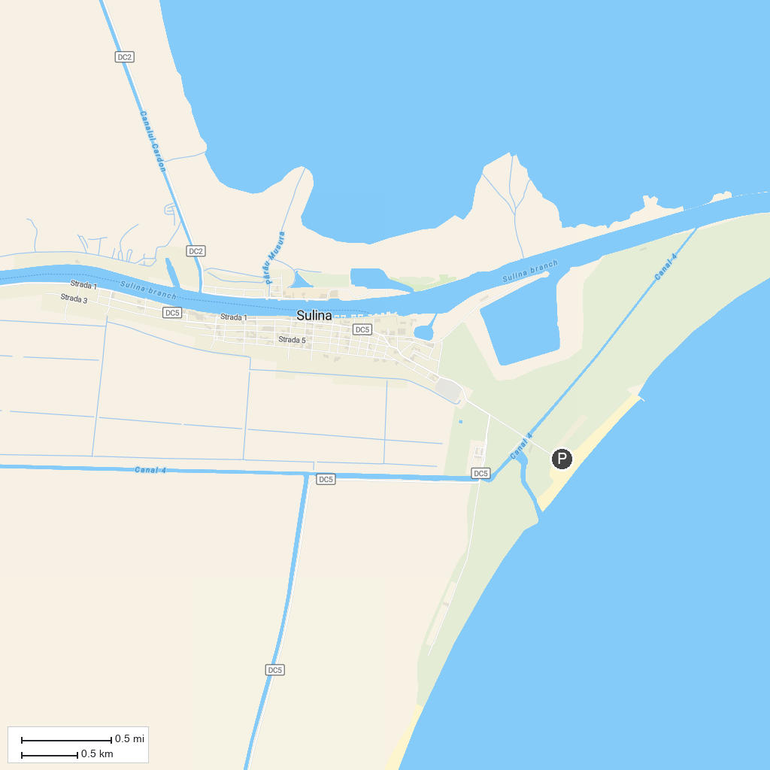
MAP KEY
1. Cetatea Salsovia | 3. Pădurea Letea
2. Stejarul Îngenuncheat
P. Cruise port / terminal
Map © MapTiler © OpenStreetMap contributors · cruiseports.org

