Willemstad, Curaçao
Curaçao's capital, Willemstad, is one of the Caribbean's most visually striking port towns — a UNESCO World Heritage waterfront of Dutch-colonial buildings painted in vivid pastels, split by a narrow channel you cross on a floating pontoon bridge. Add gin-clear beaches, dramatic limestone caves, and some of the best wreck diving in the region.
⚓ Docked — Mega Pier / Otrobanda · 🕒 Typical call: 8–10 hrs · 💵 Netherlands Antillean Guilder (ANG) · USD widely accepted · 🗣️ Papiamentu · Dutch · English
✍️ MY DAY IN PORT (FILL IN)
Ship / Date
In port | arrive ______ · all aboard ______
Booked excursion
Notes / meeting point
GETTING ASHORE
- Docking: Mega Pier (Sint Annabaai channel), Otrobanda side — steps from Willemstad center
- To center: ~5 min walk to Queen Emma Pontoon Bridge / Punda waterfront
- Best For: UNESCO Old Town · Beaches · Snorkeling & Diving · Dutch Colonial Architecture
- Don't Miss: Cross the Queen Emma Pontoon Bridge and stroll Punda's colonial waterfront
GETTING AROUND
- 🚕 Taxi: $20–$30/taxi (up to 4) — Metered taxis queue at the cruise terminal. Negotiate the fare before departing; short rides to beaches like Mambo Beach
- 📱 Rideshare: ❌ not available
TOP THINGS TO DO
- Willemstad UNESCO Walking Tour — Wander Punda's pastel Dutch-colonial waterfront, browse the Floating Market where Venezuelan vendors sell fresh produce from…
- Hato Caves — Explore an ancient limestone cave system 20 minutes from Willemstad, with stalactite and stalagmite formations, resident…
- Cas Abao or Playa Kenepa Beach Day — Curaçao's best beaches are on the rugged western coast — Cas Abao offers calm turquoise water, a beach bar, and good snorkeling…
- Wreck Diving & Snorkeling — Curaçao is one of the Caribbean's top diving destinations, with the USAT Tugboat wreck (perfect for beginners at just 5 m depth)…
- Curaçao Liqueur Distillery Tour — The Curaçao Liqueur Distillery (Senior & Co.) operates from the historic Landhuis Chobolobo in Willemstad, the company's home…
BEST WALKS
- Otrobanda to Punda Waterfront Walk: 1.5 km · ~30–45 min · Easy — Start at the cruise terminal in Otrobanda, walk east along the waterfront past the Rif Fort (now a…
- Punda Historic Core: 1 km · ~45 min · Easy — From the Pontoon Bridge, walk into Punda's historic grid: pass Fort Amsterdam (the governor's…
- Punda & Handelskade Loop: 2 km · 1.5 hrs · Easy — Cross the Queen Emma Bridge into Punda, walk the iconic Handelskade waterfront, loop through the…
WEATHER · DAYLIGHT · MONEY
Month | High °F | Low °F | Rainy days
May | 85 | 79 | 8
Jul | 85 | 79 | 15
Sep | 87 | 81 | 10
Daylight: May 6:11AM–6:52PM · Jul 6:18AM–7:04PM · Sep 6:25AM–6:36PM
cruiseports.org/curacao · Confirm terminal & all-aboard time with your ship

Willemstad, Curaçao — Port Map
Red = walkable sights · Amber = excursions farther out · P = cruise terminal
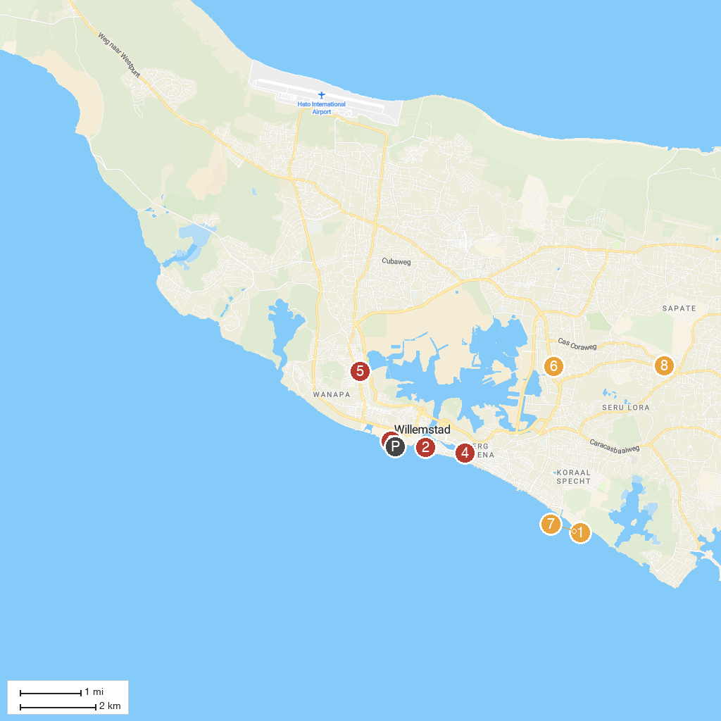
MAP KEY
1. Curaçao Sea Aquarium | 5. Gallery Alma Blou
2. Fort Church | 6. Mongui Maduro Historic House Museum
3. MV Superior Producer - Curaçao Iconic Shipwreck | 7. Substation Curacao
4. Queen of the Most Holy Rosary Cathedral | 8. Montaña Bierhuis Village
P. Cruise port / terminal
Map © MapTiler © OpenStreetMap contributors · cruiseports.org

