Currimao, Ilocos Norte, Philippines
A raw, unhurried port on the northwest coast of Luzon — your gateway to Spanish colonial churches, vast sand dunes, and the UNESCO-listed streets of Vigan.
⚓ Pier (direct berth up to 200 m) · 🕒 Typical call: 8–10 hrs · 💵 Philippine Peso (cash essential) · 🗣️ Ilocano / English spoken · 🏛️ UNESCO heritage nearby
✍️ MY DAY IN PORT (FILL IN)
Ship / Date
In port | arrive ______ · all aboard ______
Booked excursion
Notes / meeting point
GETTING ASHORE
- Docking: Pier — upgraded berth handles most cruise ships directly; very large vessels may tender
- Walk to town: ~3 km to Currimao poblacion (taxi/tricycle strongly recommended in the heat)
- Best For: Heritage seekers, foodies, sand-dune adventurers
- Don't Miss: Paoay Church (UNESCO), Ilocos Empanada, Paoay Sand Dunes 4x4 ride
GETTING AROUND
- 🚕 Taxi: PHP 210–250 to Batac (~11 km); PHP 430–550 to Laoag (~29 km) — Metered and negotiated taxis are available at the port. Confirm the fare with the driver before departing — meters are n
TOP THINGS TO DO
- Paoay Church & Malacañang of the North — Paoay's Saint Augustine Church (1710) is the definitive example of Earthquake Baroque, with massive flying buttresses unlike…
- Paoay Sand Dunes 4x4 Ride — A desert beside the sea — kilometre-wide dunes rolling down to the Ilocos coast.
- Vigan Heritage City Walk — Calle Crisologo's cobblestone streets and centuries-old Spanish colonial mansions are unlike anywhere in Southeast Asia.
- Pangil Coral Rock Formations — Massive fossilized coral formations sculpted by tidal erosion over millennia — dark, dramatic, and very photogenic right on the…
- Ilocano Food Trail — Ilocano cuisine is one of the Philippines' most distinct — bagnet (double-fried crispy pork belly), Ilocos empanada (orange-fried…
BEST WALKS
- Pangil Coastal Walk: 1–2 km · Easy · 45–60 min — Tricycle to the Pangil rock formations, then pick your way along the fossilized coral coastline.
- Currimao Town Stroll: 1.5 km · Easy · 30 min — Walk or tricycle to the poblacion, take a look at the Spanish-era Tabacalera tobacco warehouse…
WEATHER · DAYLIGHT · MONEY
Month | High °F | Low °F | Rainy days
May | 90 | 78 | 22
Jul | 86 | 77 | 28
Sep | 86 | 76 | 25
Daylight: May 5:25AM–6:23PM · Jul 5:30AM–6:37PM · Sep 5:46AM–6:00PM
cruiseports.org/currimao · Confirm terminal & all-aboard time with your ship

Currimao, Ilocos Norte, Philippines — Port Map
Red = walkable sights · Amber = excursions farther out · P = cruise terminal
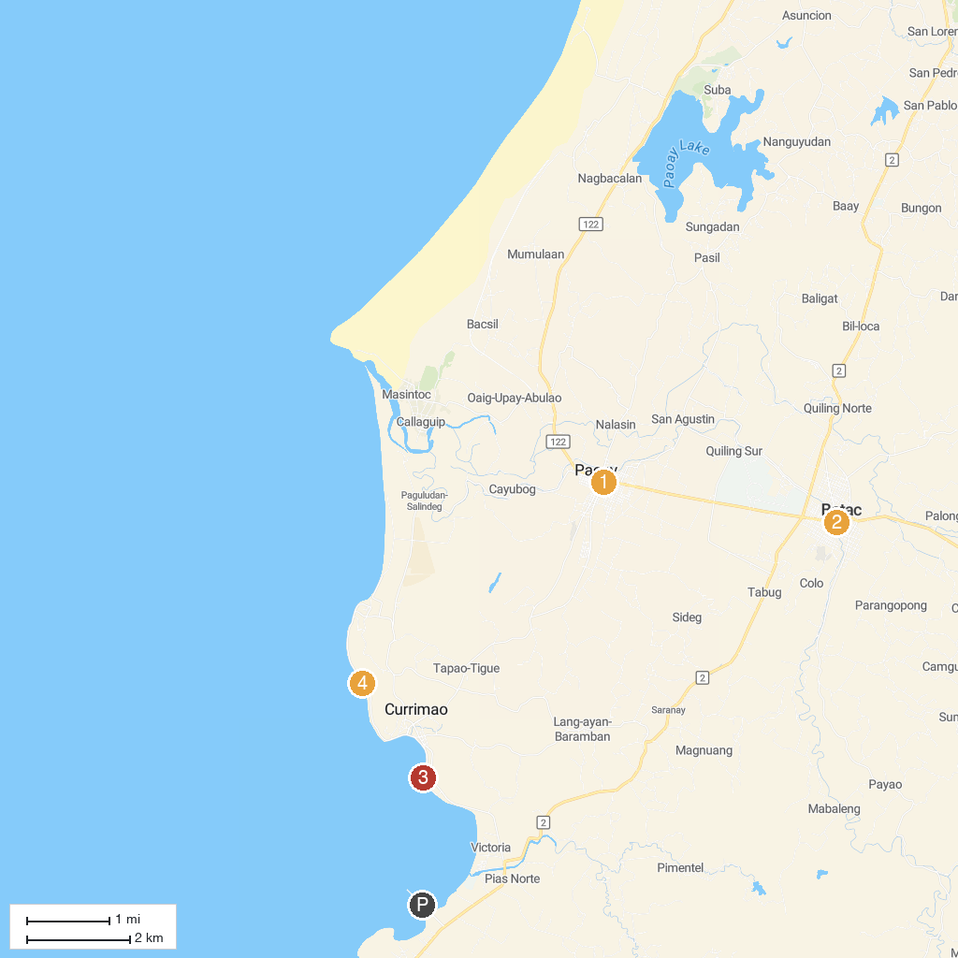
MAP KEY
1. Malacañang of the North | 4. Marcos Museum
2. Paoay Sand Dunes Adventures (Suba) | 5. Currimao South Watchtower
3. San Agustin Church of Paoay | 6. Pangil Coral Rock Formation
P. Cruise port / terminal
Map © MapTiler © OpenStreetMap contributors · cruiseports.org

