Da Nang, Central Vietnam, Vietnam
Central Vietnam's gateway city puts UNESCO World Heritage sites on both sides — ancient Hoi An to the south and the sacred Cham temples of My Son inland. Da Nang itself adds a striking riverside skyline and the soaring Lady Buddha on Son Tra Peninsula.
⚓ Pier (Tien Sa Port) · 🕒 Typical call: 8-10 hrs · 💵 Vietnamese Dong (VND) · 🗣️ Vietnamese (English in tourist areas)
✍️ MY DAY IN PORT (FILL IN)
Ship / Date
In port | arrive ______ · all aboard ______
Booked excursion
Notes / meeting point
GETTING ASHORE
- Docking: Tien Sa Port, Son Tra Peninsula — ~10-15 km from city center
- Walk to center: Not walkable — taxi or Grab required (~20 min, ~$5-8 USD)
- Best For: Hoi An Ancient Town, My Son Sanctuary, Marble Mountains, Ba Na Hills
- Don't Miss: Hoi An's lantern-lit old town — allow at least 3-4 hours
GETTING AROUND
- 🚕 Taxi: 120,000–300,000 VND (~$5–12) — Walk to the port gate (free shuttle ~500 m) to avoid the in-port pickup surcharge some drivers add for entering the secu
- 📱 Rideshare: ✅ Grab, Be, Xanh SM
- 🚌 Hop-on hop-off: ✅ Coco City Tour
TOP THINGS TO DO
- Hoi An Ancient Town — The jewel of Central Vietnam: a beautifully preserved UNESCO trading port with lantern-hung streets, the Japanese Covered Bridge…
- My Son Sanctuary — Haunting ruins of the ancient Champa Kingdom, set in a jungle valley — Vietnam's own Angkor on a smaller scale.
- Marble Mountains (Ngu Hanh Son) — Five limestone karst hills honeycombed with caves, ancient pagodas, and sweeping views over Da Nang's coastline.
- Ba Na Hills & Golden Bridge — Cable car up to a French-colonial hilltop resort at 1,400 m elevation.
- Lady Buddha & Son Tra Peninsula — The 67-metre Lady Buddha statue at Linh Ung Pagoda is visible from ships entering the harbour.
BEST WALKS
- Han River Waterfront Walk: 2-3 km | Flat | Best in late afternoon — A pleasant riverside stroll along Bach Dang Street from the Dragon Bridge north past the Han River…
- Hoi An Ancient Town Self-Guided Walk: 2 km | Flat | Allow 3-4 hrs — The old town is compact and extremely walkable.
WEATHER · DAYLIGHT · MONEY
Month | High °F | Low °F | Rainy days
May | 89 | 79 | 12
Jul | 91 | 80 | 17
Sep | 87 | 78 | 21
Daylight: May 5:17AM–6:09PM · Jul 5:23AM–6:22PM · Sep 5:35AM–5:48PM
cruiseports.org/da-nang · Confirm terminal & all-aboard time with your ship

Da Nang, Central Vietnam, Vietnam — Port Map
Red = walkable sights · Amber = excursions farther out · P = cruise terminal
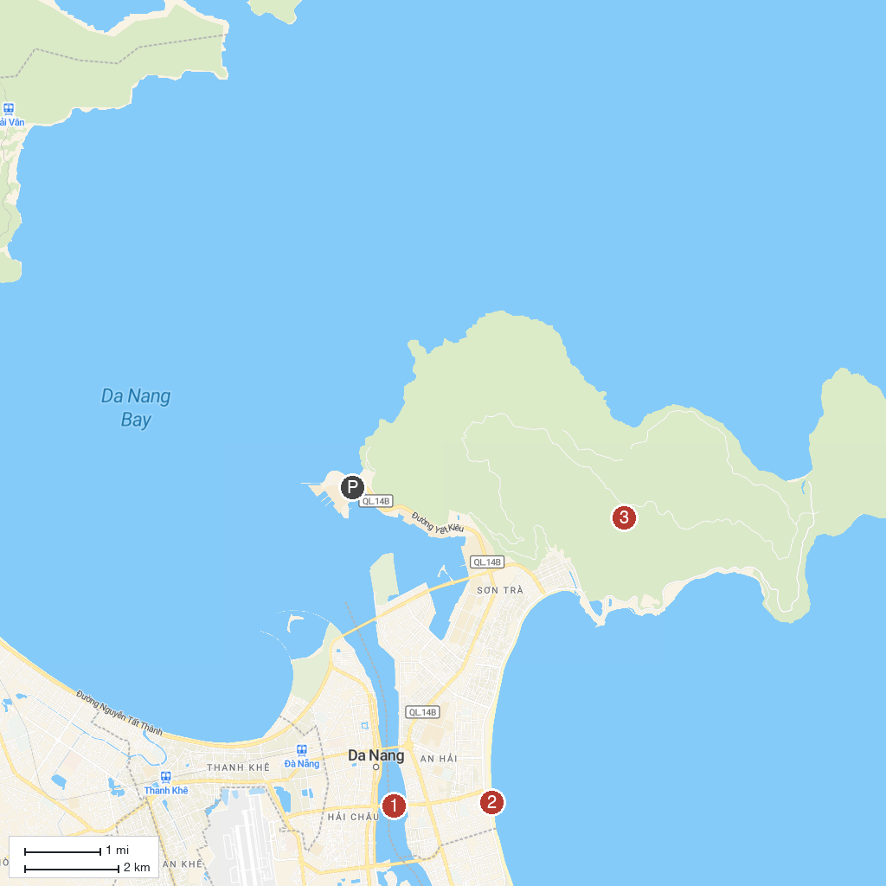
MAP KEY
1. Marble Mountains | 4. Dragon Bridge
2. Golden Bridge, Ba Na Hills | 5. My Khe Beach
3. Hoi An Ancient Town | 6. Son Tra Peninsula (Monkey Mountain)
P. Cruise port / terminal
Map © MapTiler © OpenStreetMap contributors · cruiseports.org

