Dalian, Liaoning, China
The 'Hong Kong of the North' delivers a rare mix: sweeping colonial squares, seaside drives, wild beaches, and one of China's most walkable city centers — all from a terminal steps from the action.
⚓ Pier (Dalian International Cruise Terminal) · 🕒 Typical call: 8–10 hrs · 💴 Currency: Chinese Yuan (CNY/RMB) · 🗣️ Language: Mandarin Chinese · 🛂 Visa-free for approved cruise groups
✍️ MY DAY IN PORT (FILL IN)
Ship / Date
In port | arrive ______ · all aboard ______
Booked excursion
Notes / meeting point
GETTING ASHORE
- Docking: Pier — Dalian International Cruise Terminal, East Port district
- Walk to center: ~20 min on foot or 10 min by taxi to Zhongshan Square
- Best For: Colonial history, coastal scenery, seafood, city walks
- Don't Miss: Riding the historic 201 tram through the city center
GETTING AROUND
- 🚕 Taxi: ¥10–30 — Metered taxis are plentiful at the cruise terminal. Starting fare is ¥8 for the first 3 km, then ¥2–2.4 per km — city ce
- 📱 Rideshare: ✅ DiDi
- 🚌 Hop-on hop-off: ✅
TOP THINGS TO DO
- Zhongshan Square & Historic Tram Ride — The grand circular square is ringed by meticulously preserved Russian and Japanese-era buildings — a living reminder of Dalian's…
- Binhai Road Coastal Scenic Drive — A spectacular cliff-hugging road linking beach coves, rocky headlands, and lookout points.
- Fujiazhuang Beach — One of Dalian's best sandy beaches — cleaner and less crowded than most Chinese city beaches.
- Tiger Beach Ocean Park (Laohutan) — A large marine park on the coast featuring beluga whales, sea otters, polar bears, and a coral hall.
- Lushun (Port Arthur) Full-Day Excursion — About 45 km from Dalian, Lushun was the site of famous Russo-Japanese War battles.
BEST WALKS
- Colonial Core Walk: 2.5 km • ~1 hr • Easy — From the cruise terminal waterfront, walk or taxi to Zhongshan Square and circle its ring of…
- Xinghai Square & Seaside: 3 km loop • ~1.5 hrs • Easy — Take a taxi to Xinghai Square, walk its vast promenade to the sea-view terrace, then stroll the…
WEATHER · DAYLIGHT · MONEY
Month | High °F | Low °F | Rainy days
May | 67 | 55 | 6
Jul | 80 | 72 | 9
Sep | 75 | 66 | 6
Daylight: May 4:41AM–6:58PM · Jul 4:40AM–7:18PM · Sep 5:35AM–6:02PM
cruiseports.org/dalian · Confirm terminal & all-aboard time with your ship

Dalian, Liaoning, China — Port Map
Red = walkable sights · Amber = excursions farther out · P = cruise terminal
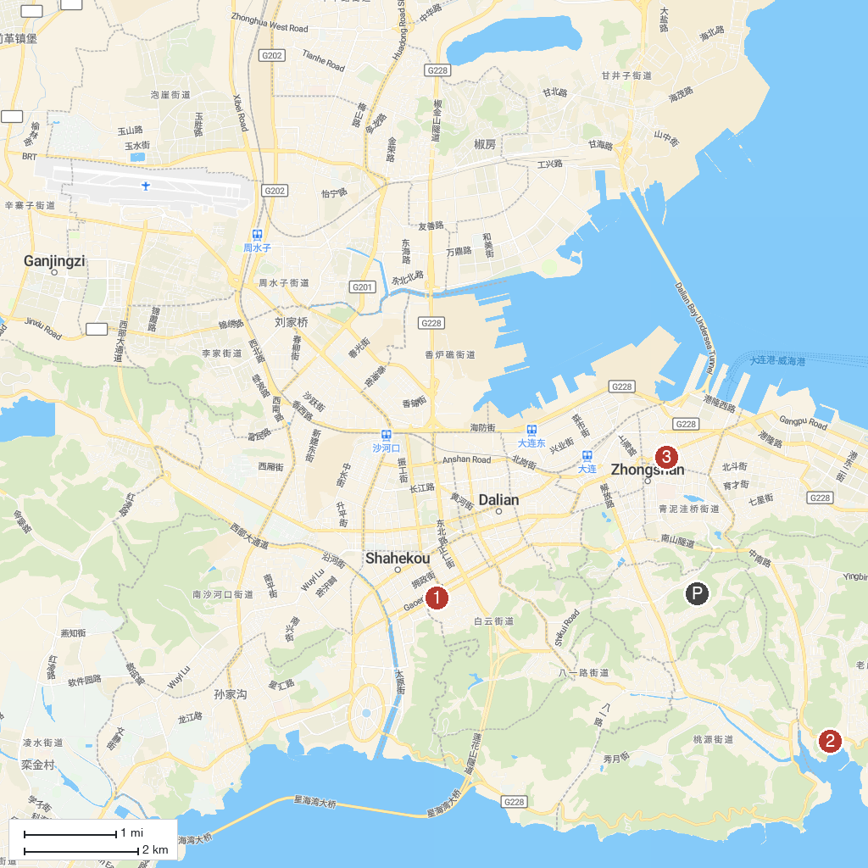
MAP KEY
1. Xinghai Square | 3. Dalian Zhongshan Square
2. Dalian Laohutan Ocean Park
P. Cruise port / terminal
Map © MapTiler © OpenStreetMap contributors · cruiseports.org

