Dammam, Eastern Province, Saudi Arabia
Saudi Arabia's oil-rich Eastern Province opens with wide corniche promenades, a stunning modern cultural centre, and gateway access to Bahrain — all from a brand-new cruise terminal on the Arabian Gulf.
⚓ Docked (King Abdulaziz Port) · 🕒 Typical call: 8–10 hrs · 💵 Saudi Riyal (SAR; pegged ~3.75/USD) · 🗣️ Arabic (English widely understood) · 🌡️ Hot & dry; Oct–Apr best
✍️ MY DAY IN PORT (FILL IN)
Ship / Date
In port | arrive ______ · all aboard ______
Booked excursion
Notes / meeting point
GETTING ASHORE
- Docking: Docked at King Abdulaziz Port cruise terminal
- Walk to centre: ~3 km to Dammam Corniche; taxi/Uber recommended
- Best For: Culture, Gulf beaches, cross-border day trips to Bahrain
- Don't Miss: King Abdulaziz Center for World Culture (Ithra) in Dhahran
GETTING AROUND
- 🚕 Taxi: 50–65 SAR (~$13–$17) — Taxis available at King Abdulaziz Port. Drivers often use fixed prices rather than meters — agree on the fare before dep
- 📱 Rideshare: ✅ Uber, Careem
TOP THINGS TO DO
- Ithra: King Abdulaziz Center for World Culture — Saudi Arabia's flagship cultural complex in Dhahran features a stunning library, cinema, innovation labs, and rotating…
- Tarout Island & Castle — A short drive north reveals Tarout Island, home to a Portuguese-era fortress and one of the world's oldest continuously inhabited…
- Half Moon Bay Beach — A crescent-shaped Gulf beach 40 km south of Dammam with calm, shallow water and good facilities.
- Day Trip to Bahrain via King Fahd Causeway — The 25 km causeway connecting Saudi Arabia with Bahrain is itself a sightseeing event.
- Dammam Corniche & Marjan Island Stroll — The city corniche runs along the Arabian Gulf with parks, cafes, and playgrounds.
BEST WALKS
- Dammam Corniche Waterfront Walk: 2 km each way | Easy | Free — Stroll the Gulf-facing promenade from King Abdulaziz Park south toward the Corniche bridge and…
- Al Khobar Corniche Promenade: 1.5 km | Easy | Free | 20 min taxi from port — Al Khobar's waterfront is slightly more polished than Dammam's, with fountains, sculptures, and the…
WEATHER · DAYLIGHT · MONEY
Month | High °F | Low °F | Rainy days
May | 99 | 78 | 0
Jul | 107 | 87 | 0
Sep | 104 | 81 | 0
Daylight: May 4:52AM–6:19PM · Jul 4:56AM–6:34PM · Sep 5:25AM–5:43PM
cruiseports.org/dammam · Confirm terminal & all-aboard time with your ship

Dammam, Eastern Province, Saudi Arabia — Port Map
Red = walkable sights · Amber = excursions farther out · P = cruise terminal
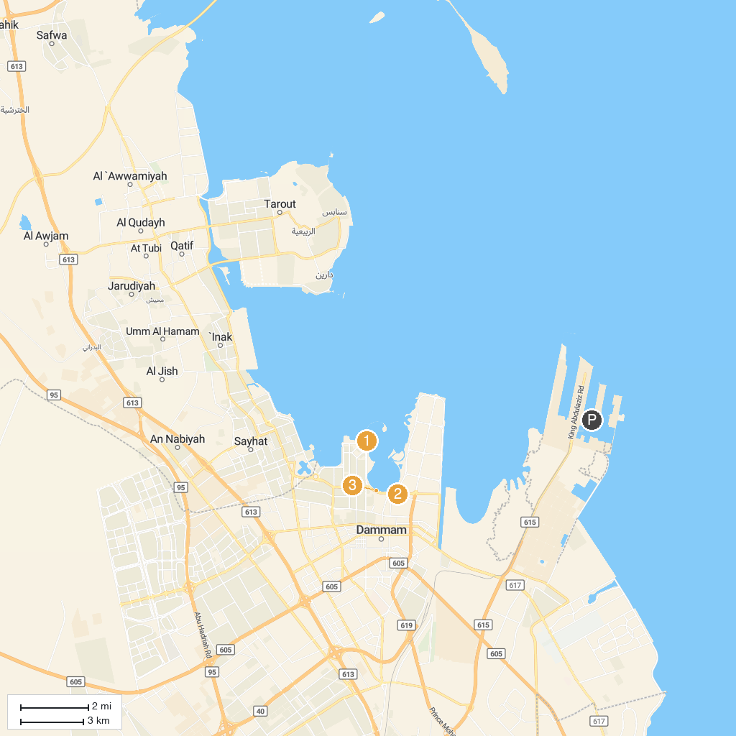
MAP KEY
1. King Abdulaziz Center for World Culture - Ithra | 5. Sails Roundabout
2. Amr Ibn Aljamooh Mosque. | 6. Dammam Corniche
3. Dolphin Village Dammam | 7. Prince Abdulmohsin Bin Jalawi Park
4. Muraikabat Mountain Park | 8. Alfelwah and Aljowharah Museum
P. Cruise port / terminal
Map © MapTiler © OpenStreetMap contributors · cruiseports.org

