Dangriga, Stann Creek, Belize
Belize's 'Culture Capital' and Garifuna heartland — a rawly authentic port of drumbeats, jungle wildlife, and reef islands just offshore.
⚓ Tender (no mega-ship pier) · 🕒 Typical call: 6-8 hrs · 💵 USD & Belize Dollar (2:1) · 🗣️ English (official), Garifuna, Creole
✍️ MY DAY IN PORT (FILL IN)
Ship / Date
In port | arrive ______ · all aboard ______
Booked excursion
Notes / meeting point
GETTING ASHORE
- Docking: Tender to town dock or Pelican Beach Resort dock — small/expedition ships only; no pier for mega-ships
- Walk to center: 5 min from town dock; ~30 min walk from Pelican Beach dock (taxis available)
- Best For: Garifuna culture, jungle excursions (jaguar reserve, ziplining), Marie Sharp's factory, reef cayes
- Don't Miss: Austin Rodriguez Drum Shop and a bowl of hudut (Garifuna fish stew in coconut broth)
GETTING AROUND
- 🚕 Taxi: $5–$15 USD — Local taxis are the primary transport option in Dangriga. Fares are negotiated before the ride — no meters. The town cen
- 📱 Rideshare: ❌ not available
TOP THINGS TO DO
- Cockscomb Basin Wildlife Sanctuary — The world's first jaguar preserve offers jungle hiking, waterfall swimming, and river tubing about 45 minutes from Dangriga.
- Marie Sharp's Hot Sauce Factory — Tour the factory where Belize's most famous export — Marie Sharp's habanero sauces — is made, with tastings of dozens of varieties.
- Tobacco Caye & Barrier Reef Snorkel — A 30–40 minute boat ride brings you to a tiny coral island on the Belize Barrier Reef with white sand, warm water, and vibrant…
- Mayflower Bocawina Zipline & Waterfalls — Zip through the rainforest canopy and rappel beside waterfalls at this national park, less than an hour from Dangriga.
- Gulisi Garifuna Museum — The premier museum dedicated to Garifuna history, language, music, and traditions — a must for understanding the culture you…
BEST WALKS
- Town Dock to Pen Cayetano Gallery: ~20 min walk • Flat • Cultural — From the town dock, walk through the market area and north through the main streets to the studio…
- Drums Monument to Austin Rodriguez Drum Shop: ~15 min walk • Flat • Cultural — Start at the Drums of My Fathers monument at the town entrance for a quick photo, then walk to…
WEATHER · DAYLIGHT · MONEY
Month | High °F | Low °F | Rainy days
May | 85 | 78 | 23
Jul | 84 | 77 | 29
Sep | 85 | 77 | 28
Daylight: May 5:21AM–6:17PM · Jul 5:27AM–6:29PM · Sep 5:41AM–5:54PM
cruiseports.org/dangriga · Confirm terminal & all-aboard time with your ship

Dangriga, Stann Creek, Belize — Port Map
Red = walkable sights · Amber = excursions farther out · P = cruise terminal
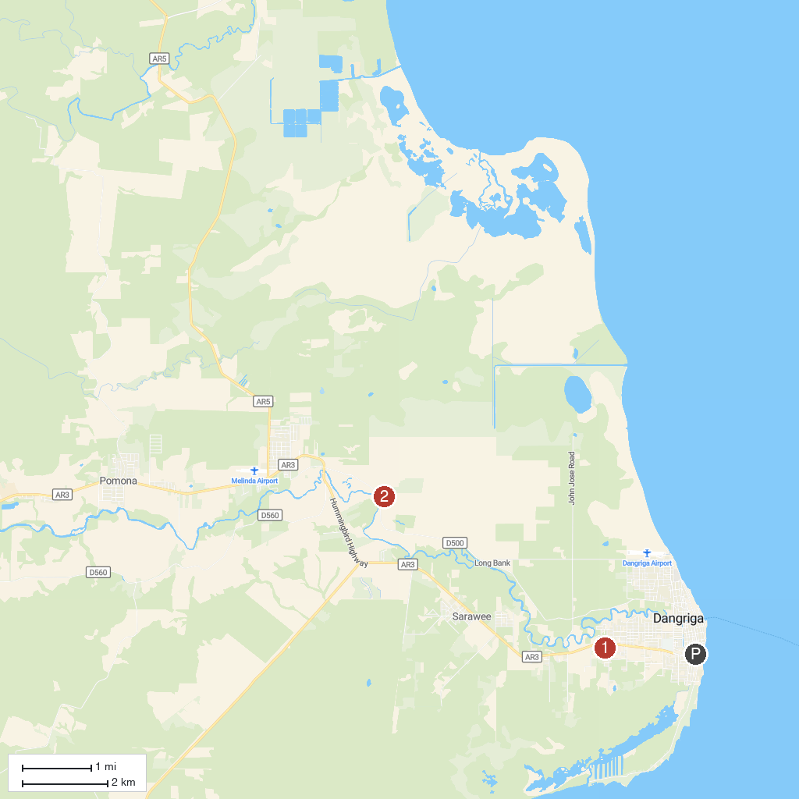
MAP KEY
1. Gulisi Garifuna Museum | 2. Marie Sharp's Factory
P. Cruise port / terminal
Map © MapTiler © OpenStreetMap contributors · cruiseports.org

