Dar es Salaam, Tanzania
Tanzania's 'Haven of Peace' is anything but quiet — a sensory-rich East African metropolis of fish markets, colonial churches, and Indian Ocean island gateways. Not a tourist bubble; a real, vibrant city.
⚓ Docked (commercial pier) · 🕒 Typical call: 8–10 hrs · 💵 TZS / USD accepted · 🗣️ Swahili & English · 🌍 East Africa gateway
✍️ MY DAY IN PORT (FILL IN)
Ship / Date
In port | arrive ______ · all aboard ______
Booked excursion
Notes / meeting point
GETTING ASHORE
- Docking: Alongside berth at Port of Dar es Salaam — no tendering. Industrial cargo port; port shuttle required to gate.
- Walk to centre: Not walkable from port gates — take a tuk-tuk (bajaji), Uber/Bolt, or tour vehicle. National Museum is ~15 min by taxi.
- Best For: Culture, history, Zanzibar day trip, wildlife safari excursions, Swahili cuisine
- Don't Miss: Kivukoni Fish Market at dawn, Tingatinga Arts Cooperative, or the fast ferry to Zanzibar
GETTING AROUND
- 🚕 Taxi: $15–25 USD — Taxis gather at the port gate and fares must be negotiated before departure — agree on a price before getting in. Expect
- 📱 Rideshare: ✅ Bolt
TOP THINGS TO DO
- Dar City Highlights & National Museum — Hit the National Museum & House of Culture (home to Olduvai Gorge fossils and slave-trade exhibits), the Azania Front Lutheran…
- Fast Ferry to Zanzibar Stone Town — Board the Azam Marine high-speed ferry (1 hr 45 min) to Zanzibar and spend a few hours exploring Stone Town's labyrinth of…
- Bongoyo Island Marine Reserve — A 30-minute boat from The Slipway puts you on a pristine white-sand island in the Dar es Salaam Marine Reserve.
- Mikumi or Nyerere Day Safari — Dar is the gateway to Tanzania's southern wildlife circuit.
- Kivukoni Fish Market & Street Food Walk — Start at dawn as fishermen auction the catch — sailfish, red snapper, octopus — then wander to nearby stalls for chips mayai…
BEST WALKS
- Waterfront Heritage Loop: 1.5 km · 30 min · Flat — From the Kivukoni Ferry Terminal, walk south past the Azania Front Lutheran Church (1898), St.
- Msasani Slipway & Oyster Bay: By taxi · Coco Beach & waterfront — Take a tuk-tuk or Uber to The Slipway — a waterfront complex with craft markets, boutiques, and…
WEATHER · DAYLIGHT · MONEY
Month | High °F | Low °F | Rainy days
May | 83 | 74 | 17
Jul | 83 | 72 | 6
Sep | 85 | 72 | 11
Daylight: May 6:25AM–6:13PM · Jul 6:36AM–6:21PM · Sep 6:16AM–6:19PM
cruiseports.org/dar-es-salaam · Confirm terminal & all-aboard time with your ship

Dar es Salaam, Tanzania — Port Map
Red = walkable sights · Amber = excursions farther out · P = cruise terminal
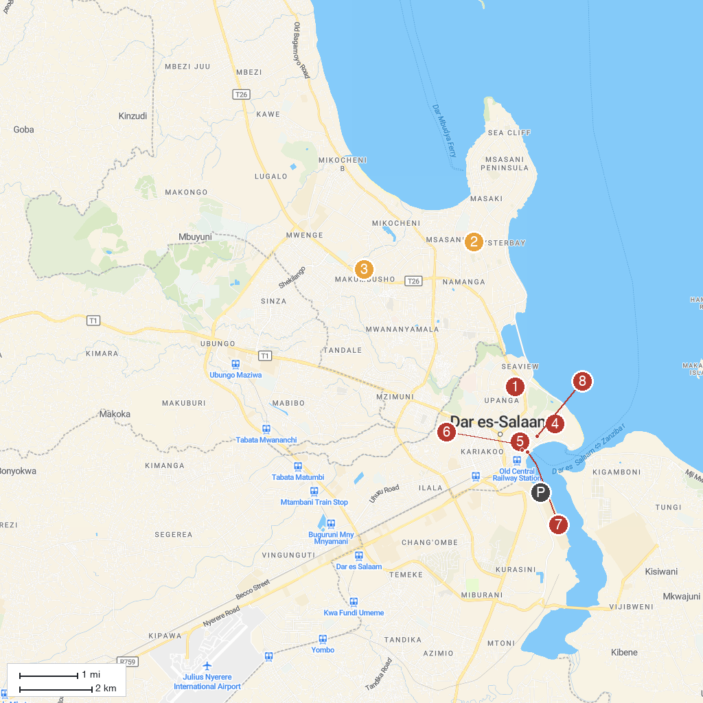
MAP KEY
1. Masjid Maamur مسجد | 5. KSIJ Dar es Salaam - Mosque
2. Tinga Tinga Arts Cooperative Society | 6. Le Grande Casino
3. Village Museum | 7. Old Boma
4. National Museum and House of Culture | 8. Askari Monument (Mnara wa Askari)
P. Cruise port / terminal
Map © MapTiler © OpenStreetMap contributors · cruiseports.org

