Dartmouth, Devon, England
Dartmouth is a picture-perfect South Devon harbour town on the River Dart — steep streets of pastel houses, a 600-year-old castle guarding the estuary mouth, and the Royal Navy's officer training college on the hill above.
⚓ Tendered into the River Dart · 🕒 Typical call: 7-10 hrs · 💵 Pound Sterling (GBP) · 🗣️ English
✍️ MY DAY IN PORT (FILL IN)
Ship / Date
In port | arrive ______ · all aboard ______
Booked excursion
Notes / meeting point
GETTING ASHORE
- Docking: Ships anchor in the River Dart; ship's tenders run to the Town Jetty in the heart of Dartmouth
- Walk to Centre: Tender lands you on the waterfront — the town centre is right at the jetty
- Best For: Castles, maritime history, riverside walks, Agatha Christie's Greenway
- Don't Miss: Dartmouth Castle, guarding the narrow estuary mouth for over 600 years
GETTING AROUND
- 🚕 Taxi: £2.80 flag fall + £1.29/km — Licensed local taxis are available near the Town Jetty for onward travel to surrounding villages or attractions. Short i
- 📱 Rideshare: ❌ not available
TOP THINGS TO DO
- Dartmouth Castle by River Ferry — Dartmouth Castle has guarded the narrow mouth of the Dart Estuary for over 600 years.
- Britannia Royal Naval College Tour — Perched on the hill above town, the BRNC (built 1905) is where all Royal Navy officers are trained — and where Princess Elizabeth…
- Greenway — Agatha Christie's Holiday Home — The Queen of Crime's beloved Georgian holiday house sits in romantic woodland gardens sweeping down to the Dart.
- Dartmouth Steam Railway & River Cruise — The 'Round Robin' combines a nostalgic steam train along the South Devon coast (Kingswear-Paignton), a river cruise on the Dart…
- Dartmouth Waterfront & Seafood — Dartmouth's narrow streets and South Embankment brim with pubs, cafes, and acclaimed seafood.
BEST WALKS
- Historic Town & Bayard's Cove: 1.5 km · 30-45 min · Easy · Some cobbles — From the Boat Float, wander the South Embankment to cobbled Bayard's Cove — where the Pilgrim…
- Riverside to Dartmouth Castle: 3 km · 60-75 min · Moderate · Some climbs — Follow the South Embankment and Castle Road along the estuary, with views across to Kingswear, out…
WEATHER · DAYLIGHT · MONEY
Month | High °F | Low °F | Rainy days
May | 59 | 47 | 11
Jul | 67 | 55 | 10
Sep | 63 | 52 | 11
Daylight: May 5:27AM–8:55PM · Jul 5:20AM–9:19PM · Sep 6:50AM–7:27PM
Representative sunrise/sunset — 2025, 15th of each month; local civil time including DST (Europe/London). Source: Astral; not a forecast or climate average.
cruiseports.org/dartmouth · Confirm terminal & all-aboard time with your ship

Dartmouth, Devon, England — Port Map
Red = walkable sights · Amber = excursions farther out · P = cruise terminal
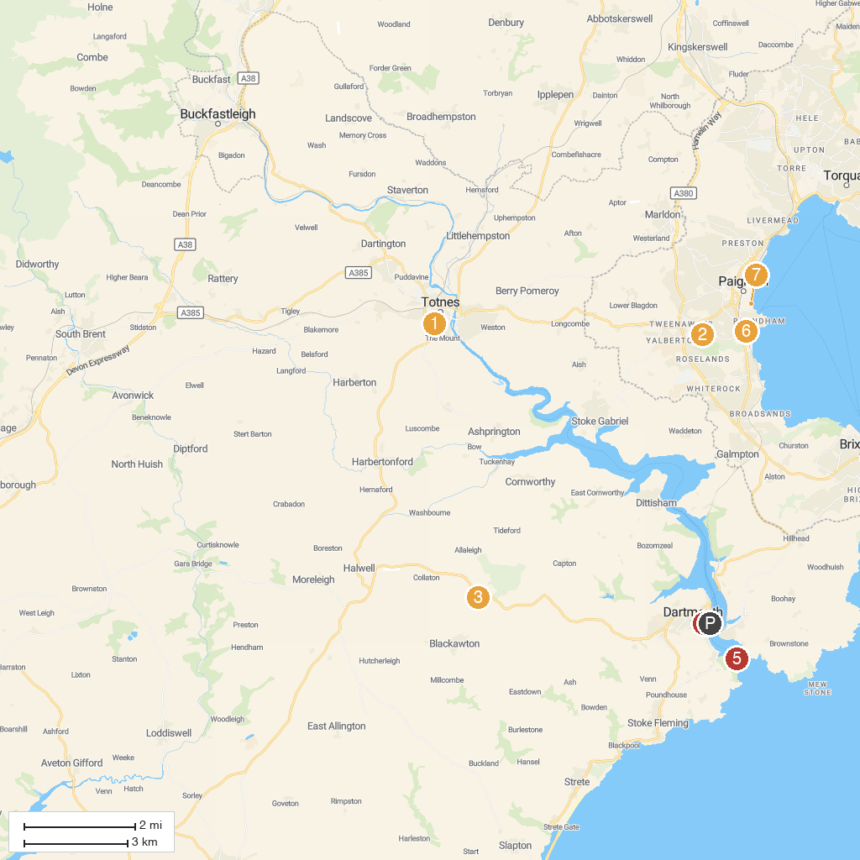
MAP KEY
1. Leechwell Garden | 5. St Saviour's Church
2. Paignton Zoo Environmental Park | 6. Dartmouth Castle
3. Woodlands Family Theme Park | 7. Young's Park
4. Kents Cavern Prehistoric Caves | 8. Pirates Bay Adventure Golf
P. Cruise port / terminal
Map © MapTiler © OpenStreetMap contributors · cruiseports.org

