Darwin, Northern Territory, Australia
Australia's tropical frontier capital — a sun-baked port city where saltwater crocs lurk beneath the surface, WWII history runs deep, and the Mindil Beach sunset turns the sky to fire.
⚓ Docked (Fort Hill Wharf) · 🕒 Typical call: 8–10 hrs · 💵 Australian Dollar (AUD) · 🗣️ English
✍️ MY DAY IN PORT (FILL IN)
Ship / Date
In port | arrive ______ · all aboard ______
Booked excursion
Notes / meeting point
GETTING ASHORE
- Docking: Fort Hill Wharf (central)
- Walk to center: ~10 min to Waterfront Precinct
- Best For: Crocs · WWII history · tropical nature
- Don't Miss: Crocosaurus Cove Cage of Death
GETTING AROUND
- 🚕 Taxi: AU$15–25 to city center — Metered taxis available at the terminal. Base fare ~AU$3.50 plus ~AU$2/km; flag one down or use the rank outside the ter
- 📱 Rideshare: ✅ Uber
- 🚌 Hop-on hop-off: ✅ Big Bus Darwin
TOP THINGS TO DO
- Crocosaurus Cove — Cage of Death — Right in the Darwin CBD, Crocosaurus Cove lets you descend into a perspex cage surrounded by massive saltwater crocodiles.
- WWII Oil Storage Tunnels & Military History — Darwin was bombed more times than Pearl Harbor.
- Museum & Art Gallery of the NT — Darwin's excellent free museum houses the preserved wreck of Sweetheart (a famous 5-metre problem croc), the haunting Cyclone…
- Litchfield National Park Day Trip — About 100 km south of Darwin, Litchfield delivers spectacular spring-fed waterfalls (Wangi, Florence, Tolmer), magnetic termite…
- Jumping Crocodile Cruise — A cruise up the Adelaide River (about 60 km east of Darwin) where wild saltwater crocodiles launch out of the water for dangling…
BEST WALKS
- Waterfront to CBD Loop: ~3 km · 1.5 hrs · easy (flat) — From the Waterfront Precinct wave lagoon, stroll along the boardwalk to Darwin's compact CBD, past…
- WWII Tunnels & Waterfront Walk: ~2 km · 1 hr · easy — A short walk from the wharf area to the WWII Oil Storage Tunnels, then back along the waterfront…
WEATHER · DAYLIGHT · MONEY
Month | High °F | Low °F | Rainy days
May | 88 | 74 | 3
Jul | 85 | 69 | 0
Sep | 88 | 75 | 6
Daylight: May 6:56AM–6:29PM · Jul 7:09AM–6:36PM · Sep 6:41AM–6:42PM
cruiseports.org/darwin · Confirm terminal & all-aboard time with your ship

Darwin, Northern Territory, Australia — Port Map
Red = walkable sights · Amber = excursions farther out · P = cruise terminal
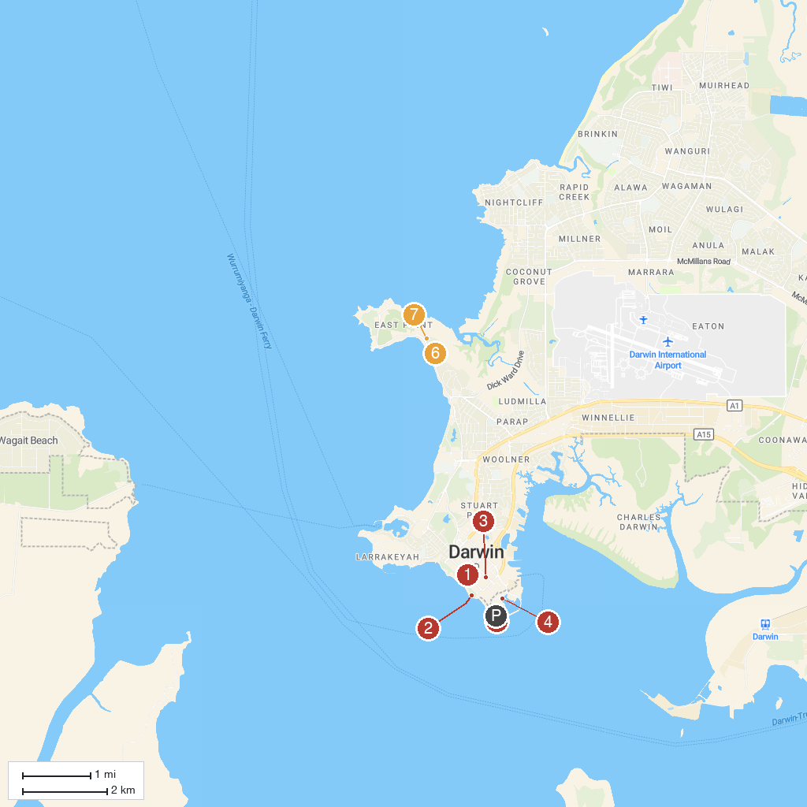
MAP KEY
1. Crocosaurus Cove | 5. Fort Hill Wharf
2. Darwin Cenotaph War Memorial | 6. Lake Alexander
3. Mason Gallery | 7. Mangrove Boardwalk
4. Darwin Waterfront Precinct | 8. Holmes Jungle Nature Park
P. Cruise port / terminal
Map © MapTiler © OpenStreetMap contributors · cruiseports.org

