Děčín, Ústí nad Labem Region, Czech Republic
Tucked into a deep sandstone gorge where the Elbe meets the Ploučnice, Děčín is the Czech Republic's gateway to Europe's most dramatic river canyon — with a baroque castle perched above it all.
⚓ Docked (river pier) · 🕒 Typical call: 8–10 hrs · 💵 Czech Koruna (CZK) · 🗣️ Czech, German spoken
✍️ MY DAY IN PORT (FILL IN)
Ship / Date
In port | arrive ______ · all aboard ______
Booked excursion
Notes / meeting point
GETTING ASHORE
- Docking: River pier near city center — no tender
- Walk to center: 5–10 min on foot
- Best For: Bohemian Switzerland hikes, castle history, sandstone scenery
- Don't Miss: Děčín Castle Long Drive & Pravčická Brána arch excursion
GETTING AROUND
- 🚕 Taxi: 100–200 CZK (~€4–8) — Taxis operate on a base fare of ~45 CZK plus ~28 CZK/km. A short ride to the city center typically costs 100–200 CZK dep
- 📱 Rideshare: ✅ Bolt
TOP THINGS TO DO
- Bohemian Switzerland & Pravčická Brána — A guided coach trip to Bohemian Switzerland National Park, culminating at Pravčická brána — Europe's largest natural sandstone…
- Děčín Castle & Rose Garden — Perched on a rocky promontory above the Elbe, the castle dates to the 10th century and was later rebuilt in baroque and…
- Kamenice River Gorge Boat Ride — Float through the narrow sandstone gorges of the Kamenice River on a flat-bottomed boat — one of Bohemian Switzerland's signature…
- Shepherd's Wall & Zoo Viewpoint — Cross the Elbe to Pastýřská stěna (Shepherd's Wall), a 160-metre sandstone cliff with panoramic views of Děčín and the Elbe gorge.
- Elbe Rafting to Schmilka — Self-guided rafting trip from Děčín downriver to the German village of Schmilka on the Saxon Switzerland border — a 15 km float…
BEST WALKS
- Embankment to Castle via the Long Drive: 2 km | Moderate (uphill) | 45–60 min — Walk from the river pier along the embankment, cross into the old town, and ascend the dramatic…
- Old Town Stroll: 1 km | Easy | 20–30 min — A flat circuit through the historic center taking in pastel facades, the Holy Rood Church, and the…
WEATHER · DAYLIGHT · MONEY
Month | High °F | Low °F | Rainy days
May | 66 | 48 | 12
Jul | 77 | 60 | 12
Sep | 69 | 53 | 11
Daylight: May 5:14AM–8:45PM · Jul 5:07AM–9:10PM · Sep 6:38AM–7:16PM
cruiseports.org/decin · Confirm terminal & all-aboard time with your ship

Děčín, Ústí nad Labem Region, Czech Republic — Port Map
Red = walkable sights · Amber = excursions farther out · P = cruise terminal
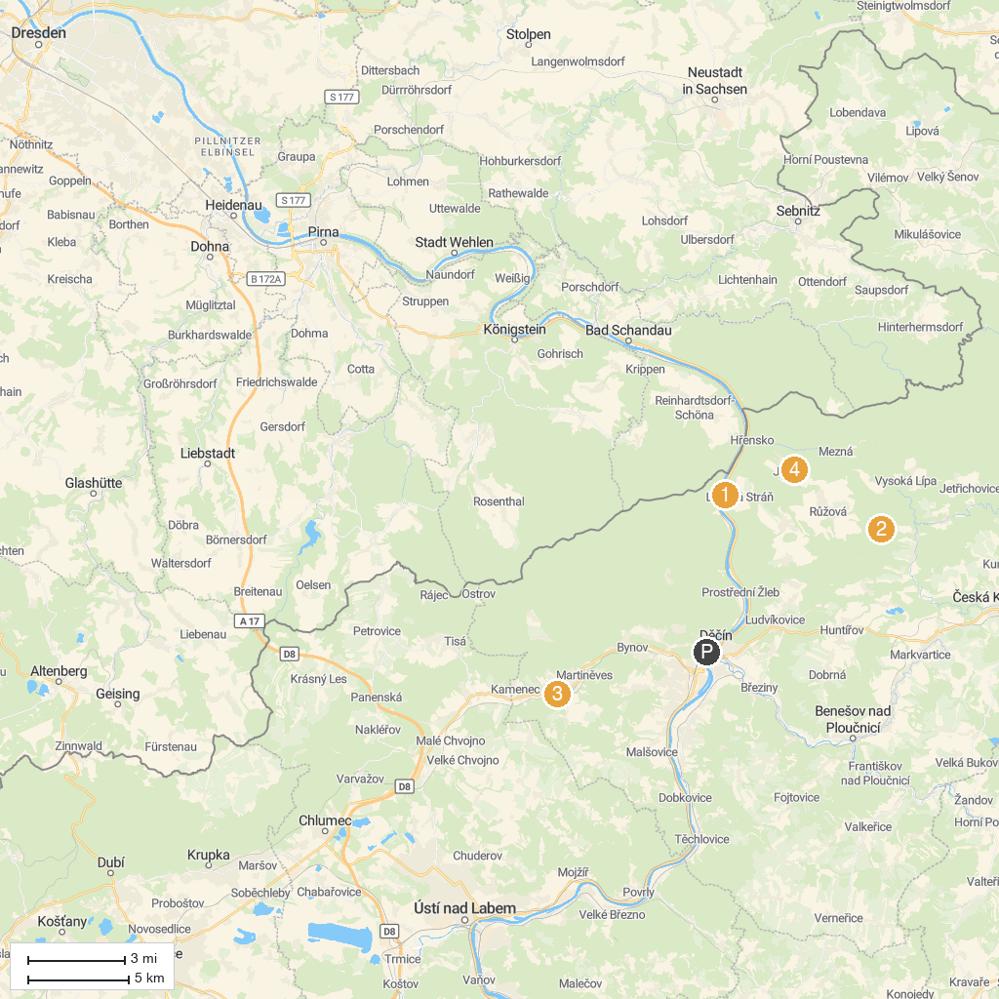
MAP KEY
1. Belvedere Viewpoint | 5. Rozhledna Strážný vrch u Merboltic
2. Šaunštejn / Schauenstein Castle | 6. Jílovský zámek
3. Malá Pravčická brána | 7. Janov Observation Tower
4. Rose Hill / Růžovský vrch | 8. Lynx' Path / Gabriela's Trail
P. Cruise port / terminal
Map © MapTiler © OpenStreetMap contributors · cruiseports.org

