Delos Island, Cyclades, Greece
The birthplace of Apollo and Artemis, Delos is an entire ancient city frozen in time — no hotels, no restaurants, no permanent residents. Just 2,000-year-old marble under an Aegean sky.
⚓ Tender via Mykonos ferry · 🕒 Typical call: 6-8 hrs (Mykonos port day) · 💶 Euro (EUR) · 🗣️ Greek / English widely spoken · 🏛️ UNESCO World Heritage Site
✍️ MY DAY IN PORT (FILL IN)
Ship / Date
In port | arrive ______ · all aboard ______
Booked excursion
Notes / meeting point
GETTING ASHORE
- Docking: No ships call directly — ferry from Mykonos Old Port (~30 min)
- Walk to Site: Immediate from Delos jetty; ruins begin at the pier
- Best For: Ancient history, archaeology, photography
- Don't Miss: Terrace of the Lions, House of Dionysus mosaics, Delos Museum
GETTING AROUND
- 🚕 Taxi: ~€2/person — If your cruise docks at Mykonos New Port (Tourlos), a SeaBus water taxi takes ~10 minutes to Mykonos harbor where Delos
- 📱 Rideshare: ❌ not available
TOP THINGS TO DO
- Delos Archaeological Site — Wander one of the best-preserved ancient cities in the Mediterranean — the Sacred Way, Sanctuary of Apollo, agora, theatre, and…
- Terrace of the Lions — Five archaic marble lions (originally around 12–16, dedicated by the Naxians ~600 BC) line the Sacred Way facing the Sacred Lake…
- Delos Archaeological Museum — On-site museum housing original mosaics, statues, pottery, and the original Lion replicas removed for preservation.
- Mykonos + Delos Combo Tour — The most popular ship excursion format: morning in Mykonos Town, ferry to Delos with a guide, return by mid-afternoon.
BEST WALKS
- Sacred Way & Lion Circuit: 2–3 km | 2–3 hrs | Moderate — From the ferry jetty, follow the Sacred Way past the Sanctuary of Apollo, through the agora, up to…
WEATHER · DAYLIGHT · MONEY
Month | High °F | Low °F | Rainy days
May | 76 | 58 | 12
Jul | 89 | 71 | 11
Sep | 80 | 64 | 10
Daylight: May 6:10AM–8:20PM · Jul 6:10AM–8:39PM · Sep 7:01AM–7:26PM
Representative sunrise/sunset — 2025, 15th of each month; local civil time including DST (Europe/Athens). Source: Astral; not a forecast or climate average.
cruiseports.org/delos-island · Confirm terminal & all-aboard time with your ship

Delos Island, Cyclades, Greece — Port Map
Red = walkable sights · Amber = excursions farther out · P = cruise terminal
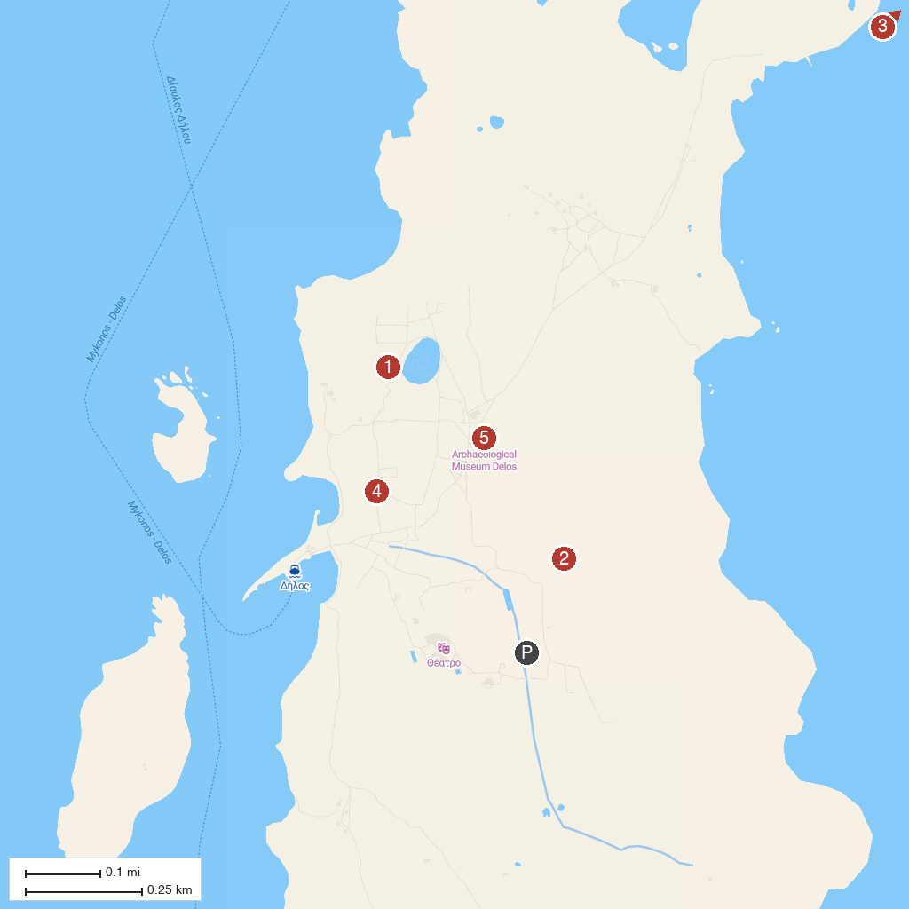
MAP KEY
1. Terrace of the Lions, Delos | 4. Mount Kynthos, Delos
2. Sanctuary of Apollo, Delos | 5. Delos Archaeological Museum
3. House of the Dolphins, Delos
P. Cruise port / terminal
Map © MapTiler © OpenStreetMap contributors · cruiseports.org

