Dendera (Qena), Upper Egypt, Egypt
Ships dock at Qena on the Nile, then a short bus transfer lands you at the Temple of Hathor — one of ancient Egypt's most intact and colorful temple complexes. Vivid 2,000-year-old paint still blazes across the ceilings.
⚓ Docked at Qena pier · 🕒 Typical call: 4–6 hrs · 💵 Egyptian Pound (EGP) · 🗣️ Arabic · 🌡️ Hot & dry — shade scarce
✍️ MY DAY IN PORT (FILL IN)
Ship / Date
In port | arrive ______ · all aboard ______
Booked excursion
Notes / meeting point
GETTING ASHORE
- Docking: Docked at Qena — bus transfer to Dendera (~5 km)
- Temple entry: ~140 EGP (~$3 USD) adults; students ~70 EGP
- Best For: Ancient temples, hieroglyphics, original painted ceilings
- Don't Miss: Astronomical ceiling, rooftop chapels, underground crypts
GETTING AROUND
- 🚕 Taxi: $5–$15 USD — Negotiated taxis wait near the dock to take passengers the ~5 km to Dendera Temple. Always agree on the fare before depa
TOP THINGS TO DO
- Temple of Hathor, Dendera — The headline attraction: a Ptolemaic-era temple dedicated to Hathor, goddess of love and music.
- Dendera & Abydos Combined Day — Pair Dendera with the Temple of Seti I at Abydos (~90 km north) — one of Egypt's holiest sites featuring the famous King List and…
- Qena Local Market Walk — If time allows after the temple, Qena's street market near the corniche offers spices, pottery, and local produce.
- Hathor Temple Roof at Sunrise — For passengers on early-docking itineraries, reaching the rooftop chapels in morning light reveals spectacular Nile Valley…
BEST WALKS
- Dendera Temple Complex Loop: ~1 km inside complex | Easy | 1.5–2.5 hrs — Enter the main pylon, cross the courtyard to the Great Hypostyle Hall, work through the inner…
WEATHER · DAYLIGHT · MONEY
Month | High °F | Low °F | Rainy days
May | 74 | 56 | 10
Jul | 90 | 69 | 4
Sep | 82 | 63 | 9
Daylight: May 5:24AM–7:52PM · Jul 5:23AM–8:11PM · Sep 6:22AM–6:50PM
cruiseports.org/dendera-qena · Confirm terminal & all-aboard time with your ship

Dendera (Qena), Upper Egypt, Egypt — Port Map
Red = walkable sights · Amber = excursions farther out · P = cruise terminal
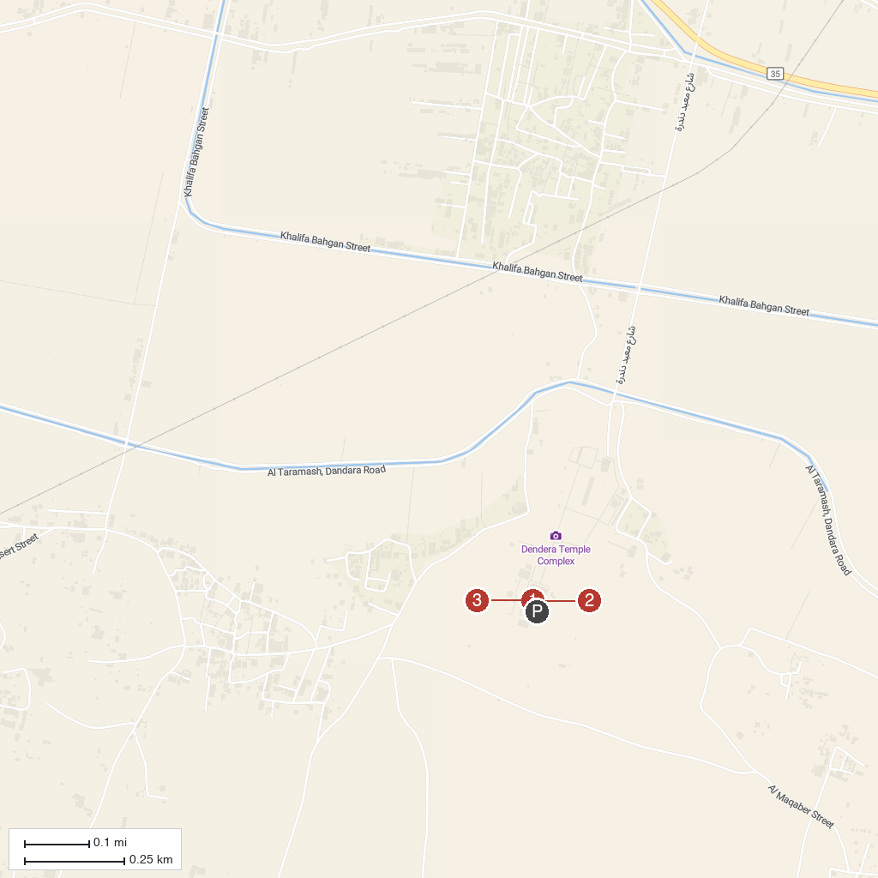
MAP KEY
1. Temple of Hathor, Dendera | 3. Sacred Lake, Dendera Temple Complex
2. Dendera Zodiac Ceiling Chamber
P. Cruise port / terminal
Map © MapTiler © OpenStreetMap contributors · cruiseports.org

