Dénia, Alicante, Spain
A boutique Costa Blanca gem dominated by a Moorish hilltop castle, backed by the dramatic Montgó mountain, and celebrated worldwide for its extraordinary red shrimp and UNESCO-recognised gastronomy.
⚓ Tender port (no pier) · 🕒 Typical call: 6–8 hrs · 💶 Euro (€) · 🗣️ Spanish / Valenciano · 🍤 UNESCO Gastronomy City
✍️ MY DAY IN PORT (FILL IN)
Ship / Date
In port | arrive ______ · all aboard ______
Booked excursion
Notes / meeting point
GETTING ASHORE
- Docking: Tender — ships anchor in the bay; tenders land at the Maritime Station or Marina de Dénia
- Walk to center: ~15 min flat walk (1 km) from the tender landing to Marqués de Campo
- Best For: Foodies, history lovers, beach-goers, and those seeking an authentic Spanish town
- Don't Miss: Gamba Roja de Dénia (red shrimp) — expensive but a genuine bucket-list bite
GETTING AROUND
- 🚕 Taxi: €6–8 — Taxis are available at the port and take about 6–8 minutes to the city center. Fixed meter rates apply.
- 📱 Rideshare: ✅ Uber
TOP THINGS TO DO
- Castell de Dénia & Archaeological Museum — The 11th-century Moorish castle sits on a rocky promontory above the old town with 360° views of the sea and Montgó mountain.
- Les Rotes Marine Reserve Coves — The rocky southern coastline forms part of a protected marine reserve with crystal-clear snorkelling waters.
- Gamba Roja & Gastronomy Tour — Dénia is a UNESCO Creative City of Gastronomy, world-famous for its sweet Gamba Roja (red shrimp).
- Les Marines Sandy Beach — A wide stretch of golden sand running north from the town centre, with shallow warm water, beach bars (chiringuitos), and sunbed…
- Montgó Natural Park Hike — The dramatic limestone massif looming over Dénia offers marked trails through Mediterranean scrubland.
BEST WALKS
- Port to Castle Loop: 2–3 km · 1.5–2 hrs · Easy with one uphill stretch — Walk from the tender landing through the Baix la Mar fisherman's quarter, up through the Les Roques…
- Waterfront to Les Marines Beach: 2.5 km one-way · 30 min · Easy and flat — Head north from the tender landing along the seafront promenade past the fishing harbour to Playa…
WEATHER · DAYLIGHT · MONEY
Month | High °F | Low °F | Rainy days
May | 73 | 60 | 4
Jul | 86 | 73 | 2
Sep | 81 | 70 | 9
Daylight: May 6:47AM–9:05PM · Jul 6:47AM–9:23PM · Sep 7:41AM–8:07PM
cruiseports.org/denia · Confirm terminal & all-aboard time with your ship

Dénia, Alicante, Spain — Port Map
Red = walkable sights · Amber = excursions farther out · P = cruise terminal
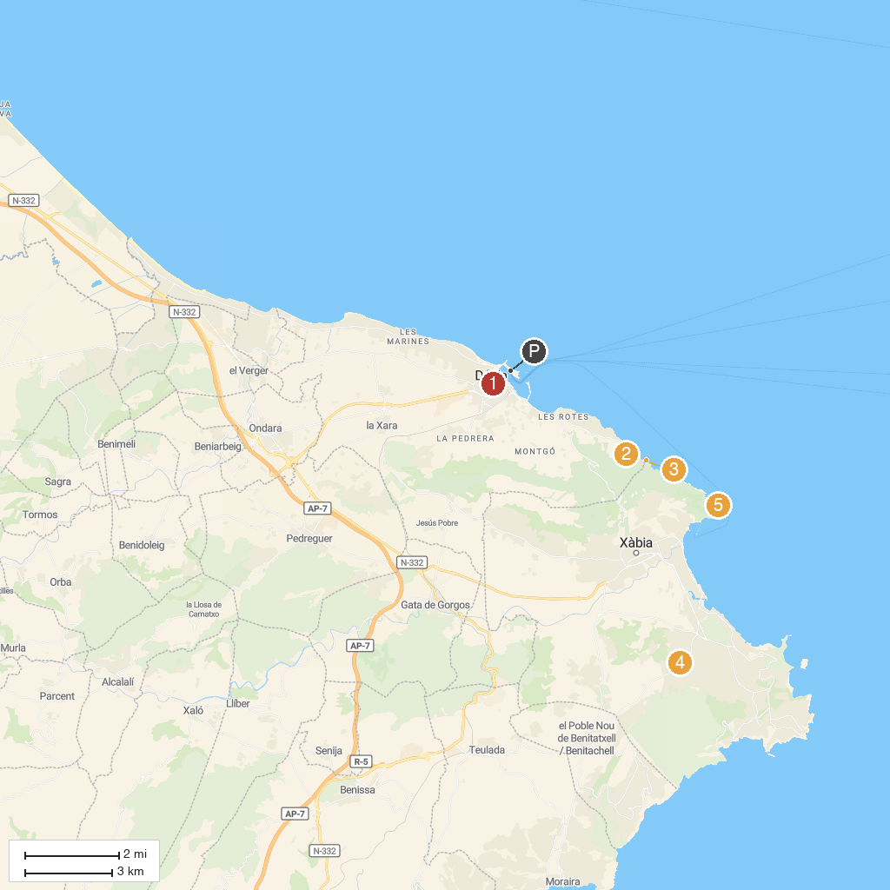
MAP KEY
1. Parròquial de Santa Caterina Màrtir | 5. Parque Pinosol
2. Túnel del Castell | 6. Cova de les Calaveres
3. Torre del Gerro | 7. Cape San Antonio, Spain
4. Cova Tallada
P. Cruise port / terminal
Map © MapTiler © OpenStreetMap contributors · cruiseports.org

