Detroit, Michigan, USA
The Motor City reinvented: Detroit docks you steps from the acclaimed Riverwalk, soaring Art Deco towers, and the recording studios that gave the world Motown. Great Lakes cruising at its most urban and walkable.
⚓ Pier — docked at Detroit Cruise Terminal · 🕒 Typical call: 8–10 hrs · 💵 USD · 🗣️ English · 🎵 UNESCO City of Design
✍️ MY DAY IN PORT (FILL IN)
Ship / Date
In port | arrive ______ · all aboard ______
Booked excursion
Notes / meeting point
GETTING ASHORE
- Docking: Pier — Detroit Cruise Terminal, 130 E. Atwater St., riverfront downtown
- Walk to center: 2 min to Renaissance Center; 12 min to Campus Martius
- Best For: Architecture, music history, Riverwalk, unique American food
- Don't Miss: Guardian Building lobby, Motown Museum, a Coney Dog rivalry lunch
GETTING AROUND
- 🚕 Taxi: $10–$15 — Checker Transportation and local cabs serve the waterfront area. Flat downtown-to-downtown rate of ~$10 is common; meter
- 📱 Rideshare: ✅ Uber, Lyft
TOP THINGS TO DO
- The Henry Ford Museum & Greenfield Village — Rosa Parks' bus, Lincoln's chair from Ford's Theatre, Edison's actual Menlo Park lab — this massive complex in Dearborn is one of…
- Motown Museum — Hitsville U.S.A. — Stand in Studio A where Stevie Wonder, The Supremes, Marvin Gaye, and the Jackson 5 cut their hits.
- Art Deco Downtown Walk — Detroit has some of the finest Art Deco architecture in North America.
- Detroit Institute of Arts (DIA) — One of the top art museums in the US.
- Coney Dog Rivalry & Detroit Pizza — Detroit has two iconic foods: the Coney Dog (beanless chili, mustard, onions) from Lafayette or American Coney Island…
BEST WALKS
- Riverwalk & Hart Plaza: 1.5 miles · easy · 30–45 min one way — Head west from the cruise terminal along the Detroit Riverwalk past Hart Plaza — site of the iconic…
- Financial District Art Deco Loop: 1.5 miles · easy · 1–1.5 hrs — Walk north from the Renaissance Center to the Guardian Building — enter the free lobby and spend 15…
WEATHER · DAYLIGHT · MONEY
Month | High °F | Low °F | Rainy days
May | 68 | 51 | 12
Jul | 82 | 66 | 11
Sep | 74 | 59 | 10
Daylight: May 6:10AM–8:46PM · Jul 6:09AM–9:06PM · Sep 7:12AM–7:41PM
cruiseports.org/detroit-mi · Confirm terminal & all-aboard time with your ship

Detroit, Michigan, USA — Port Map
Red = walkable sights · Amber = excursions farther out · P = cruise terminal
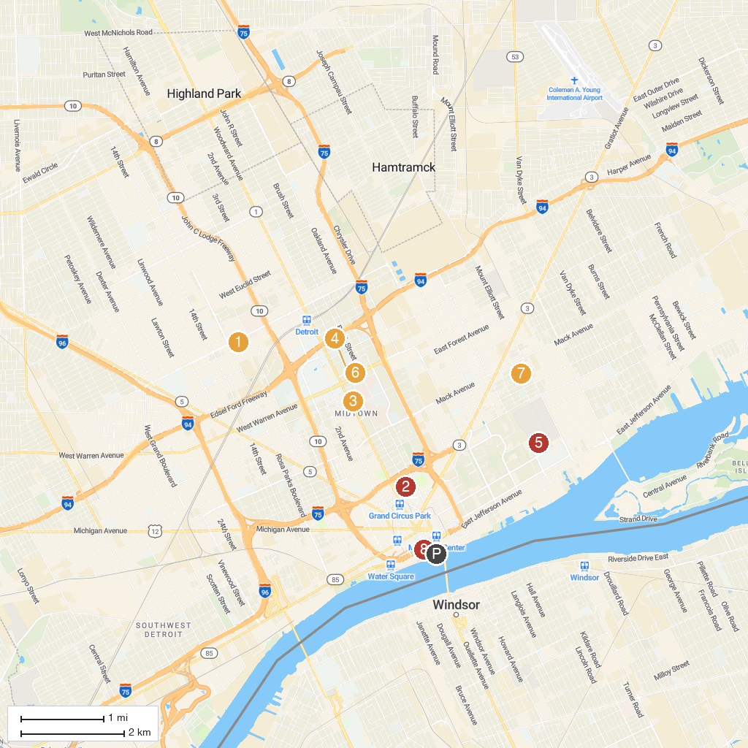
MAP KEY
1. Motown Museum | 5. Elmwood Cemetery
2. Comerica Park | 6. Charles H. Wright Museum of African American History
3. Museum of Contemporary Art Detroit | 7. The Heidelberg Project
4. Michigan Science Center | 8. Hart Plaza
P. Cruise port / terminal
Map © MapTiler © OpenStreetMap contributors · cruiseports.org

