Dijon, Burgundy, France
The medieval capital of the Dukes of Burgundy, Dijon rewards cruise visitors with a perfectly walkable historic centre, cobblestone squares alive with café culture, and some of the most celebrated food and wine in France.
⚓ River barge dock / coach excursion · 🕒 Typical call: 6-8 hrs · 💶 Currency: Euro (€) · 🗣️ Language: French · 🍷 Burgundy wine country
✍️ MY DAY IN PORT (FILL IN)
Ship / Date
In port | arrive ______ · all aboard ______
Booked excursion
Notes / meeting point
GETTING ASHORE
- Docking: Barges: Port du Canal (1.5 km to centre). River ships: motorcoach from Chalon-sur-Saône (~60 min).
- Walk to Centre: 15–20 min flat walk or Tram T2 from Port du Canal; coach passengers drop at Place Darcy.
- Best For: History, Burgundy wine, French gastronomy, Gothic architecture
- Don't Miss: Rub the Owl (La Chouette) on Notre-Dame de Dijon with your left hand for good luck.
GETTING AROUND
- 🚕 Taxi: €8–15 — Taxis from Port du Canal to the city center. Base fare €2.30 plus ~€1.80/km daytime. Call Taxis Dijonnais (+33 3 80 41 4
- 📱 Rideshare: ✅ Uber, Bolt
TOP THINGS TO DO
- Palace of the Dukes & Free Beaux-Arts Museum — The centrepiece of Dijon is the Palace of the Dukes of Burgundy, whose wing houses the Musée des Beaux-Arts — one of France's…
- Burgundy Gastronomy & Mustard Trail — Dijon is the culinary capital of France's most food-obsessed region.
- Cité Internationale de la Gastronomie et du Vin — Opened in 2022 in a spectacular restored historic hospital complex, this massive venue celebrates French gastronomy and Burgundy…
- Côte de Nuits & Côte de Beaune Wine Country — Drive south through the UNESCO-listed Burgundy vineyard slopes — the most celebrated wine geography on Earth.
- Owl Trail Self-Guided Walk (Parcours de la Chouette) — Follow 22 brass owl plaques embedded in the cobblestones through Dijon's entire historic centre.
BEST WALKS
- Historic Heart: Owl Trail Highlights: 2.5 km · 45–60 min · Easy · Cobblestones — The classic Dijon loop.
- Canal & Gastronomy Quarter: 2 km · 30–40 min · Easy · Flat — For barge passengers arriving at Port du Canal, this walk follows the canal towpath northeast into…
WEATHER · DAYLIGHT · MONEY
Month | High °F | Low °F | Rainy days
May | 66 | 49 | 11
Jul | 79 | 61 | 9
Sep | 72 | 55 | 8
Daylight: May 6:03AM–9:09PM · Jul 5:59AM–9:32PM · Sep 7:17AM–7:51PM
cruiseports.org/dijon · Confirm terminal & all-aboard time with your ship

Dijon, Burgundy, France — Port Map
Red = walkable sights · Amber = excursions farther out · P = cruise terminal
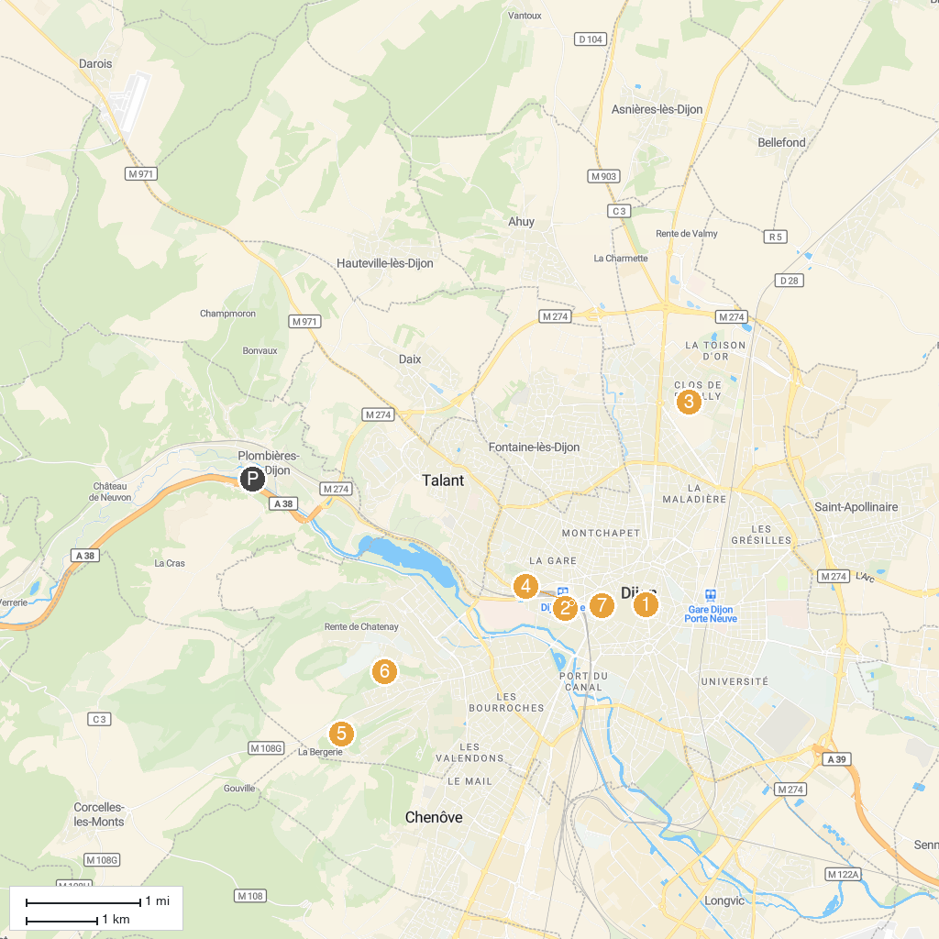
MAP KEY
1. Museum of Fine Arts Dijon | 5. Parc de la Combe Saint-Joseph
2. Jardin Botanique de l'Arquebuse | 6. Parc de la Combe Persil
3. Pouilly Castle Park | 7. Cathédrale Saint-Bénigne de Dijon
4. Natural History Museum | 8. PARC EVASION - Parc loisirs Chevigny
P. Cruise port / terminal
Map © MapTiler © OpenStreetMap contributors · cruiseports.org

