Dikili, Aegean, Turkey
A tranquil Aegean town that punches above its weight — doorstep access to a UNESCO World Heritage acropolis, crystalline Blue Flag beaches, and geothermal springs bubbling into the sea.
⚓ Pier (small ships dock; large ships may tender) · 🕒 Typical call: 7–9 hrs · 💵 Turkish Lira (TRY); EUR/USD accepted at taxis · 🗣️ Turkish; limited English in town
✍️ MY DAY IN PORT (FILL IN)
Ship / Date
In port | arrive ______ · all aboard ______
Booked excursion
Notes / meeting point
GETTING ASHORE
- Docking: Pier for small-medium ships; larger vessels anchor and tender to the harbor
- Walk to center: 5 min flat stroll along the promenade (Kordon)
- Best For: Ancient ruins (Pergamon), beach days, authentic Turkish town life
- Don't Miss: Pergamon Acropolis cable car & the Tuesday weekly market
GETTING AROUND
- 🚕 Taxi: Low (short distance) — Taxis (including Styl Taxi and Mert) are available at the port. Fares for the short hop to town are minimal; agree on pr
TOP THINGS TO DO
- Pergamon Acropolis & Asclepion — One of antiquity's great cities — the Acropolis clings to a dramatic hilltop with the world's steepest ancient theater, while the…
- Killik Bay & Thermal Mud Baths — Drive south to Bademli's Killik Bay — often called the 'Maldives of the Aegean' for its turquoise water and distinctive golden…
- Çandarlı Castle — A beautifully preserved Genoese fortress perched over the sea in the coastal town of Çandarlı.
- Dikili Tuesday Market — If your ship calls on Tuesday, walk straight to the weekly pazar.
- Dikili Blue Flag Beach — A long sandy public beach just north of the pier, awarded Blue Flag status for its clean water.
BEST WALKS
- Kordon Promenade Stroll: 1.5 km · Flat · 20 min — Walk the seafront Kordon from the pier north past fish restaurants, tea gardens, and the public…
- Town Center & Mosque: 2 km · Flat · 30 min — Head inland from the promenade to Dikili's central square and the Merkez Camii mosque.
WEATHER · DAYLIGHT · MONEY
Month | High °F | Low °F | Rainy days
May | 76 | 59 | 6
Jul | 92 | 72 | 1
Sep | 84 | 67 | 3
Daylight: May 5:59AM–8:18PM · Jul 5:59AM–8:37PM · Sep 6:54AM–7:20PM
cruiseports.org/dikili · Confirm terminal & all-aboard time with your ship

Dikili, Aegean, Turkey — Port Map
Red = walkable sights · Amber = excursions farther out · P = cruise terminal
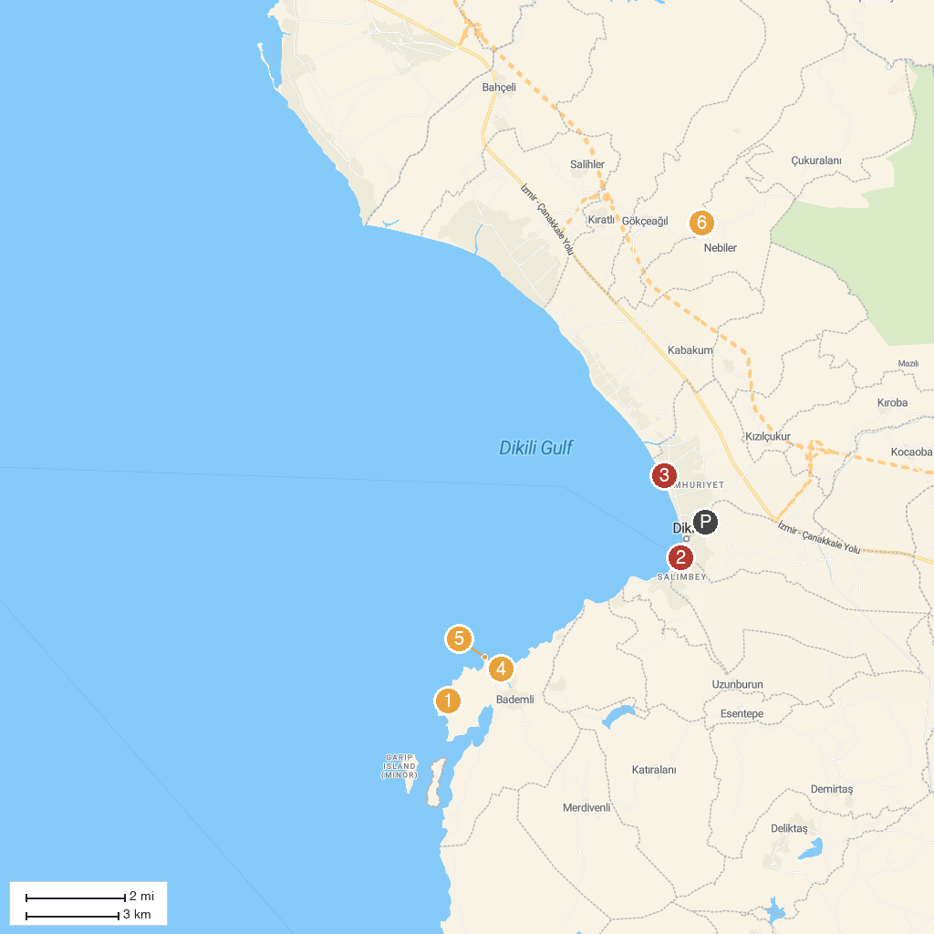
MAP KEY
1. Fame Beach | 4. Bademli Halk Plajı
2. Dikili Tekne Turu Yasmin Tur | 5. Kane Antik Kenti
3. Kleos Beach | 6. Aşıklar Şelalesi
P. Cruise port / terminal
Map © MapTiler © OpenStreetMap contributors · cruiseports.org

