Diu Island, Gujarat, India
A former Portuguese enclave off the Gujarat coast, Diu is India's 'Island of Calm' — whitewashed colonial streets, an imposing 16th-century sea fort, and quiet beaches — including Blue Flag–certified Ghoghla — without the crowds.
⚓ Tender port · 🕒 Typical call: 6–8 hrs · 💵 Indian Rupee (INR) — carry cash · 🗣️ Gujarati / Hindi / some English · 🍺 Alcohol legal (unlike mainland Gujarat)
✍️ MY DAY IN PORT (FILL IN)
Ship / Date
In port | arrive ______ · all aboard ______
Booked excursion
Notes / meeting point
GETTING ASHORE
- Docking: Tender to Diu Bunder Jetty (no cruise pier)
- Walk to center: Diu Fort 10 min, town center 15 min
- Best For: Colonial history, relaxed beaches, Portuguese architecture
- Don't Miss: Naida Caves light show, Diu Fort sea cannons, Gangeshwar Temple at high tide
GETTING AROUND
- 🚕 Taxi: ₹200–₹600 (~$2–$7 USD) — Taxis are available at the docking area and around town, metered at roughly ₹13–₹14/km. Confirm the fare with the driver
- 📱 Rideshare: ❌ not available
TOP THINGS TO DO
- Diu Fort & Old Town Walk — The Portuguese-built Diu Fort (1535) dominates the eastern tip of the island, surrounded by water on three sides.
- Naida Caves — Just outside the city wall, this labyrinthine network of rock cavities was quarried by the Portuguese for building stone.
- St. Paul's Church & Diu Museum — St.
- Nagoa Beach & Hoka Trees — Diu's most famous horseshoe-shaped beach is lined with the rare Hoka tree (brought from Africa by Portuguese sailors) and is safe…
- Gangeshwar Mahadev Temple — Five ancient Shiva Lingas are carved into coastal rocks at the shoreline.
BEST WALKS
- Fort to Old Town Heritage Walk: 1.5 km · 30 min · Easy — From the Bunder Jetty, walk east along the waterfront to Diu Fort, then loop back west through the…
- Naida Caves Stroll: Short drive + 20 min on foot · Easy — Tuk-tuk to the Naida Caves parking area (5 min from jetty), then walk the loop through the cave…
WEATHER · DAYLIGHT · MONEY
Month | High °F | Low °F | Rainy days
May | 94 | 79 | 1
Jul | 85 | 79 | 27
Sep | 85 | 77 | 14
Daylight: May 6:09AM–7:15PM · Jul 6:14AM–7:29PM · Sep 6:33AM–6:48PM
cruiseports.org/diu-island · Confirm terminal & all-aboard time with your ship

Diu Island, Gujarat, India — Port Map
Red = walkable sights · Amber = excursions farther out · P = cruise terminal
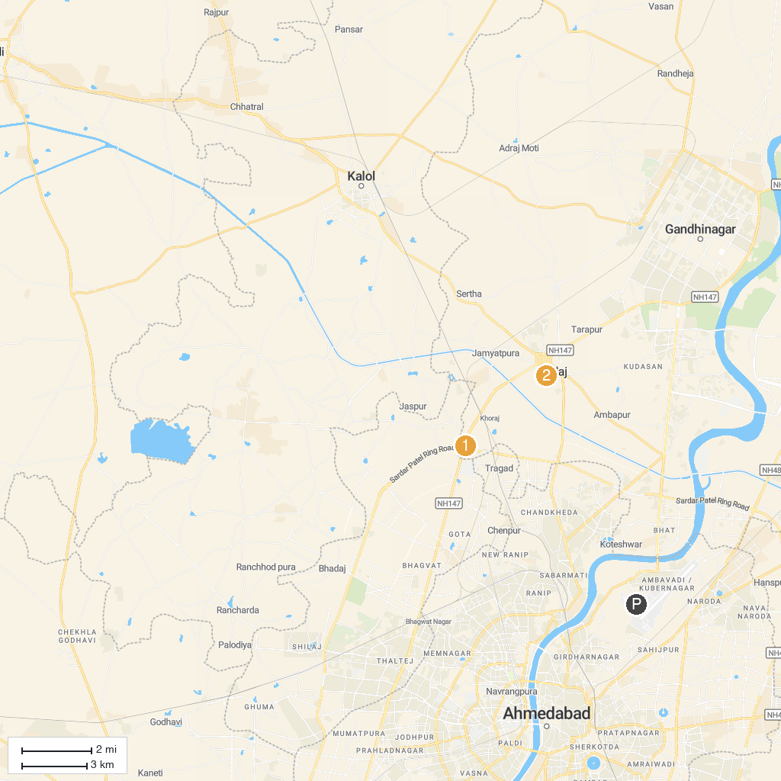
MAP KEY
1. Shri Maa Vaishnodevi Temple, Ahmedabad | 5. The Adalaj Stepwell
2. GEER Foundation - Haran Udhyan | 6. Indroda Zoo
3. Deer Park | 7. Sarita Udhyan
4. Dandi Kutir (Salt Mount) Museum | 8. Gandhinagar Riverfront
P. Cruise port / terminal
Map © MapTiler © OpenStreetMap contributors · cruiseports.org

