Dole, Jura, France
Where Louis Pasteur was born and canal life still defines the rhythm of a town that provincial France somehow kept to itself — cobblestone alleys, stone bridges, and Vin Jaune on the terrace.
⚓ Docked (canal quay) · 🕒 Typical call: 6-8 hrs · 💶 Currency: Euro (€) · 🗣️ Language: French · 🚶 Walkable old town
✍️ MY DAY IN PORT (FILL IN)
Ship / Date
In port | arrive ______ · all aboard ______
Booked excursion
Notes / meeting point
GETTING ASHORE
- Docking: Moored along canal quay — no tender. Steps from the old quarter.
- Walk to center: Tanners' Quarter: 1 min. Notre-Dame Collegiate: 8-10 min (uphill).
- Best For: History, French gastronomy, Jura wine, leisurely canal walks.
- Don't Miss: Maison Natale de Louis Pasteur and the Quartier des Tanneurs.
GETTING AROUND
- 🚕 Taxi: ~€8–12 — Taxis are available in Dole with a base fare of €8 (covers first 2.4 km). Given the port's proximity to town, most rides
TOP THINGS TO DO
- Maison Natale de Louis Pasteur — The birthplace of the father of microbiology and inventor of pasteurization and the rabies vaccine.
- Old Town & Circuit du Chat Perché — Follow the bronze cat-paw trail through Dole's 16th-century stone alleyways, hidden courtyards, the grand Collégiale Notre-Dame…
- Jura Wine & Cheese Tasting — Sample Comté, Morbier, and the singular Vin Jaune — a nutty oxidative white aged under a yeast film — at local cave shops and…
- Day Trip to Beaune — Burgundy's wine capital is roughly 45 minutes by road.
- Doubs River & Canal Walk — Stroll or rent a bike along the canal towpaths where the Doubs River and the Canal du Rhône au Rhin meet.
BEST WALKS
- Canal Quay to Notre-Dame via the Tanners' Quarter: 1.2 km · 20-25 min · Easy to moderate (cobbles, gentle uphill) — From the canal mooring, walk through the romantic Quartier des Tanneurs with its low-roofed stone…
- Canal & Jardin des Chevannes Loop: 1.5 km · 25-30 min · Easy — Head along the canal bank south-west toward the Jardin des Chevannes for a quiet riverside park…
WEATHER · DAYLIGHT · MONEY
Month | High °F | Low °F | Rainy days
May | 67 | 50 | 14
Jul | 80 | 61 | 11
Sep | 72 | 55 | 10
Daylight: May 6:02AM–9:07PM · Jul 5:58AM–9:29PM · Sep 7:16AM–7:49PM
cruiseports.org/dole-jura · Confirm terminal & all-aboard time with your ship

Dole, Jura, France — Port Map
Red = walkable sights · Amber = excursions farther out · P = cruise terminal
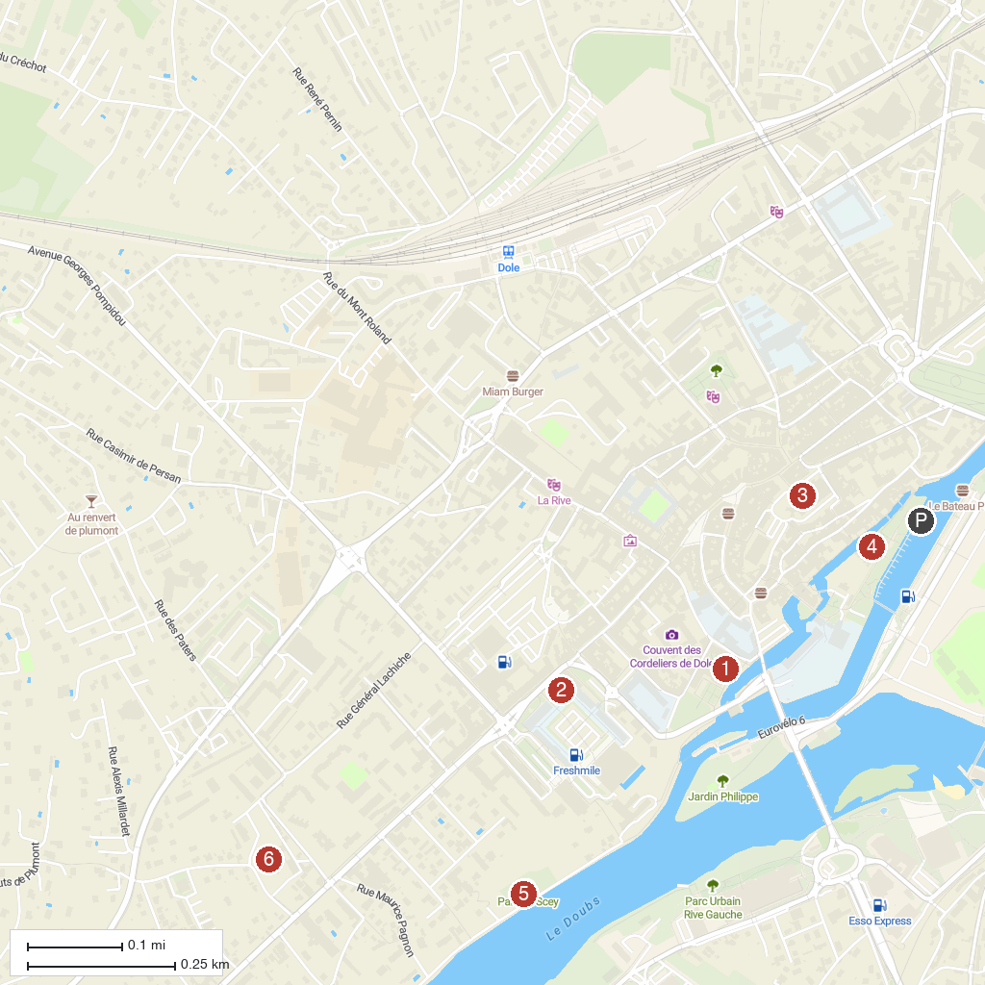
MAP KEY
1. Dole Hôtel-Dieu Public Library | 5. Chevannes Garden
2. Auxonne Castle | 6. Parc de Scey
3. Museum of Fine Arts, Dole | 7. Église Saint-Jean-l'Évangéliste
4. Collégiale Notre-Dame de Dole
P. Cruise port / terminal
Map © MapTiler © OpenStreetMap contributors · cruiseports.org

