Dover, Kent, England
England's gateway port, perched beneath the famous White Cliffs — a walk-off terminal just minutes from a 2,000-year-old fortress and a short train ride from London.
⚓ Docked — Western Docks cruise terminals · 🕒 Typical call: 8–12 hrs (often homeport turnaround) · 💷 British Pounds (GBP) · cards accepted widely · 🗣️ English
✍️ MY DAY IN PORT (FILL IN)
Ship / Date
In port | arrive ______ · all aboard ______
Booked excursion
Notes / meeting point
GETTING ASHORE
- Docking: Western Docks (Cruise Terminal 1 & 2)
- To town center: 10–15 min walk
- Best For: History · Day trips · London access
- Don't Miss: White Cliffs · Dover Castle
GETTING AROUND
- 🚕 Taxi: ~£10 to town/station — Local taxis are available at the terminal. The ride to Dover Priory train station or town center is short (about 1.5 mil
- 📱 Rideshare: ✅ Uber
- 🚌 Hop-on hop-off: ✅ YMS Travel (Blue Bus)
TOP THINGS TO DO
- White Cliffs of Dover Walk — The most famous coastline in England — chalk cliffs towering 100 metres above the Channel, managed by the National Trust.
- Dover Castle — One of the most impressive medieval castles in England, with origins stretching back to the Iron Age and Roman lighthouse.
- Canterbury Cathedral & Old City — A UNESCO World Heritage Site just 30 minutes by train — the spiritual home of the Church of England, with a medieval cathedral…
- London Day Trip — The greatest city in the world is 90 minutes by high-speed train from Dover Priory.
- Leeds Castle & Kent Countryside — Called 'the loveliest castle in the world,' Leeds Castle sits on two islands in a lake amid parkland.
BEST WALKS
- Terminal to White Cliffs Viewpoint: ~4 km · 2 hrs · moderate — Walk along the seafront from the cruise terminal past Dover town center, up to the National Trust…
- Dover Town & Castle Climb: ~3 km · 2 hrs · moderate (uphill to castle) — Walk from the terminal into Dover town center, browse the High Street, then climb Castle Hill Road…
WEATHER · DAYLIGHT · MONEY
Month | High °F | Low °F | Rainy days
May | 72 | 56 | 13
Jul | 86 | 71 | 14
Sep | 78 | 65 | 10
Daylight: May 5:04AM–8:38PM · Jul 4:57AM–9:03PM · Sep 6:30AM–7:08PM
Representative sunrise/sunset — 2025, 15th of each month; local civil time including DST (Europe/London). Source: Astral; not a forecast or climate average.
cruiseports.org/dover · Confirm terminal & all-aboard time with your ship

Dover, Kent, England — Port Map
Red = walkable sights · Amber = excursions farther out · P = cruise terminal
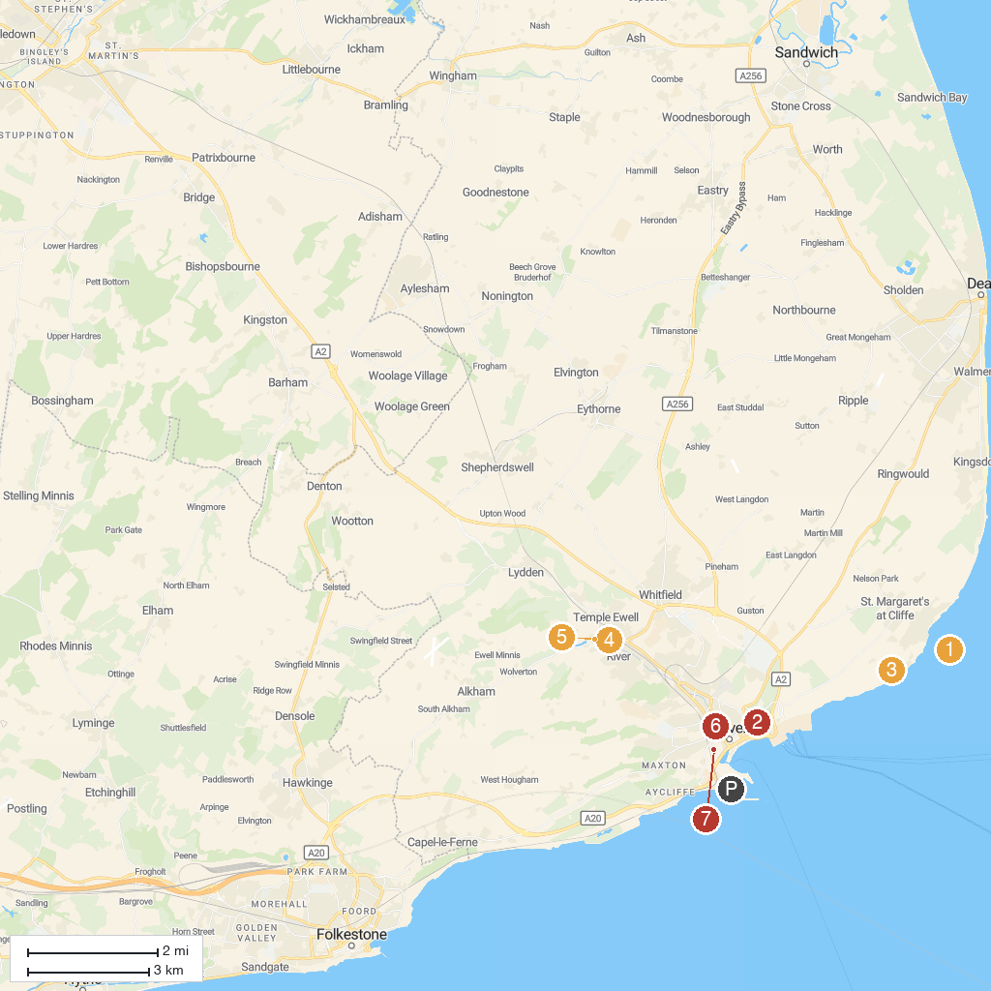
MAP KEY
1. South Foreland Heritage Coast | 5. Kearsney Abbey Gardens
2. Dover Castle | 6. Russell Gardens
3. Deans Oak Tree Fredville Park | 7. Maison Dieu
4. National Trust - South Foreland Lighthouse | 8. Western Heights Of Dover
P. Cruise port / terminal
Map © MapTiler © OpenStreetMap contributors · cruiseports.org

