Drobeta-Turnu Severin, Mehedinți, Romania
Gateway to the Iron Gates and site of Emperor Trajan's legendary Danube bridge, this unhurried Romanian city rewards curious cruisers with 2,000 years of history in a single walkable afternoon.
⚓ Pier (river pontoon) · 🕒 Typical call: 6-8 hrs · 💵 Romanian Leu (RON) · 🗣️ Romanian (some English)
✍️ MY DAY IN PORT (FILL IN)
Ship / Date
In port | arrive ______ · all aboard ______
Booked excursion
Notes / meeting point
GETTING ASHORE
- Docking: River pontoon pier — no tender required
- Walk to center: ~10-15 min uphill (800 m)
- Best For: Roman history, Danube scenery, unhurried culture
- Don't Miss: Trajan's Bridge pillar at the Iron Gates Museum
GETTING AROUND
- 🚕 Taxi: 10–20 RON (€2–4) — Local taxis are inexpensive by Western standards. A ride to the city center or Iron Gates Museum should cost under 20 RO
- 📱 Rideshare: ✅ Uber, Bolt
TOP THINGS TO DO
- Iron Gates Region Museum & Trajan's Bridge — The region's flagship museum holds Roman artifacts and coins, but the real draw is the outdoor archaeology park where you can…
- Medieval Fortress of Severin — A beautifully restored 13th-century fortress that defended the Danube crossing against Ottoman forces.
- Water Castle Panorama — The city's striking 1910 neo-Gothic water tower now serves as an exhibition space and observation point.
- Iron Gates Gorge Viewing — Drobeta sits at the eastern end of the Iron Gates (Cazanele Dunării), the Danube's deepest and most dramatic gorge.
- Danube Cuisine & Local Wine — Sample the region's Balkan-inflected Romanian cooking: mici (grilled sausages), ciorbă de pește (sour Danube fish soup), and…
BEST WALKS
- Roman Ruins to City Center Loop: 3–4 hrs | ~3 km | Easy–moderate (uphill start) — From the pier head east along the riverside path to the Iron Gates Museum and Trajan's Bridge…
WEATHER · DAYLIGHT · MONEY
Month | High °F | Low °F | Rainy days
May | 71 | 53 | 12
Jul | 84 | 65 | 6
Sep | 75 | 58 | 6
Daylight: May 6:01AM–8:50PM · Jul 5:58AM–9:11PM · Sep 7:08AM–7:39PM
cruiseports.org/drobeta-turnu-severin · Confirm terminal & all-aboard time with your ship

Drobeta-Turnu Severin, Mehedinți, Romania — Port Map
Red = walkable sights · Amber = excursions farther out · P = cruise terminal
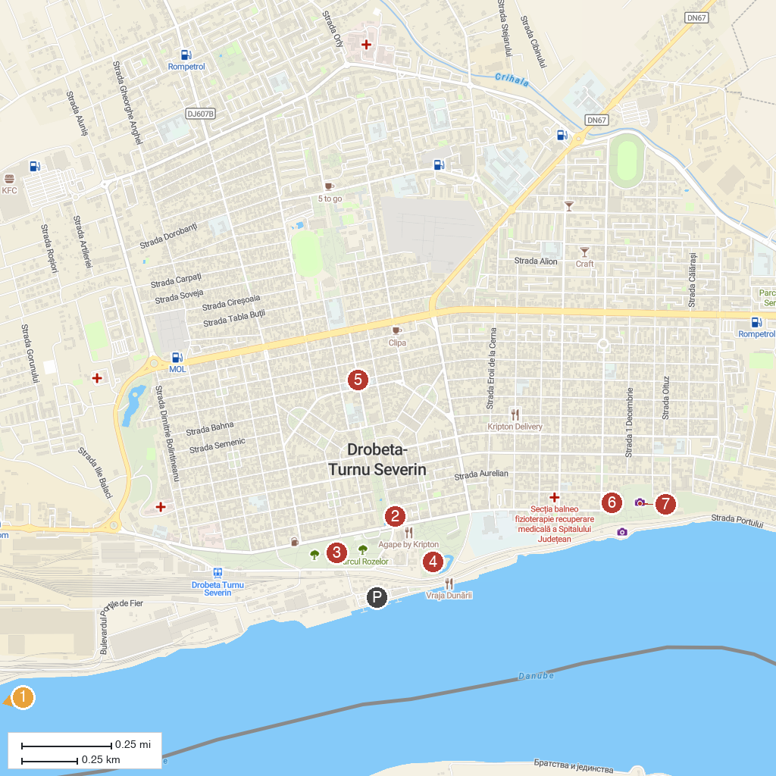
MAP KEY
1. Archeological Museum of Djerdap | 5. Water Castle
2. Fântâna Cinetică | 6. Muzeul Regiunii Porților de Fier
3. Parcul Rozelor | 7. The Castrum of Drobeta
4. Fortress of Severin
P. Cruise port / terminal
Map © MapTiler © OpenStreetMap contributors · cruiseports.org

