Duba, Tabuk, Saudi Arabia
A frontier port on the Red Sea's pristine northwest coast, Duba sits at the crossroads of ancient Midianite history and Saudi Arabia's $500 billion vision for the future — with untouched coral reefs just offshore.
⚓ Pier (docked — mandatory shuttle to town) · 🕒 Typical call: 8-10 hrs · 💵 Saudi Riyal (SAR) · cards widely accepted · 🗣️ Arabic · English understood in tourist areas · 👗 Modest dress required — shoulders & knees covered
✍️ MY DAY IN PORT (FILL IN)
Ship / Date
In port | arrive ______ · all aboard ______
Booked excursion
Notes / meeting point
GETTING ASHORE
- Docking: Pier-docked at secure commercial port; mandatory shuttle to Duba Corniche (~15–20 min)
- Walk to Center: Not walkable from port — shuttle required; Corniche & Old Town compact on foot
- Best For: Red Sea snorkeling, desert adventures, Saudi culture & cuisine
- Don't Miss: King Abdulaziz Castle overlook, fish market sayadiyah, Wadi Al-Disah canyon (guided excursion)
GETTING AROUND
- 🚕 Taxi: SAR 15–30 — Taxis are the most reliable option from the port into Duba town center. The city is compact and most rides are short; ag
TOP THINGS TO DO
- Wadi Al-Disah Canyon — Saudi Arabia's most dramatic natural wonder: soaring sandstone cliffs, freshwater springs, and towering palm groves in a remote…
- Red Sea Snorkeling & Coral Reefs — The waters off Duba host pristine coral gardens with minimal dive tourism — near-zero bleaching compared to the southern Red Sea.
- Tabuk City & Castle — Drive about 2.5 hours inland to Tabuk's Ottoman-era castle (built circa 1559 to guard the Hajj water station, restored several…
- Duba Old Town & Fish Market — A self-guided walk through the compact old town: browse the fish market where local fishermen bring in fresh Red Sea catch…
- Sharma Private Beach — About 50 km north of Duba lies an unspoiled white-sand beach with shallow turquoise water, now bordering the developing NEOM zone.
BEST WALKS
- Corniche to King Abdulaziz Castle: 1.5 km · 25 min · Easy — From the Corniche promenade, walk north past the Prince Fahd bin Sultan Mosque and climb the hill…
- Fish Market & Old Souq Loop: 1 km · 20 min · Easy — Head to the old harbor area for the daily fish market — best before noon — then browse the souq…
WEATHER · DAYLIGHT · MONEY
Month | High °F | Low °F | Rainy days
May | 102 | 76 | 0
Jul | 109 | 86 | 0
Sep | 105 | 81 | 0
Daylight: May 5:34AM–6:56PM · Jul 5:38AM–7:10PM · Sep 6:04AM–6:22PM
cruiseports.org/duba-tabuk · Confirm terminal & all-aboard time with your ship

Duba, Tabuk, Saudi Arabia — Port Map
Red = walkable sights · Amber = excursions farther out · P = cruise terminal
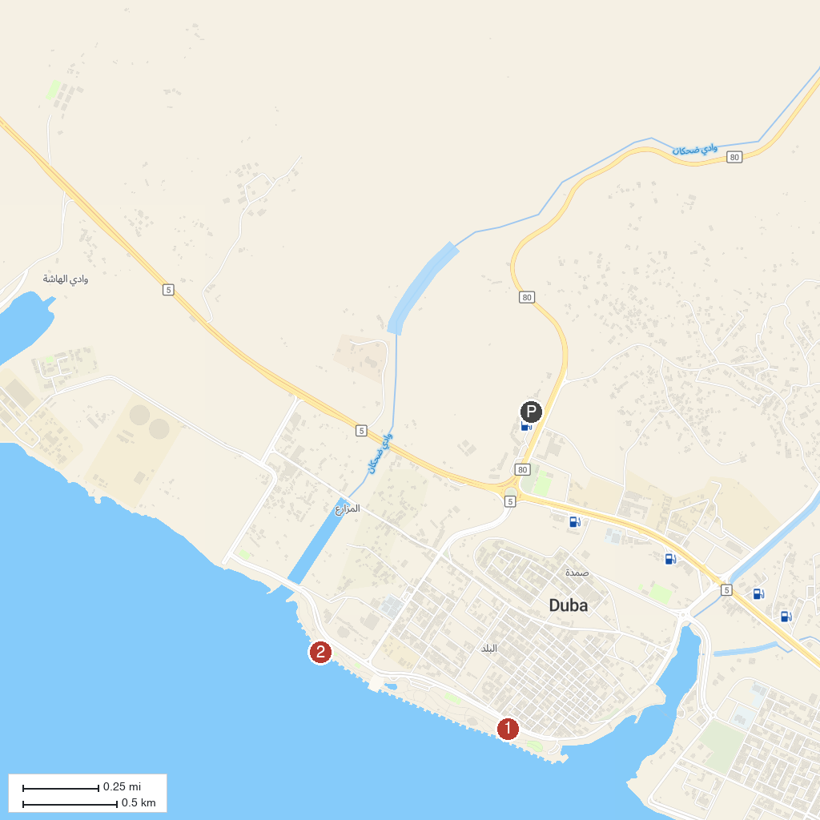
MAP KEY
1. Duba beach front | 2. كورنيش ضباء
P. Cruise port / terminal
Map © MapTiler © OpenStreetMap contributors · cruiseports.org

