Dublin, Leinster, Ireland
Ireland's capital packs Viking history, literary giants, and world-class pubs into a walkable Georgian city — all within reach of a single cruise day.
⚓ Docked (Alexandra Quay) · 🕒 Typical call: 8–10 hrs · 💶 Currency: Euro (€) · 🗣️ Language: English / Irish
✍️ MY DAY IN PORT (FILL IN)
Ship / Date
In port | arrive ______ · all aboard ______
Booked excursion
Notes / meeting point
GETTING ASHORE
- Docking: Alexandra Quay (Berth 33 or Berth 18), ~1.5–3 km from city centre; shuttle or taxi required from industrial zone
- Walk to Centre: Not walkable from berth — taxi €10–15, Luas tram from The Point, or cruise shuttle
- Best For: History, pub culture, literary heritage, Wicklow countryside day trips
- Don't Miss: Book of Kells at Trinity College, Guinness Storehouse, and a pint in Temple Bar
GETTING AROUND
- 🚕 Taxi: €12–€18 — Licensed metered taxis from the port to city center (O'Connell St area). Groups of 3–4 often find taxis cheaper than shu
- 📱 Rideshare: ✅ Uber, Bolt
- 🚌 Hop-on hop-off: ✅
TOP THINGS TO DO
- Guinness Storehouse — Seven floors of brewing history ending with a complimentary pint and 360° views from the Gravity Bar over Dublin's rooftops.
- Trinity College & Book of Kells — Walk the cobbled squares of Ireland's oldest university and see the 9th-century illuminated gospel manuscript in the Long Room…
- Dublin City Hop-On Hop-Off Bus — Cover all the highlights — Dublin Castle, Christ Church Cathedral, St.
- Wicklow Mountains & Glendalough — Head south into the 'Garden of Ireland' to visit the 6th-century monastic settlement of Glendalough in a glacial valley — one of…
- Boyne Valley — Newgrange & Hill of Tara — Drive north to Ireland's Ancient East: Newgrange passage tomb (older than Stonehenge) and the Hill of Tara, seat of the High…
BEST WALKS
- Dublin City Centre Highlights Walk: 3–4 km · 1–1.5 hrs · Easy · Flat — Start at O'Connell Bridge and walk south across to Trinity College, continue to Dublin Castle and…
- Phoenix Park Ramble: 3–5 km in park · 1.5 hrs · Easy · Free entry — Europe's largest urban park — home to wild fallow deer, Áras an Uachtaráin (President's residence)…
WEATHER · DAYLIGHT · MONEY
Month | High °F | Low °F | Rainy days
May | 58 | 48 | 13
Jul | 67 | 56 | 14
Sep | 63 | 53 | 12
Daylight: May 5:25AM–9:18PM · Jul 5:16AM–9:44PM · Sep 6:59AM–7:39PM
cruiseports.org/dublin · Confirm terminal & all-aboard time with your ship

Dublin, Leinster, Ireland — Port Map
Red = walkable sights · Amber = excursions farther out · P = cruise terminal
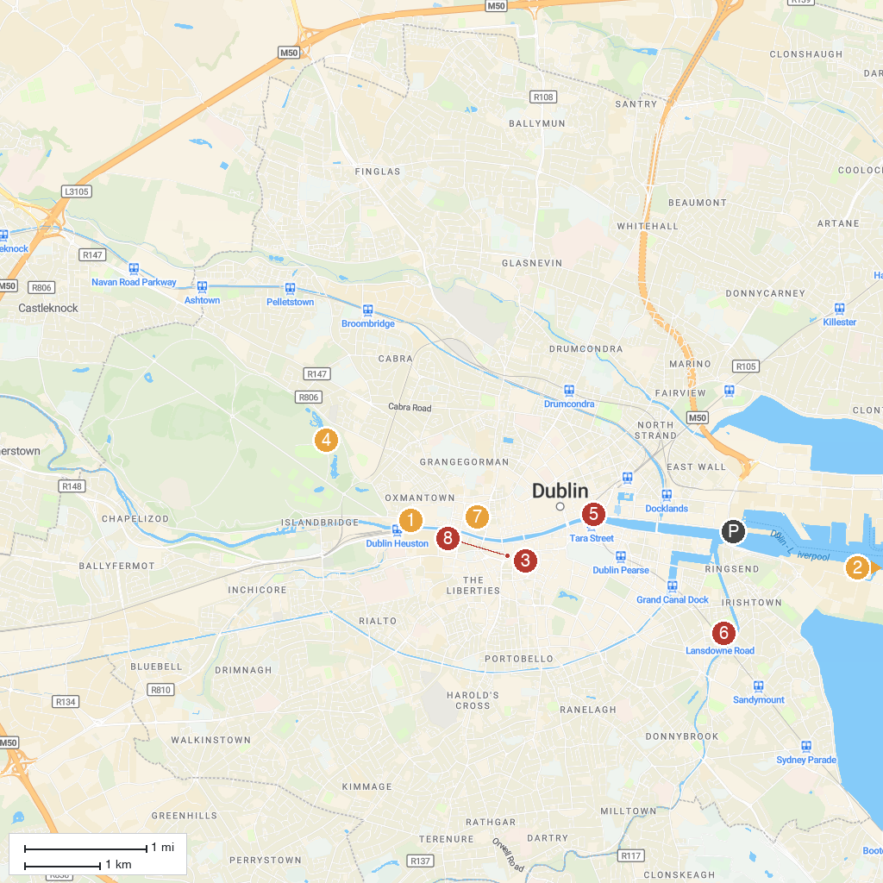
MAP KEY
1. Anna Livia | 5. The Custom House
2. Poolbeg Lighthouse | 6. Aviva Stadium
3. Dublin Castle | 7. Jameson Distillery Bow St.
4. Dublin Zoo | 8. Christ Church Cathedral
P. Cruise port / terminal
Map © MapTiler © OpenStreetMap contributors · cruiseports.org

